Saint Mary Catholic Church
701 East Third Street, Wilton, IA 52778

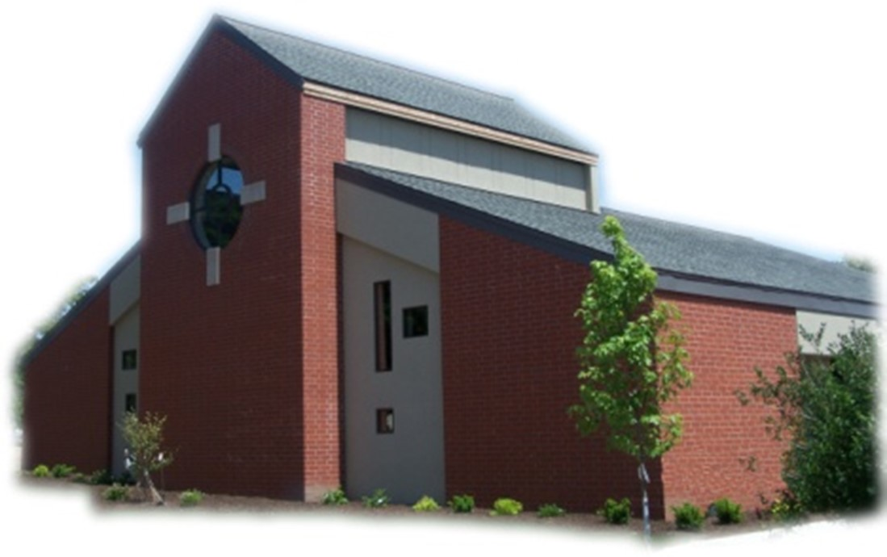
22nd Sunday of Ordinary Time - August 31, 2025

Sacramental Priest, Rev. Robert “Bud” Grant Email: grantrobert@sau.edu
Priest Moderator, Rev. Thom Hennen Email: hennent@diodav.org

Parish Life Coordinator, Deacon Dan Freeman
Cell - 563-320-2462 Email: wiltonstmary@diodav.org

Office Manager - Rosemary Sullivan Director of Religious Education – Hilary Henke
Cell - 563-723-1050 / wiltonstmaryfin@diodav.org Cell - 563-260-5861 / wiltonstmarydre@diodav.org

Mass Time: Sunday – 8:30 a.m.
Religious Education Classes start at 9:30 am during the School year.

Website: https://www.stmarywilton.org Facebook Page - https://www.facebook.com/stmarysofwilton
Happy Labor Day – may you always labor in the love of God!

Today’s Readings – 8-31-25. This weekend we recognize and honor all those who work. There is a dignity in work no matter how humble the task or job may seem or whether it is paid or not, and all who work or who are looking for work are celebrated on Labor Day. As we gather today around the table of the Lord, we hear Jesus teach guests also gathered around a banquet table of the importance of humility. May we approach both our work and the eucharistic table with humility, recognizing God’s grace in making us worthy of both. This weekend we recognize and honor all those who work. There is a dignity in work no matter how humble the task or job may seem or whether it is paid or not, and all who work or who are looking for work are celebrated on Labor Day. As we gather today around the table of the Lord, we hear Jesus teach guests also gathered around a banquet table of the importance of humility. May we approach both our work and the eucharistic table with humility, recognizing God’s grace in making us worthy of both.

St. Mary Parish Schedule:
- Sun Aug 31st Mass. (Labor Day Weekend)
- Wed Sep 3rd Faith Formation Committee meeting at 5:30 pm.
- Sun Sep 7th Mass. RE Registration. 9:30-11 am Teacher Inservice.
- Sun Sep 14th Mass – Exaltation of Holy Cross. RE Registration. Parish/Finance Councils.
- Sun Sep 21st Mass – Catechetical Sunday. RE Classes start. Bless Students & Teachers.
    - Parent meeting for all Religious Ed. Pre-K – Grade 6, 9:30 am in the Parish Hall.
- Sun Sep 28th Mass. RE Classes. Priesthood Sunday. 2025-26 ADA Kick off.

2024-25 ADA – we hope that those who haven’t completed their pledge payments for this past year’s ADA can finish their pledges very soon as we will start the new ADA pledge soon. 2024-25 ADA Goal - $19,450. Total Pledged - $31,162. Total Paid as of 8-20-25 is $25,602. Thank you!

New Priest Moderator – Father Dale Mallory has replaced Bishop-elect Thom Hennen as our Priest Moderator and for St. Andrew effective September 1st. Father Mallory also is assigned as Chaplain at St. Ambrose and Pastor of St. Peter Parish of Buffalo.

Registration for Religious Education - Sundays, Sept. 7th and Sept. 14th after Masses. You may also download a form from our website. Those who have previously registered only have to indicate if they will allow pictures of their children to be published on St. Mary’s Facebook or Website. Teachers’ children pay NO fees for Religious Education regardless of numbers.

Coffee & Donuts coming Soon!!! Along with the beginning of our Religious Education program also comes our coffee and donuts after Mass. There is a sign-up board in the Gathering Area for preparation and cleanup. Please sign up early and often.

EPIC Breakfast Thank you! – to Andrew & Andrea Koopman, Gina & Steve Holladay, Amanda Rockow, Gail & Bill McCrabb, Rosemary Sullivan, Henry Bentley, and all of the others that helped out, thank you for the great breakfast that was prepared, cooked and served. Tasted Great!

Thank you, Beverly Bentley, for trimming all of the bushes around the church ground and cleaning up afterwards. The place looks great!

Bingo – New date - Saturday, October 4th doors open at 5:00 pm, Games begin at 5:30 pm. Contact Amanda Rockow for details or to volunteer. The proceeds will go to our Youth Group activities and NCYC.

Coordinator of Youth Ministry (CYM) job opening. Time commitment is approximately 10 hours per month for 10 months (August – May). Contact Deacon Dan for details.

Pilgrims of Hope – The Bishops of Iowa have released a Pastoral Reflection on Immigration. This reflection seeks to remind our Catholic community of the authentic teaching of the Church on immigration and of the long-standing Catholic Social Teaching on Immigration. The full document may be accessed at https://iowacatholicconference.org/. Following are key points:
Part I - “Wherever you lodge, I will lodge” (Ruth 1:16)
- The Catholic Church has always proclaimed the inviolable dignity of the human person, created in the image and likeness of God.
- The right to migrate has long been affirmed in Catholic moral teaching.
- In welcoming the migrant, we welcome Jesus himself.
Part II - Immigration through the Lens of Catholic Social Teaching
- At the core of Catholic Social Teaching is the conviction that every person has a right to live in conditions consistent with his or her human dignity.
- The Church is called to defend her most vulnerable children. This is why Catholic institutions engage in legal aid, resettlement and advocacy efforts.
- Nations have the right to regulate their borders for the sake of the common good, provided these safeguards are justly enacted with respect for fundamental human rights.
- more to follow next week.

OCIA – Non-Catholic or Catholic – this is a great way to enhance your understanding of what we believe and why. The Order of Christian Initiation of Adults is a process through which non-baptized or baptized non-Catholic men and women enter the Catholic Church. It can also just be a way to learn more about our faith. The process is marked by Study, Discussion, and Prayer. To learn more about our Catholic Faith please contact Deacon Dan. Classes will start in September.

A Women’s Discernment Evening is scheduled for Thursday September 18 at 5:30 pm at St. Mary in Iowa City. Join sisters from the Dominican Sisters of St. Cecilia for dinner and a Holy Hour. The public is invited to the Holy Hour as we pray for vocations and all those discerning.

SURVEY - Consultation of the Laity: The USCCB wants to learn how the people of God are living out their baptism and how parish leadership can better support that. The survey is open until the end of September. Please fill out this survey at - https://www.surveymonkey.com/r/6PMVLP3.

Saint for August 31st – Saint Joseph of Arimathea and Saint Nicodemus. In Jerusalem, the Saints received the body of Jesus after it was taken down from the cross, wrapped it in a linen cloth, and placed it in a tomb. Joseph, a noble councilor and disciple of the Lord, was awaiting the kingdom of God; Nicodemus, a Pharisee and leader of the Jews, came to Jesus by night to inquire about his mission and later defended his cause before the priests and Pharisees who sought to arrest Jesus.

50th Wedding Anniversary Mass and Reception with Bishop Walsh at St. Patrick Catholic Church in Iowa City on Sunday, October 19, 2025, at 2 p.m. Please send me your name and address if you were married in 1975 or have not attended a Diocesan 50th Anniversary previously.

Celebrate World Day for Grandparents and Elderly: September 6th – 7th. The theme for the 2025 celebration selected by the pope is “Blessed are those who have not lost hope.” The celebration of World Day for Grandparents and the Elderly was moved to the first weekend after Labor Day to coincide with National Grandparents (and the Elderly) Day in the United States.

Great Resources – Catholic Moms at https://www.catholicmom.com/. Another great resource is https://www.catholic.org/.

Fighting to break free from pornography? Get Help! https://integrityrestored.com/ or https://www.strive21.com/, or https://www.covenanteyes.com/. Call 563-334-4505 for a local group.

STEP Theology Online - Connecting the Catholic intellectual life to the life of the Church: June 16 classes begin. The Diocese of Davenport has partnered with STEP at the University of Notre Dame to offer online formation for the people of the diocese. Learn more about certificate offerings through STEP which has 20 years’ experience of offering “satellite” intellectual formation. Individuals receive a 50% discount off $99. Questions, https://www.davenportdiocese.org/ff-step or contact Trevor Pullinger at pullinger@davenportdiocese.org.

Questions about our Faith – here’s your chance to ask any question pertaining to the Catholic Church and our Catholic Faith that you are curious about. Simply email your question to wiltonstmary@diodav.org and it will be answered in the Bulletin anonymously.

Crisis Emergency Phone: 855-581-8111 for those contemplating suicide in Eastern Iowa. A crisis is any stress or pressure that has become far too great for you to cope with alone. Trained counselors are available to meet in person anywhere. Mobile outreach is also offered.

Meal Train Ministry - Our meal train ministry helps parishioners who have recently had a baby, those who have recently lost a loved one, are going through an illness or rough time, or those who are temporarily homebound and need assistance with meals. If you'd like more information, would like to nominate a parishioner, or would like to be put on the list to make meals when able, please contact Sarah Costello at 563-210-3977 or email slcostello09@gmail.com.

Mass Intention for Sunday, September 7, 2025 – Jerry Williams
Lay Mass Ministers for Sunday, September 7, 2025.
Announcer & 1st Reading – Nolan Williams 2nd Reading – Jessica Williams
EMHC –Steve Grotzky & Linda Lund Gift Bearers – Linda & Don Kraklio
Ushers – Gail & Bill McCrabb Servers – Carter, Cooper, & Tucker Smyser

Mass Intentions for the deceased are $5.00 each. Please indicate who the Mass is to be said for and how many Masses are requested. We will try to honor requested Mass dates.

Protecting God’s Children - To report child abuse contact the Iowa Dept. of Human Services Child Abuse hotline: 800-362-2178 and if clergy involved or church personnel also notify Alicia Owens, Victim Assistance Coordinator, 563-349-5002; vac@diodav.org or PO Box 232, Bettendorf, IA.

New Parishioners: Please complete the Registration form online at https://www.stmarywilton.org/ or to request a form after Mass. The completed form may be placed in the Contribution Basket or given to Deacon Dan. See the contact information on the Bulletin to contact me with any questions.
Envelopes – If you are not receiving Parish Contribution Envelopes, please contact Deacon Dan.

The Coming Home Network was established to help non-Catholic Christians, clergy and laity, discover the truth and beauty of Catholicism and to make the journey home to full communion with the Catholic Church. https://chnetwork.org/.

Sacraments - to schedule participation in any of these please contact Deacon Dan:
- Baptism – A prep class required for family’s first child. Contact Deacon Dan 1 month prior.
- Confession – email Father Bud at grantrobert@sau.edu for times prior/after Mass.
- Marriage – contact Deacon Dan a minimum of 7 months prior to the proposed ceremony.
- Anointing – Anyone having surgery or experiencing illness may ask for the Rite of Anointing of the Sick. Father Bud will anoint immediately after Mass. Contact Deacon Dan.
- Funeral Preparation – please contact Deacon Dan. A great booklet is available to help.

