Saint Mary Catholic Church
701 East Third Street, Wilton, IA 52778

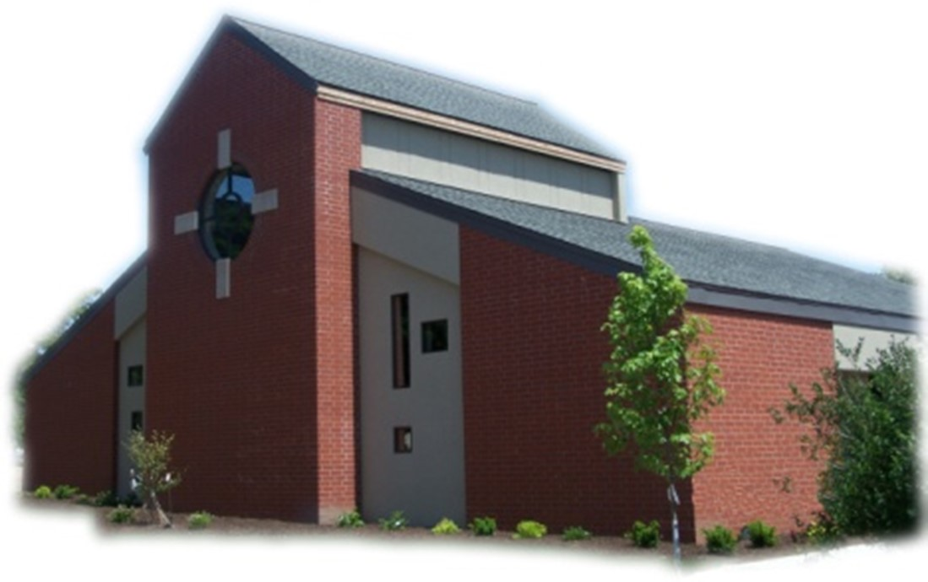
18th Sunday of Ordinary Time - August 3, 2025

Sacramental Priest, Rev. Robert “Bud” Grant Email: grantrobert@sau.edu
Priest Moderator, Rev. Thom Hennen Email: hennent@diodav.org

Parish Life Coordinator, Deacon Dan Freeman
Cell - 563-320-2462 Email: wiltonstmary@diodav.org

Office Manager - Rosemary Sullivan Director of Religious Education – Hilary Henke
Cell - 563-723-1050 / wiltonstmaryfin@diodav.org Cell - 563-260-5861 / wiltonstmarydre@diodav.org

Mass Time: Sunday – 8:30 a.m.
Religious Education Classes start at 9:30 am during the School year.

Website: https://www.stmarywilton.org Facebook Page - https://www.facebook.com/stmarysofwilton
Today’s Readings – 8-3-25. “You can’t take it with you.” It’s a reminder that the wealth we accumulate in this world does not transfer to the next. In our secular society, this saying often implies that you should spend your wealth now while you can enjoy it, but our faith demands that we look at wealth differently. Building up material wealth is irrelevant to our vocation as disciples and can distract us from what is truly important. Let us lift our hearts and raise our voices to God, who is the source of our true wealth. Question of the Week - What or whom have I thought of when I have received an unexpected bounty? How can I be a more generous person?

St. Mary Parish Schedule:
- Sun Aug 3rd Mass.
- Tue Aug 5th Faith Formation Committee meeting at 5:30 pm.
- Sun Aug 10th Mass. No Parish or Finance Council meeting – Deacon gone.
- Fri Aug. 15th Mass - Assumption of Blessed Virgin Mary. 7pm - Holy Day of Obligation.
- Sun Aug 17th Mass. RE Registration.
- Sun Aug 24th Mass. Parish Breakfast after Mass. Parish grounds cleanup after Breakfast.
- Sun Aug 31st Mass.
- Wed Sep 3rd Faith Formation Committee meeting at 5:30 pm.
- Sun Sep 7th Mass. RE Registration. 9:30-11 am Teacher Inservice.

2024-25 ADA – Please complete your last year’s ADA pledge payments. Thank you!

Parish Cleanup – Sunday, August 24th after Breakfast please gather young and old to clean up our parish grounds. We need to rake up debris, wash windows inside and outside, etc. Please bring hedge trimmers & extension cords, rakes, and other as needed. Many hands make light work

50th Wedding Anniversary Mass and Reception with Bishop Walsh at St. Patrick Catholic Church in Iowa City on Sunday, October 19, 2025, at 2 p.m. Please send me your name and address if you were married in 1975 or have not attended a Diocesan 50th Anniversary previously.

OCIA – Non-Catholic or Catholic – this is a great way to enhance your understanding of what we believe and why. The Order of Christian Initiation of Adults is a process through which non-baptized or baptized non-Catholic men and women enter the Catholic Church. It can also just be a way to learn more about our faith. The process is marked by Study, Discussion, and Prayer. To learn more about our Catholic Faith please contact Deacon Dan. Classes will start in September.

Coordinator of Youth Ministry (CYM) job opening. Time commitment is approximately 10 hours per month for 10 months (August – May). Contact Deacon Dan for details.

Bingo – Save the date - Saturday, September 20th starting at 5:30 pm. Contact Amanda Rockow for details or to volunteer. The proceeds will go to our Youth Group activities and NCYC.

Envelopes – If you are not receiving Parish Contribution Envelopes, please contact Deacon Dan.

Update - Religious Education - St. Mary Parish Religious Education program is looking for two volunteer teachers for 4th grade and one volunteer teacher for 2nd grade for the 2025-2026 school year. Classes run from September 21st - April 12th with an average of one week per month off. Volunteers receive free Religious Education Registration for their children. Please contact DRE Hilary Henke at wiltonstmarydre@diodav.org if you are interested.

Ireland in March 2026 - Join Father Jeff Belger and fellow members of the Newman Center community on a once-in-a-lifetime pilgrimage; includes visits to St. Patrick’s Purgatory, Knock Shrine, and more - as we celebrate the Feast of St. Patrick where he spread the Gospel. To learn more or to sign up, visit their website at www.iowacatholic.org or contact Kristie Wert, Director of Operations at kristie@newman-ic.org. Spots are limited – so don’t miss this incredible opportunity!

Small Faith Groups – This is a great way to grow your faith in the company of our St. Mary community. The Parish will help by publicizing your group and purpose as well as provide books / supplies as needed. We are called to engage our faith and to grow. We can do this by studying and learning from our many resources as well as each other. Sign up forms are in the Gathering Area.
- Explore the Sunday Readings with Coffee & Donuts – will meet after Mass.
- Bible Study Invitation! – yet to be determined.
- Women’s Small Faith Group - will meet on weekday mornings.
- Discernment Group – where and how is God calling me. Contact Deacon Dan.
- Eucharistic Exposition, Adoration, & Benediction monthly service – contact Deacon Dan.

Assumption of the Blessed Virgin Mary is a Holy Day of obligation. Mass at St. Mary will be held at 7:00 pm, Friday, August 15th, 2025.
The Story of the Assumption of the Blessed Virgin Mary.
On November 1, 1950, Pope Pius XII defined the Assumption of Mary to be a dogma of faith: “We pronounce, declare and define it to be a divinely revealed dogma that the immaculate Mother of God, the ever-Virgin Mary, having completed the course of her earthly life, was assumed body and soul to heavenly glory.” The pope proclaimed this dogma only after a broad consultation of bishops, theologians and laity. There were few dissenting voices. What the pope solemnly declared was already a common belief in the Catholic Church. We find homilies on the Assumption going back to the sixth century. In following centuries, the Eastern Churches held steadily to the doctrine, but some authors in the West were hesitant. However, by the 13th century there was universal agreement. The feast was celebrated under various names - Commemoration, Dormition, Passing, Assumption - from at least the fifth or sixth century. Today it is celebrated as a solemnity.

Coffee & Donuts coming Soon!!! Along with the beginning of our Religious Education program also comes our coffee and donuts after Mass. There is a sign-up board in the Gathering Area for preparation and cleanup. Please sign up early and often.

Great Resources – Catholic Moms at https://www.catholicmom.com/. Another great resource is https://www.catholic.org/.

The Clothes Closet will be changing over to winter clothes on Thursday, August 28th at 9:00 am.

Fighting to break free from pornography? Get Help! https://integrityrestored.com/ or https://www.strive21.com/, or https://www.covenanteyes.com/. Call 563-334-4505 for a local group.

STEP Theology Online - Connecting the Catholic intellectual life to the life of the Church: June 16 classes begin. The Diocese of Davenport has partnered with STEP at the University of Notre Dame to offer online formation for the people of the diocese. Learn more about certificate offerings through STEP which has 20 years’ experience of offering “satellite” intellectual formation. Individuals receive a 50% discount off $99. Questions, https://www.davenportdiocese.org/ff-step or contact Trevor Pullinger at pullinger@davenportdiocese.org.

855-581-8111 is the Crisis System emergency phone number for those contemplating suicide in Eastern Iowa. A crisis is any stress or pressure that has become far too great for you to cope with alone. The crisis system was established due to several core services that each region in the state of Iowa would need to carry out. The crisis system also offers mobile outreach. Trained counselors are able to meet people in person wherever they are located. “Mobile crisis outreach has responded to schools, hospitals, jails, homes, and more, usually arriving on site within 60 minutes.”

Meal Train Ministry - Our meal train ministry helps parishioners who have recently had a baby, those who have recently lost a loved one, are going through an illness or rough time, or those who are temporarily homebound and need assistance with meals. If you'd like more information, would like to nominate a parishioner, or would like to be put on the list to make meals when able, please contact Sarah Costello at 563-210-3977 or email slcostello09@gmail.com.

Mass Intention for Sunday, August 10, 2025 – Julius Timmerman
Lay Mass Ministers for Sunday, August 10, 2025.
Announcer & 1st Reading – Nevin Williams 2nd Reading & Prayers of Faithful–Jessica Williams
EMHC – Steph Lilienthal, Denise Timmerman, Jacqueline Grotzky
Gift Bearers – Andy Koopmann Family Ushers – Tom Kelley & Rick Janney
Servers – Kensington & Kinley Boorn & Scarlet Grotzky

Mass Intention, Friday, August 15, 2025 –– Virginette Finck
Assumption of Blessed Virgin Mary Mass - Lay Mass Ministers for Friday, August 15, 2025.
Announcer & 1st Reading – Dennis Sass 2nd Reading & Prayers of Faithful – Joe Kaufman
EMHC – Rick Janney, Denise Timmerman & Amanda Rockow
Gift Bearers – Terry Martz & Colleen Nichols Ushers – Colleen Nichols & Fred Grunder
Servers – Amelia & Lucy Costello & Scarlet Grotzky

Protecting God’s Children - To report child abuse contact the Iowa Dept. of Human Services Child Abuse hotline: 800-362-2178 and if clergy involved or church personnel also notify Alicia Owens, Victim Assistance Coordinator, 563-349-5002; vac@diodav.org or PO Box 232, Bettendorf, IA.

New Parishioners: Please complete the Registration form online at https://www.stmarywilton.org/ or to request a form after Mass. The completed form may be placed in the Contribution Basket or given to Deacon Dan. See the contact information on the Bulletin to contact me with any questions.

The Coming Home Network was established to help non-Catholic Christians, clergy and laity, discover the truth and beauty of Catholicism and to make the journey home to full communion with the Catholic Church. https://chnetwork.org/.

Blessings & Prayers Offered. Blessings or Special Prayers for your family or any family event or gathering such as an engagement, birthday, etc., or for your home, pets, livestock, crops, new buildings or for any other reason are offered to celebrate God’s goodness or ask for His grace. Blessings and Prayers with our family and friends help all of us recognize that God is always among us and wants to be active in our lives. Please contact Deacon Dan for more information.

Sacraments - to schedule participation in any of these please contact Deacon Dan:
- Baptism – A prep class required for family’s first child. Contact Deacon Dan 1 month prior.
- Confession – email Father Bud at grantrobert@sau.edu for times prior/after Mass.
- Marriage – contact Deacon Dan a minimum of 7 months prior to the proposed ceremony.
- Anointing – Anyone having surgery or experiencing illness may ask for the Rite of Anointing of the Sick. Father Bud will anoint immediately after Mass. Contact Deacon Dan.
- Funeral Preparation – please contact Deacon Dan. A great booklet is available to help.

