Saint Mary Catholic Church
701 East Third Street, Wilton, IA 52778

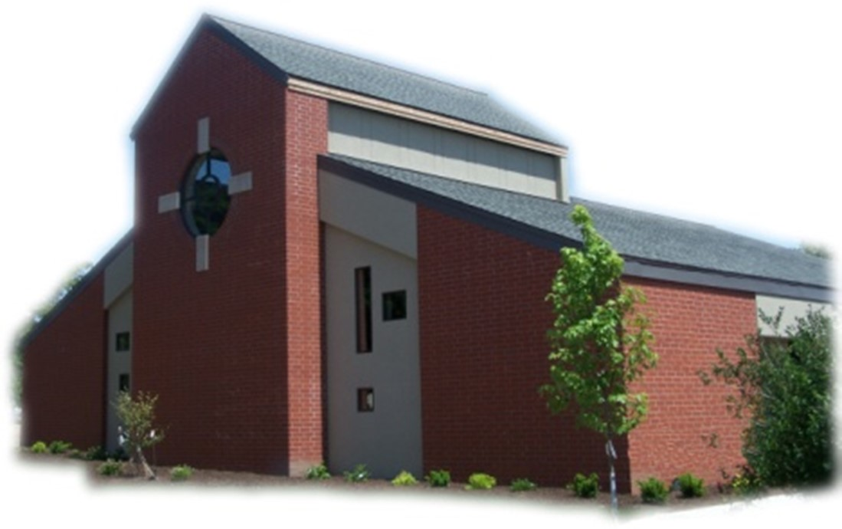
17th Sunday of Ordinary Time - July 27, 2025

Sacramental Priest, Rev. Robert “Bud” Grant Email: grantrobert@sau.edu
Priest Moderator, Rev. Thom Hennen Email: hennent@diodav.org

Parish Life Coordinator, Deacon Dan Freeman
Cell - 563-320-2462 Email: wiltonstmary@diodav.org

Office Manager - Rosemary Sullivan Director of Religious Education – Hilary Henke
Cell - 563-723-1050 / wiltonstmaryfin@diodav.org Cell - 563-260-5861 / wiltonstmarydre@diodav.org

Mass Time: Sunday – 8:30 a.m.
Religious Education Classes start at 9:30 am during the School year.

Website: https://www.stmarywilton.org Facebook Page - https://www.facebook.com/stmarysofwilton
Today’s Readings – 7-27-25. When we want something from a friend, whether it’s something they have or a favor they could do for us, we normally just go ahead and ask. Jesus tells his disciples today that we should approach God the same way. He assures us that the Father in heaven listens to our prayers and that we should persist in prayer, for we are a needy people, ultimately dependent on God. Our lives are in God’s hands and so we pray that God watches over us, forgives us, and has mercy on us, as we proclaim when praying how Jesus taught us. Question of the Week - Over the coming week, take time each day to persistently ask God for a need of yours or a friend. At the end of the week, answer this question: What have I learned by persisting in prayer daily for this need?

St. Mary Parish Schedule:
- Sun Jul 27th Mass. Deacon will be gone.
- Sun Aug 3rd Mass.
- Tue Aug 5th Faith Formation at 5:30 pm.
- Sun Aug 10th Mass. No Parish or Finance Council meeting
- Fri Aug. 15th Mass - Assumption of Blessed Virgin Mary. 7:00 pm -– Holy Day of Obligation.
- Sun Aug 17th Mass. RE Registration.
- Sun Aug 24th Mass. Parish Breakfast after Mass. Parish grounds cleanup after Breakfast.

2024-25 ADA – Please complete your last year’s ADA pledge payments. Thank you!

Parish Cleanup – Sunday, August 24th after Breakfast please gather young and old to clean up our parish grounds. We need to trim the hedges/bushes, rake up debris, wash outside windows, etc. Please bring hedge trimmers & extension cords, rakes, and other as needed. Many hands make light work

50th Wedding Anniversary Mass and Reception with Bishop Walsh at St. Patrick Catholic Church in Iowa City on Sunday, October 19, 2025, at 2 p.m. Please send me your name and address if you were married in 1975 or had not attended a Diocesan 50th Anniversary previously.

OCIA – Non-Catholic or Catholic – this is a great way to enhance your understanding of what we believe and why. The Order of Christian Initiation of Adults is a process through which non-baptized or baptized non-Catholic men and women enter the Catholic Church. It can also just be a way to learn more about our faith. The process is marked by Study, Discussion, and Prayer. To learn more about our Catholic Faith please contact Deacon Dan. Classes will start in September.

Coordinator of Youth Ministry (CYM) job opening. Time commitment is approximately 10 hours per month for 10 months (August – May). Contact Deacon Dan for details.

Bingo – Save the date - Saturday, September 20th starting at 5:30 pm. Contact Amanda Rockow for details or to volunteer. The proceeds will go to our Youth Group activities and NCYC.

Great Resource – Catholic Moms at https://www.catholicmom.com/.
Small Faith Groups – This is a great way to grow your faith in the company of our St. Mary community. The Parish will help by publicizing your group and purpose as well as provide books / supplies as needed. We are called to engage our faith and to grow. We can do this by studying and learning from our many resources as well as each other. Sign up forms are in the Gathering Area.
- Explore the Sunday Readings with Coffee & Donuts – will meet after Mass.
- Bible Study Invitation! – yet to be determined.
- Women’s Small Faith Group - will meet on weekday mornings.
- Discernment Group – where and how is God calling me. Contact Deacon Dan.
- Eucharistic Exposition, Adoration, & Benediction monthly service – contact Deacon Dan.

The Clothes Closet will be changing over to winter clothes on Thursday, August 28th at 9:00 am.
Ireland in March 2026 - Join Father Jeff Belger and fellow members of the Newman Center community on a once-in-a-lifetime pilgrimage; includes visits to St. Patrick’s Purgatory, Knock Shrine, and more - as we celebrate the Feast of St. Patrick where he spread the Gospel. To learn more or to sign up, visit their website at www.iowacatholic.org or contact Kristie Wert, Director of Operations at kristie@newman-ic.org. Spots are limited – so don’t miss this incredible opportunity!

What is Natural Family Planning? - What if a couple could deepen their love while honoring God’s plan for life? Marriage is a sacred gift, a partnership with God. Natural Family Planning (NFP) empowers couples to work with God’s design, using natural methods to plan their family while strengthening their marriage. "Among the many blessings that God has showered upon us in Christ is the blessing of marriage, a gift bestowed by the Creator from the creation of the human race. It is a source of blessing to the couple, to their families, and to society and includes the wondrous gift of co-creating human life. Indeed, as Pope John Paul II never tired of reminding us, the future of humanity depends on marriage and the family." The Church’s teaching on contraception is not just a doctrine that states what not to do, but how to work with God’s plan for authentic love within a marriage. A human life is of inestimable value; a human soul is destined to share a blissful eternity with God, the angels, and saints. Only God can create a new human soul; the Lord works with human beings to bring forth a new person, allowing them to be “co-creators”. In sexual intimacy, spouses invite God to create a new human soul, who then entrusts parents with the momentous task of guiding their child toward heaven. The Catholic Church supports the methods of NFP because they respect God’s design for married love. NFP is an umbrella term for certain methods, used to achieve and avoid conception. These methods reflect the dignity of the human person within the context of marriage and family life, promote openness to life, and recognizes the value of the child. By respecting the love-giving and life-giving natures of marriage, NFP strengthens the bond between husband and wife, fostering love, mutual respect and communication. In this age of continuous assaults on God’s design for life and love, if Catholics reclaimed our rich heritage, it would do the world a great deal of good. To find more information on NFP and discover how it can transform your marriage and align your family with God’s beautiful plan. Visit the USCCB’s website (https://www.usccb.org/topics/natural-family-planning/what-natural-family-planning) for Church teachings and resources or the Diocese of Davenport (https://www.davenportdiocese.org/natural-family-planning) to connect with local NFP teachers.

Fighting to break free from pornography? Get Help! https://integrityrestored.com/ or https://www.strive21.com/, or https://www.covenanteyes.com/. Call 563-334-4505 for a local group.

Mass Intention for Sunday, August 3, 2025 – Leonard Gough
Lay Mass Ministers for Sunday, August 3, 2025.
Announcer & 1st Reading – Ahren Gross 2nd Reading – Amanda Vasey
EMHC – Linda Lund & Henry Bentley Gift Bearers – Jean & Jay Semsch
Ushers – Gail & Bill McCrabb Servers – Natalie Koopmann, Elsie DeLong, & Tillie Marolf

Protecting God’s Children - To report child abuse contact the Iowa Dept. of Human Services Child Abuse hotline: 800-362-2178 and if clergy involved or church personnel also notify Alicia Owens, Victim Assistance Coordinator, 563-349-5002; vac@diodav.org or PO Box 232, Bettendorf, IA.

New Parishioners: Please complete the Registration form online at https://www.stmarywilton.org/ or to request a form after Mass. The completed form may be placed in the Contribution Basket or given to Deacon Dan. See the contact information on the Bulletin to contact me with any questions.

Envelopes – If you are not receiving Parish Contribution Envelopes, please contact Deacon Dan.

The Coming Home Network was established to help non-Catholic Christians, clergy and laity, discover the truth and beauty of Catholicism and to make the journey home to full communion with the Catholic Church. Learn more at CHNetwork.org

STEP Theology Online - Connecting the Catholic intellectual life to the life of the Church: June 16 classes begin. The Diocese of Davenport has partnered with STEP at the University of Notre Dame to offer online formation for the people of the diocese. Learn more about certificate offerings through STEP which has 20 years’ experience of offering “satellite” intellectual formation. Individuals receive a 50% discount off $99. Questions, https://www.davenportdiocese.org/ff-step or contact Trevor Pullinger at pullinger@davenportdiocese.org.

Blessings & Prayers Offered. Blessings or Special Prayers for your family or any family event or gathering such as an engagement, birthday, etc., or for your home, pets, livestock, crops, new buildings or for any other reason are offered to celebrate God’s goodness or ask for His grace. Blessings and Prayers with our family and friends help all of us recognize that God is always among us and wants to be active in our lives. Please contact Deacon Dan for more information.

Sacraments - to schedule participation in any of these please contact Deacon Dan:
- Baptism – A prep class required for family’s first child. Contact Deacon Dan 1 month prior.
- Confession – email Father Bud at grantrobert@sau.edu for times prior/after Mass.
- Marriage – contact Deacon Dan a minimum of 7 months prior to the proposed ceremony.
- Anointing – Anyone having surgery or experiencing illness may ask for the Rite of Anointing of the Sick. Father Bud will anoint immediately after Mass. Contact Deacon Dan.
- Funeral Preparation – please contact Deacon Dan. A great booklet is available to help.

855-581-8111 is the Crisis System emergency phone number for those contemplating suicide in Eastern Iowa. A crisis is any stress or pressure that has become far too great for you to cope with alone. The crisis system was established due to several core services that each region in the state of Iowa would need to carry out. The crisis system also offers mobile outreach. Trained counselors are able to meet people in person wherever they are located. “Mobile crisis outreach has responded to schools, hospitals, jails, homes, and more, usually arriving on site within 60 minutes.”

Meal Train Ministry - Our meal train ministry helps parishioners who have recently had a baby, those who have recently lost a loved one, are going through an illness or rough time, or those who are temporarily homebound and need assistance with meals. If you'd like more information, would like to nominate a parishioner, or would like to be put on the list to make meals when able, please contact Sarah Costello at 563-210-3977 or email slcostello09@gmail.com.

2025-26 Parish Leadership Team

Trustees: (2 year term)
Denise Timmerman 563-349-3880 denisetimmerman13@gmail.com
Henry Bentley 563-340-3111 henrybentley1961@outlook.com

Parish Council: (2 year term)
Damon Boorn (24) Chair/At Large 563-260-9816 damon.boorn@gmail.com
Jessica Williams (25) 563-320-3699 jess_99@yahoo.com
Kathy Keese (22) Secretary/At Large 563-260-4904 Kskeese5@gmail.com
Taci Lilienthal (25) 563-343-1144 taci.lilienthal@gmail.com
Jeremiah Costello (23) Faith Form. 563-370-2065 Jeremiahecostello@gmail.com
Scott Wolf Cemetery 563-370-3734 srwolf64@gmail.com
Jim Gavin Bldg. & Grounds 563-506-5112 gavinjames@netwtc.net
Dennis Sass Liturgy 319-430-2063 dwsass51@gmail.com

Finance Council: (4 year term)
Phil Keese (22) Chair 563-260-4905 plkeese5@gmail.com
Andrea Shaffer (24) 563-299-5632 shafferauto06@gmail.com
Eric Thornton (25) 563-299-4624 eric6982@hotmail.com

