Saint Mary Catholic Church
701 East Third Street, Wilton, IA 52778

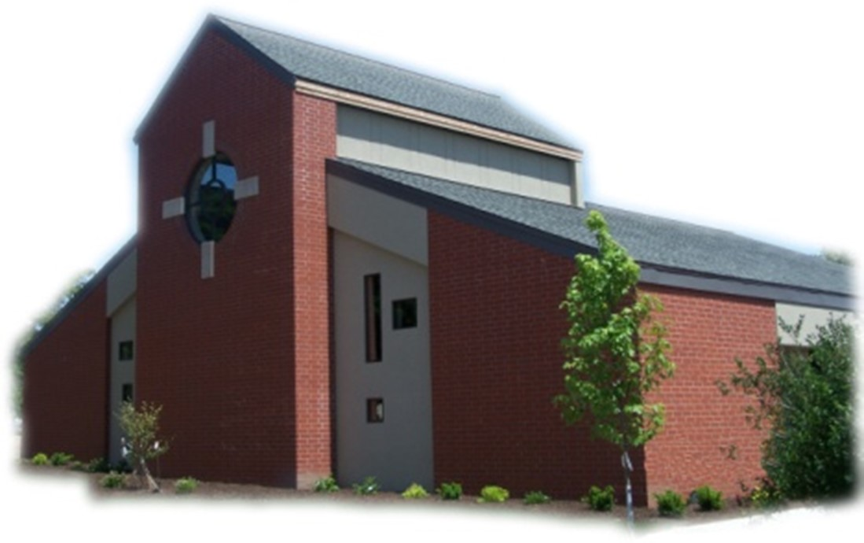
16th Sunday of Ordinary Time - July 20, 2025

Sacramental Priest, Rev. Robert “Bud” Grant Email: grantrobert@sau.edu
Priest Moderator, Rev. Thom Hennen Email: hennent@diodav.org

Parish Life Coordinator, Deacon Dan Freeman
Cell - 563-320-2462 Email: wiltonstmary@diodav.org

Office Manager - Rosemary Sullivan Director of Religious Education – Hilary Henke
Cell - 563-723-1050 / wiltonstmaryfin@diodav.org Cell - 563-260-5861 / wiltonstmarydre@diodav.org

Mass Time: Sunday – 8:30 a.m.
Religious Education Classes start at 9:30 am during the School year.

Website: https://www.stmarywilton.org Facebook Page - https://www.facebook.com/stmarysofwilton
Today’s Readings – 7-20-25. We do not know when, where, or how our Lord will come to us. He could appear as a stranger, as someone in need whom we have never met before. Or maybe we’ll encounter Jesus in a dream, while in deep reflection, or in prayer. We are assured of encountering him here and now in a number of ways: as an assembly gathered in his name, in the priest celebrating Mass, in each other, and certainly in the Eucharist, when we receive his Body and Blood. Our readings today remind us that the Lord comes in many ways, and we are called to always respond with attention and kindness. Question of the Week - How am I hospitable to others in need of food or rest, or just some companionship? How can I see the Lord in such hospitality?

St. Mary Parish Schedule:
- Sun Jul 20th Mass.
- Tue Jul 22nd OCIA Team meeting at 5:30 pm.
- Sun Jul 27th Mass. Deacon will be gone.
- Sun Aug 3rd Mass.
- Tue Aug 5th Faith Formation at 5:30 pm.
- Sun Aug 10th Mass.
- Fri Aug. 15th Mass - Assumption of Blessed Virgin Mary. 7:00pm -– Holy Day obligation.

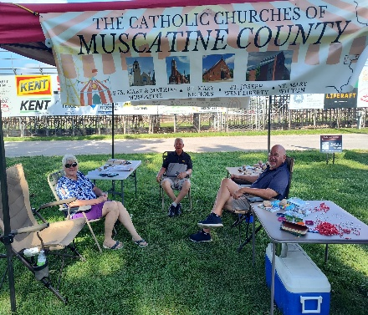
50th Wedding Anniversary Mass and Reception with Bishop Walsh at St. Patrick Catholic Church in Iowa City on Sunday, October 19, 2025, at 2 p.m. Please send me your name and address if you were married in 1975 or had not attended a Diocesan 50th Anniversary previously.

Muscatine County Fair – a Catholic presence. Thank you to all who worked or visited our tent on Wednesday. It was hot but a lot of fun reaching out to people who passed by. Letting them know that the Catholic Church is alive and well even at the fair.

OCIA – Non-Catholic or Catholic – this is a great way to enhance your understanding of what we believe and why. The Order of Christian Initiation of Adults is a process through which non-baptized or baptized non-Catholic men and women enter the Catholic Church. It can also just be a way to learn more about our faith. The process is marked by Study, Discussion, and Prayer. To learn more about our Catholic Faith please contact Deacon Dan. Classes will start in September.

OCIA Team meeting – Tuesday, July 22nd at 5:30 pm for anyone interested in helping those who want to join our faith/church. Come, learn how we welcome new members to the Catholic Faith.

Coordinator of Youth Ministry (CYM) job opening. Time commitment is approximately 10 hours per month for 10 months (August – May). Contact Deacon Dan for details.

Bingo – Save the date - Saturday, September 20th starting at 5:30 pm. Contact Amanda Rockow for details or to volunteer. The proceeds will go to our Youth Group activities and NCYC.

Small Faith Groups – This is a great way to grow your faith in the company of our St. Mary community. The Parish will help by publicizing your group and purpose as well as provide books / supplies as needed. We are called to engage our faith and to grow. We can do this by studying and learning from our many resources as well as each other. Sign up forms are in the Gathering Area.
- Explore the Sunday Readings with Coffee & Donuts – will meet after Mass.
- Bible Study Invitation! – yet to be determined.
- Women’s Small Faith Group - will meet on weekday mornings.
- Discernment Group – where and how is God calling me. Contact Deacon Dan.
- Eucharistic Exposition, Adoration, & Benediction monthly service – contact Deacon Dan.

Prayers are requested for Cameron Costello and all the Seminarians of the Davenport Diocese.
Library – Anyone who wishes to donate appropriate books may leave them on the bookcase and they will be taken care of. A checkout system will be devised shortly.

Ireland in March 2026 - Join Father Jeff Belger and fellow members of the Newman Center community on a once-in-a-lifetime pilgrimage; includes visits to St. Patrick’s Purgatory, Knock Shrine, and more - as we celebrate the Feast of St. Patrick where he spread the Gospel. To learn more or to sign up, visit their website at www.iowacatholic.org or contact Kristie Wert, Director of Operations at kristie@newman-ic.org. Spots are limited – so don’t miss this incredible opportunity!

Do you know a future Priest or Deacon? Please give serious thought as to who you would recommend/encourage to be a Priest or Deacon. Speak to them. Please send me their names so that we can ask them to prayerfully consider their vocation to the clergy.

Vocations Discernment Pilgrimage - Men 18-35. Join Bishop Walsh, priests and seminarians from the Diocese of Davenport on a pilgrimage to the Our Lady of Guadalupe Shrine in La Crosse, WI for a weekend of prayer and reflection. This is a unique opportunity to more intentionally discern a call to the priesthood. August 8 – 10, 2025. Contact Deacon Dan for more information.

Married Couples. Give your marriage a well-deserved vacation. Plan to go on a Worldwide Marriage Encounter Weekend and come back with a marriage that is refreshed and full of energy! Our next weekend is September 12-14 in Dubuque. For more information call Denise and Greg at (563)920-9419 or visit wwme.org.

Our Lady of the Prairie – Retreat at 2664 145th Avenue, Wheatland, Iowa 52777. Details and register at www.theprairieretreat.org, or email – olpretreat@gmail.com, or call 563-374-1092.
- Lectio Divina – Online only – Every Tuesday beginning July 1st 9-10 am with Linda Clewell, SMM Oblate. Consider making it a steady prayer in your life. Free Will Offering.
- Living an Integral Catholic Life by Fr. Thomas Hennen. Saturday, September 7th at 9am-4pm. Spend a quiet day away from the busyness of life in a beautiful setting with talks, table discussion, and plenty of time for personal prayer and walking the grounds. Fee is $40

The Clothes Closet will be changing over to winter clothes on Thursday, August 28th at 9:00 am.

Fighting to break free from pornography? Get Help! https://integrityrestored.com/ or https://www.strive21.com/, or https://www.covenanteyes.com/. Call 563-334-4505 for a local group.

Mass Intention for Sunday, July 27, 2025 – Ken Grunder
Lay Mass Ministers for Sunday, July 27, 2025 – Deacon will be gone.
Announcer & 1st Reading – Kinley Boorn 2nd Reading & Prayers of Faithful – Renee Cooley
EMHC – Jacqueline Grotzky, Rick Janney & Dennis Sass Gift Bearers – Jamey Meyer Family
Ushers – Andy Koopmann & Fred Grunder Servers – Colin & Conor Thornton, Ruby Timmerman

Protecting God’s Children - To report child abuse contact the Iowa Dept. of Human Services Child Abuse hotline: 800-362-2178 and if clergy involved or church personnel also notify Alicia Owens, Victim Assistance Coordinator, 563-349-5002; vac@diodav.org or PO Box 232, Bettendorf, IA.

New Parishioners: Please complete the Registration form online at https://www.stmarywilton.org/ or to request a form after Mass. The completed form may be placed in the Contribution Basket or given to Deacon Dan. See the contact information on the Bulletin to contact me with any questions.
Envelopes – If you are not receiving Parish Contribution Envelopes, please contact Deacon Dan.

The Coming Home Network was established to help non-Catholic Christians, clergy and laity, discover the truth and beauty of Catholicism and to make the journey home to full communion with the Catholic Church. Learn more at CHNetwork.org

STEP Theology Online - Connecting the Catholic intellectual life to the life of the Church: June 16 classes begin. The Diocese of Davenport has partnered with STEP at the University of Notre Dame to offer online formation for the people of the diocese. Learn more about certificate offerings through STEP which has 20 years’ experience of offering “satellite” intellectual formation. Individuals receive a 50% discount off $99. Questions, https://www.davenportdiocese.org/ff-step or contact Trevor Pullinger at pullinger@davenportdiocese.org.

Blessings & Prayers Offered. Blessings or Special Prayers for your family or any family event or gathering such as an engagement, birthday, etc., or for your home, pets, livestock, crops, new buildings or for any other reason are offered to celebrate God’s goodness or ask for His grace. Blessings and Prayers with our family and friends help all of us recognize that God is always among us and wants to be active in our lives. Please contact Deacon Dan for more information.

Sacraments - to schedule participation in any of these please contact Deacon Dan:
- Baptism – A prep class required for family’s first child. Contact Deacon Dan 1 month prior.
- Confession – email Father Bud at grantrobert@sau.edu for times prior/after Mass.
- Marriage – contact Deacon Dan a minimum of 7 months prior to the proposed ceremony.
- Anointing – Anyone having surgery or experiencing illness may ask for the Rite of Anointing of the Sick. Father Bud will anoint immediately after Mass. Contact Deacon Dan.
- Funeral Preparation – please contact Deacon Dan. A great booklet is available to help.

855-581-8111 is the Crisis System emergency phone number for those contemplating suicide in Eastern Iowa. A crisis is any stress or pressure that has become far too great for you to cope with alone. The crisis system was established due to several core services that each region in the state of Iowa would need to carry out. The crisis system also offers mobile outreach. Trained counselors are able to meet people in person wherever they are located. “Mobile crisis outreach has responded to schools, hospitals, jails, homes, and more, usually arriving on site within 60 minutes.”

Meal Train Ministry - Our meal train ministry helps parishioners who have recently had a baby, those who have recently lost a loved one, are going through an illness or rough time, or those who are temporarily homebound and need assistance with meals. If you'd like more information, would like to nominate a parishioner, or would like to be put on the list to make meals when able, please contact Sarah Costello at 563-210-3977 or email slcostello09@gmail.com.

2025-26 Parish Leadership Team

Trustees: (2 year term)
Denise Timmerman 563-349-3880 denisetimmerman13@gmail.com
Henry Bentley 563-340-3111 henrybentley1961@outlook.com

Parish Council: (2 year term)
Damon Boorn (24) Chair/At Large 563-260-9816 damon.boorn@gmail.com
Jessica Williams (25) 563-320-3699 jess_99@yahoo.com
Kathy Keese (22) Secretary/At Large 563-260-4904 Kskeese5@gmail.com
Taci Lilienthal (25) 563-343-1144 taci.lilienthal@gmail.com
Jeremiah Costello (23) Faith Form. 563-370-2065 Jeremiahecostello@gmail.com
Scott Wolf Cemetery 563-370-3734 srwolf64@gmail.com
Jim Gavin Bldg. & Grounds 563-506-5112 gavinjames@netwtc.net
Dennis Sass Liturgy 319-430-2063 dwsass51@gmail.com

Finance Council: (4 year term)
Phil Keese (22) Chair 563-260-4905 plkeese5@gmail.com
Andrea Shaffer (24) 563-299-5632 shafferauto06@gmail.com
Eric Thornton (25) 563-299-4624 eric6982@hotmail.com

