Saint Mary Catholic Church
701 East Third Street, Wilton, IA 52778

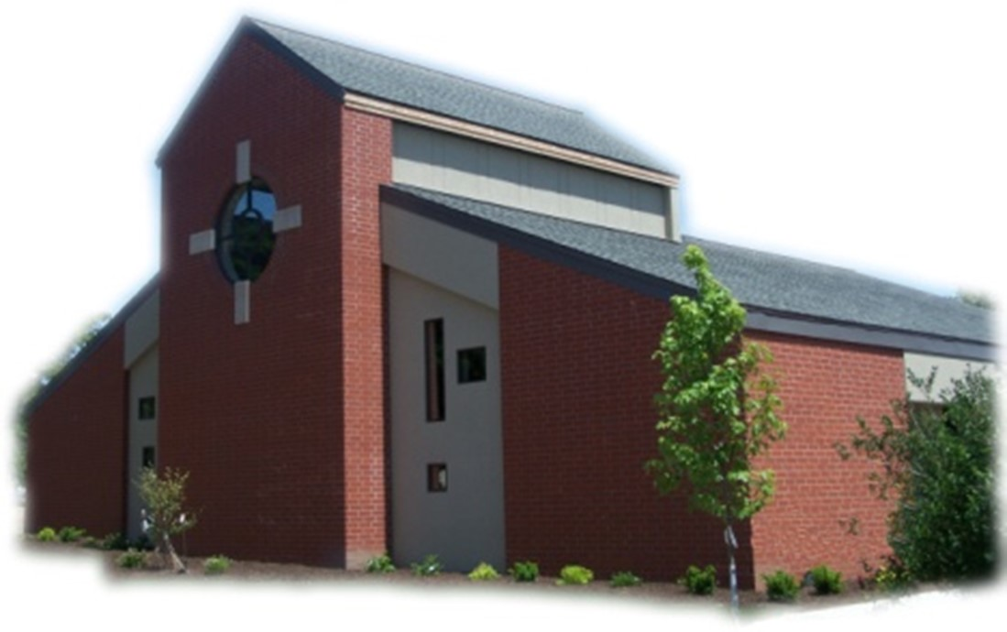
15th Sunday of Ordinary Time - July 13, 2025

Sacramental Priest, Rev. Robert “Bud” Grant Email: grantrobert@sau.edu
Priest Moderator, Rev. Thom Hennen Email: hennent@diodav.org

Parish Life Coordinator, Deacon Dan Freeman
Cell - 563-320-2462 Email: wiltonstmary@diodav.org

Office Manager - Rosemary Sullivan Director of Religious Education – Hilary Henke
Cell - 563-723-1050 / wiltonstmaryfin@diodav.org Cell - 563-260-5861 / wiltonstmarydre@diodav.org

Mass Time: Sunday – 8:30 a.m.
Religious Education Classes start at 9:30 am during the School year.

Website: https://www.stmarywilton.org Facebook Page - https://www.facebook.com/stmarysofwilton
Today’s Readings – 7-13-25. Today we hear the story of the good Samaritan, the parable that Jesus told to explain how far-reaching the concept of neighbor is and how to show love to our neighbor in need. Remember, Samaritans were looked down upon by the Jewish people in that era. If even Samaritans were neighbors, then everyone was. If this undesirable Samaritan is the only person willing to minister to this injured man, we should do the same, ministering to anyone in need, no matter how different they are. May we heed this lesson today just as Jesus taught it two thousand years ago. Question of the Week - To whom can I become a neighbor? How will I follow my compassionate heart even if my head comes up with a dozen different excuses?

St. Mary Parish Schedule:
- Sun Jul 13th Mass. Parish & Finance Councils meet after Mass.
- Wed Jul 16th St. Mary Day at Muscatine County Fair - West Liberty 11 am – 7 pm.
- Sun Jul 20th Mass.
- Tue Jul 15th OCIA Team meeting at 5:30 pm.
- Sun Jul 27th Mass.
- Sun Aug 3rd Mass.
- Tue Aug 5th Father Bud’s 41st Ordination Anniversary -1984.
- Tue Aug 5th Faith Formation at 5:30 pm.
- Sun Aug 10th Mass. Parish & Finance Council meeting after Mass.

EPIC - Muscatine County Fair – a Catholic presence. Please sign up on the form in the Gathering Area if you are willing to volunteer a 4 hour time period to represent our St. Mary Parish. Fair dates are Wednesday, July 16 – Sunday, July 20, 2025. St. Mary will man the tent on Wednesday, July 16th from 11:00 am to 7:00 pm. Details will be sent to everyone who signs up.

OCIA - Order of Christian Initiation of Adults. It’s a process through which non-baptized or baptized non-Catholic men and women enter the Catholic Church. The process is marked by Study, discussion, and Prayer. To learn more about our Catholic Faith please contact Deacon Dan.

OCIA Team meeting – Tuesday, July 22nd at 5:30 pm for anyone interested in helping those who want to join our faith/church. Come, learn how we welcome new members to the Catholic Faith.

Coordinator of Youth Ministry (CYM) job opening. Time commitment is approximately 10 hours per month for 10 months (August – May). Contact Deacon Dan for details.

Prayers are requested for Cameron Costello and all the Seminarians of the Davenport Diocese.

Bingo – Save the date - Faith Formation Committee will be sponsoring Bingo night on Saturday, September 20th starting at 5:30 pm. The proceeds will go to our Youth Group activities and NCYC.

2024-25 Annual Financial Report is attached to this Bulletin. Please contact me or one of our Council Members with any questions or concerns.

Ireland in March 2026 - Join Father Jeff Belger and fellow members of the Newman Center community on a once-in-a-lifetime pilgrimage; includes visits to St. Patrick’s Purgatory, Knock Shrine, and more - as we celebrate the Feast of St. Patrick where he spread the Gospel. To learn more or to sign up, visit their website at www.iowacatholic.org or contact Kristie Wert, Director of Operations at kristie@newman-ic.org. Spots are limited – so don’t miss this incredible opportunity!

Do you know a future Priest or Deacon? Young men do not one day decide in isolation to be a priest. Seminarians say that they were encouraged by several people, over multiple occasions that they would be a good Priest / Deacon and that they should prayerfully consider a vocation. Please give some serious thought as to who you know that you want to encourage to be a Priest or Deacon. Speak to them. We will be asking for names in the next few weeks and will follow up to let them know that our parish would support them and help them discern whatever vocation they may choose.
Small Faith Groups – This is a great way to grow your faith in the company of our St. Mary community. The Parish will help by publicizing your group and purpose as well as providing books / supplies as needed. We are called to engage our faith and to grow. We can do this by studying and learning from our many resources as well as each other. Sign up forms are in the Gathering Area.
- Explore the Sunday Readings with Coffee & Donuts – will meet after Mass.
- Bible Study Invitation! – yet to be determined.
- Women’s Small Faith Group - will meet on weekday mornings.
- Discernment Group – where and how is God calling me. Contact Deacon Dan.
- Eucharistic Exposition, Adoration, & Benediction monthly service – contact Deacon Dan.

Library – Anyone who wishes to donate appropriate books may leave them on the bookcase and they will be taken care of. A checkout system will be devised shortly.

Vocations Discernment Pilgrimage - Men 18-35. Join Bishop Walsh, priests and seminarians from the Diocese of Davenport on a pilgrimage to the Our Lady of Guadalupe Shrine in La Crosse, WI for a weekend of prayer and reflection. This is a unique opportunity to more intentionally discern a call to the priesthood. August 8 – 10, 2025. Contact Deacon Dan for more information.

Married Couples. Give your marriage a well-deserved vacation. Plan to go on a Worldwide Marriage Encounter Weekend and come back with a marriage that is refreshed and full of energy! Our next weekend is September 12-14 in Dubuque. For more information call Denise and Greg at (563)920-9419 or visit wwme.org.

Our Lady of the Prairie – Retreat at 2664 145th Avenue, Wheatland, Iowa 52777. Details and register at www.theprairieretreat.org, or email – olpretreat@gmail.com, or call 563-374-1092.
- Lectio Divina – Online only – Every Tuesday beginning July 1st 9-10 am with Linda Clewell, SMM Oblate. Consider making it a steady prayer in your life. Free Will Offering

Fighting to break free from pornography? Get Help! https://integrityrestored.com/ or https://www.strive21.com/, or https://www.covenanteyes.com/. Call 563-334-4505 for a local group.

Mass Intention for Sunday, July 20, 2025 – Jerry Williams
Lay Mass Ministers for Sunday, July 20, 2025
Announcer & 1st Reading – Renee Cooley 2nd Reading – Madison Smyser
EMHC – Denise Timmerman & Judy Freeman Ushers – Dennis Sass & Joe Kaufman
Gift Bearers – Jeremy Lawlor Family Servers – Carter, Cooper, & Tucker Smyser

Protecting God’s Children - To report child abuse contact the Iowa Dept. of Human Services Child Abuse hotline: 800-362-2178 and if clergy involved or church personnel also notify Alicia Owens, Victim Assistance Coordinator, 563-349-5002; vac@diodav.org or PO Box 232, Bettendorf, IA.

New Parishioners: Please complete the Registration form online at https://www.stmarywilton.org/ or to request a form after Mass. The completed form may be placed in the Contribution Basket or given to Deacon Dan. See the contact information on the Bulletin to contact me with any questions.
Envelopes – If you are not receiving Parish Contribution Envelopes, please contact Deacon Dan.

The Coming Home Network was established to help non-Catholic Christians, clergy and laity, discover the truth and beauty of Catholicism and to make the journey home to full communion with the Catholic Church. Learn more at CHNetwork.org

STEP Theology Online - Connecting the Catholic intellectual life to the life of the Church: June 16 classes begin. The Diocese of Davenport has partnered with STEP at the University of Notre Dame to offer online formation for the people of the diocese. Learn more about certificate offerings through STEP which has 20 years’ experience of offering “satellite” intellectual formation. Individuals receive a 50% discount off $99. Questions, https://www.davenportdiocese.org/ff-step or contact Trevor Pullinger at pullinger@davenportdiocese.org.
Blessings & Prayers Offered. Blessings or Special Prayers for your family or any family event or gathering such as an engagement, birthday, etc., or for your home, pets, livestock, crops, new buildings or for any other reason are offered to celebrate God’s goodness or ask for His grace. Blessings and Prayers with our family and friends help all of us recognize that God is always among us and wants to be active in our lives. Please contact Deacon Dan for more information.

Sacraments - to schedule participation in any of these please contact Deacon Dan:
- Baptism – A prep class required for family’s first child. Contact Deacon Dan 1 month prior.
- Confession – email Father Bud at grantrobert@sau.edu for times prior/after Mass.
- Marriage – contact Deacon Dan a minimum of 7 months prior to the proposed ceremony.
- Anointing – Anyone having surgery or experiencing illness may ask for the Rite of Anointing of the Sick. Father Bud will anoint immediately after Mass. Contact Deacon Dan.
- Funeral Preparation – please contact Deacon Dan. A great booklet is available to help.

855-581-8111 is the Crisis System emergency phone number for those contemplating suicide in Eastern Iowa. A crisis is any stress or pressure that has become far too great for you to cope with alone. The crisis system was established due to several core services that each region in the state of Iowa would need to carry out. The crisis system also offers mobile outreach. Trained counselors are able to meet people in person wherever they are located. “Mobile crisis outreach has responded to schools, hospitals, jails, homes, and more, usually arriving on site within 60 minutes.”

Meal Train Ministry - Our meal train ministry helps parishioners who have recently had a baby, those who have recently lost a loved one, are going through an illness or rough time, or those who are temporarily homebound and need assistance with meals. If you'd like more information, would like to nominate a parishioner, or would like to be put on the list to make meals when able, please contact Sarah Costello at 563-210-3977 or email slcostello09@gmail.com.

Holy Communion - Parishioners that are homebound or hospitalized may request that Holy Communion be brought to them after Mass on Sunday, or other days as necessary. Please contact Deacon Dan at 563-320-2462 or wiltonstmary@diodav.org with your request.

2025-26 Parish Leadership Team

Trustees: (2 year term)
Denise Timmerman 563-349-3880 denisetimmerman13@gmail.com
Henry Bentley 563-340-3111 henrybentley1961@outlook.com

Parish Council: (2 year term)
Damon Boorn (24) President/At Large 563-260-9816 damon.boorn@gmail.com
Jessica Williams (25) 563-320-3699 jess_99@yahoo.com
Kathy Keese (22) Secretary/At Large 563-260-4904 Kskeese5@gmail.com
Taci Lilienthal (25) 563-343-1144 taci.lilienthal@gmail.com
Jeremiah Costello (23) Faith Form. 563-370-2065 Jeremiahecostello@gmail.com
Scott Wolf Cemetery 563-370-3734 srwolf64@gmail.com
Jim Gavin Bldg. & Grounds 563-506-5112 gavinjames@netwtc.net
Dennis Sass Liturgy 319-430-2063 dwsass51@gmail.com

Finance Council: (4 year term)
Phil Keese (22) 563-260-4905 plkeese5@gmail.com
Andrea Shaffer (24) 563-299-5632 shafferauto06@gmail.com
Eric Thornton (25) 563-299-4624 eric6982@hotmail.com

