Saint Mary Catholic Church
701 East Third Street, Wilton, IA 52778

Commemoration of All the Faithful Departed
All Souls’ Day - November 2, 2025

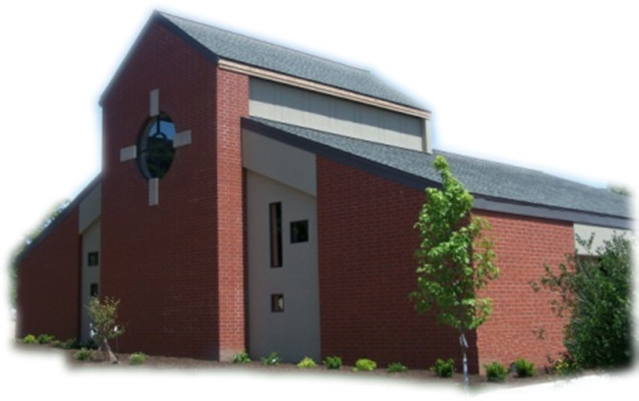

Sacramental Priest, Rev. Robert “Bud” Grant Email: grantrobert@sau.edu
Priest Moderator, Rev. Dale Mallory Email: malloryd@diodav.org

Parish Life Coordinator, Deacon Dan Freeman
Cell - 563-320-2462 Email: wiltonstmary@diodav.org

Office Manager - Rosemary Sullivan Director of Religious Education – Hilary Henke
Cell - 563-723-1050 / wiltonstmaryfin@diodav.org Cell - 563-260-5861 / wiltonstmarydre@diodav.org

Mass Time: Sunday – 8:30 a.m.
Religious Education Classes start at 9:30 am during the School year.

Website: https://www.stmarywilton.org Facebook Page - https://www.facebook.com/stmarysofwilton
Today’s Readings – 11-2-25. Jesus told his disciples, “Blessed are they who mourn, for they will be comforted.” Today we mourn all those who have died, especially those we love, those who are close to us. But we indeed are comforted: by our memories of them, by sharing our grief with our loved ones, and by our faith, which tells us that death is not the end. Their souls are in the arms of God, forever comforted from the suffering and hardships they faced in life. Our faith in the Resurrection allows us to be pilgrims of hope in this life, placing our trust in God’s love and mercy. Question of the Week - Who do I remember in a special way today? Throughout this coming week, can I commit to unite myself with them in prayer?

St. Mary Parish Schedule:
- Sun Nov 2nd Mass – All Souls’ Day. RE Classes. 1st Grade – Gift Bearers.
        - Youth Hayrack Ride & Bonfire from 3-6 pm.
- Tue Nov 4th Faith Formation at 5:30 pm.
- Sun Nov 9th Mass. Dedication St. John Latern. RE Classes. Recognition of Veterans.
    - Parish & Finance Councils meet after Mass. Mass Training – Grades 4-5.
- Wed Nov 12th Liturgy Committee at 5:30 pm. (Advent Postcards)
- Sun Nov 16th Mass. RE Classes. Mass Ministry – Grades 4-5. Mass Lay Ministry Training.
- Thu Nov 20th NCYC Trip to Indianapolis, IN. Return Sun., Nov 23rd.
- Sun Nov 23rd Mass - Christ the King Sunday. RE Classes. Decorate after Mass for Advent.
- Sun Nov 30th Mass 1st Sun. Advent. NO RE Classes. Thanksgiving week.

Christian Initiation Classes – Helping those Becoming Catholic or Joining the Catholic Church. Candidates, Sponsors, & Friends invited. All sessions are in the Parish Hall. Everyone is invited.
- Wed Nov 5th 5:30 pm Denise & Dennis Intro. to Sacraments, Baptism / Confirmation
- Sun Nov 16th 9:45 am Katy & Jim Marriage, Divorce/Annulment, & Holy Orders.
- Sun Nov 30th 9:45 am Amanda & Dyllin Liturgical Year – Advent, Christmas, Lent, etc.

Youth Hayrack Ride & Bonfire – Sunday afternoon, November 2nd from 3 – 6 pm at the Jeremy Lawlor farm, located at 865 230th Street, Stockton, IA 52769. All current Confirmation students, High School Students from St. Mary and a friend and parents are invited. Fun, Food, Fellowship, and Faith activities will be provided. Please respond to Dennis Sass’s text messages.

Saint for November 2nd – Commemoration of All the Faithful Departed (All Souls' Day). The Church today prays for all who, in the purifying suffering of Purgatory, await the day they will join in heavenly glory. The celebration of the Mass, which represents the Sacrifice of Christ on Calvary, has always been the principal means by which the Church fulfills the great responsibility of charity toward the dead. Death cannot break the bonds of the Body of Christ.

Parish Vocation Ministry – Bishop Walsh has asked us to identify 3 – 4 parishioners of St. Mary to serve on our Vocations Committee who will guide our parish in promoting and supporting vocations specifically here at St. Mary through diocesan support. Please contact Deacon Dan to volunteer for this critical mission.

Vocations Prayer: Almighty Father, we beg you for an increase in religious vocations and holy marriages in our diocese. Help us to be generous in our response to Your call. Choose from our homes those who are needed for Your work and strengthen us with the courage to say “yes” and to follow You. Help us as a Diocese, as a parish, as families to encourage and foster vocations to the priesthood, permanent diaconate, and consecrated life. Through Jesus Christ our Lord. Amen.

Thanksgiving Food Drive - The Religious Ed classes would like to provide a Thanksgiving meal to families in need in the Durant and Wilton communities and are accepting donations of nonperishable items. Examples of menu items are shown below. However, give what you can! Please place items in the boxes in the Gathering Area. All Donations Will Be Accepted now through November 16th. Food will then be sorted into meals and presented by the children at Mass on November 23rd. Items to donate; Canned Ham, Stuffing Mix, Instant Mashed Potatoes, Cans or Packets of Gravy, Canned Vegetables, Boxed Mac and Cheese, Canned Fruit, and Canned Soups.
Book of Remembrance – is in the Gathering Area so Parishioners may place names of deceased loved ones to be prayed for during the month of November.

2025 Christmas card for The Catholic Messenger - Youths in grades K-6 of the Davenport Diocese are invited to create a Christmas Card for the Messenger Annual Contest. The artwork should focus on the religious nature of Christmas. Please submit original artwork only, no black and white drawings. Complete drawings on white, 8 ½- by 11-inch paper using colored pencil, crayon, marker or paints. If you use the color yellow, it should be a deeper shade or surrounded by a dark color because yellow is hard to reproduce. Messenger staff members will judge the entries based on originality and the ability to convey what Christmas means to Catholics. On the back of the artwork, include the following information about the artist: first and last name, age, grade, home address, school (public, private or home school and location) and parish (name and city). Please do not fold entries. Any information omitted could be grounds for disqualification. Winning entries will be featured in the Dec. 18th Catholic Messenger. Mail all entries to The Catholic Messenger, 780 W. Central Park Ave., Davenport, IA 52804-1901. Entries must be postmarked by Nov. 19th

Veteran’s Recognition – The 4th Graders will help honor our Veterans on November 9th this year. During mass, veterans will be recognized and handed an American flag. After mass, the 4th graders will help serve donuts, clean up the decorations, and then attend class as usual.

2025-26 Annual Diocesan Appeal – Please consider your gift. Thank you for your generosity!
2024-25 ADA Goal $19,450. Pledged $30,162. Paid $27,762. Thank you for your gift!

Lay Mass Ministries and Altar Servers – Everyone is asked to sign up again even though you have previously signed up. Training will be held in November. We will begin an Advanced Altar Server training class for all those who want to intentionally minister to God and to their parish.

Thanksgiving Dinner – A Dinner on Thanksgiving Day will be sponsored by the Mill Sports Lounge, the Candy Kitchen, and the Axe & Oak Whiskey House at the Axe & Oak Whiskey House , 117 West 4th Street, downtown Wilton. Turkey, ham, mashed potatoes and gravy, dressing, buttered corn and pumpkin pie will be served starting at 11 am until 1 pm. Beverages will include iced tea, coffee, water or milk. Come alone or bring the family, all are welcome. We will accept free will donations. 100% of the donations, plus some matching funds, will go to the Wilton “Shop with a Cop: program. Anyone interested in helping us prepare the dinner, serve, bus tables or help clean up can contact Fred Grunder at 563-343-0040 or email at fkgrunder@gmail.com.

All Saints, Saturday, November 1st is NOT a Holy Day of Obligation this year.

Daylight Savings Time ends November 2nd. Fall back an hour!

Coffee & Donuts during Religious Ed. Sundays after Mass. There is a sign-up board in the Gathering Area for preparation, serving, and cleanup. Please sign up early and often.

Prayers are requested for Cameron Costello and all the Seminarians of the Davenport Diocese. We also pray for the 11 men in Diaconate Formation to be Ordained July 2027.

Mass Intention for Sunday, November 9, 2025 – Deb Krogman
Lay Mass Ministers for Sunday, November 2, 2025.
Announcer & 1st Reading – Megan Smyser 2nd Reading – Madison Smyser
EMHC – Mary Grotzky & Steph Lilienthal Gift Bearers – Denise & Tom Austin
Ushers – Terry Martz & Rick Janney Servers – Elsie DeLong, Brady Blake, & Scarlet Grotzky

Mass Intentions for the deceased are $5.00 each. Please indicate who the Mass is for, who requested it, and how many Masses are requested. We will try to honor requested Mass dates.

Sacraments - to schedule participation in any of these please contact Deacon Dan:
- Baptism – A prep class required for family’s first child. Contact Deacon Dan 1 month prior.
- Confession – email Father Bud at grantrobert@sau.edu for times prior/after Mass.
- Marriage – contact Deacon Dan a minimum of 7 months prior to the proposed ceremony.
- Anointing – Anyone having surgery or experiencing illness may ask for the Rite of Anointing of the Sick. Father Bud will anoint immediately after Mass. Contact Deacon Dan.
- Funeral Preparation – please contact Deacon Dan. A great booklet is available to help.

Prayer Chain Request - please contact Colleen at 563-260-2212 or collienichols@yahoo.com.

Protecting God’s Children - To report child abuse contact the Iowa Dept. of Human Services Child Abuse hotline: 800-362-2178 and if clergy involved or church personnel also notify Alicia Owens, Victim Assistance Coordinator, 563-349-5002; vac@diodav.org or PO Box 232, Bettendorf, IA.

New Parishioners: Please complete the Registration form online at https://www.stmarywilton.org/ or to request a form after Mass. The completed form may be placed in the Contribution Basket or given to Deacon Dan. See the contact information on the Bulletin to contact me with any questions.
Envelopes – If you are not receiving Parish Contribution Envelopes, please contact Deacon Dan.

Parish Directory – Anyone who would like to have their picture in the Cell Phone Directory App should submit a picture to Deacon Dan to wiltonstmary@diodav.org or text to – 563-320-2462.

Crisis Emergency Phone: 855-581-8111 or call 988 if contemplating suicide. Contact Deacon Dan or Father Bud.

Rachels’s Vineyard - a safe place to heal hearts broken by abortion. Supportive, confidential, and non-judgmental space where women and men can share, release and reconcile painful emotions. Each weekend is run by volunteers who care deeply about you. Many of the facilitators have suffered the same loss. For more information or to register call Teresa at 563-542-8378.

Questions about our Faith – here’s your chance to ask any question pertaining to the Catholic Church and our Catholic Faith that you are curious about. Simply email your question to wiltonstmary@diodav.org and it will be answered in the Bulletin anonymously.

Fighting to break free from pornography? Get Help! https://integrityrestored.com/ or https://www.strive21.com/, or https://www.covenanteyes.com/. Call 563-334-4505 for a local group.

The Coming Home Network was established to help non-Catholic Christians, clergy and laity to make the journey home to full communion with the Catholic Church. https://chnetwork.org/.

Meal Train Ministry - Our meal train ministry helps parishioners who have recently had a baby, those who have recently lost a loved one, are going through an illness or rough time, or those who are temporarily homebound and need assistance with meals. If you'd like more information, would like to nominate a parishioner, or would like to be put on the list to make meals when able, please contact Sarah Costello at 563-210-3977 or email slcostello09@gmail.com.

