Saint Mary Catholic Church
701 East Third Street, Wilton, IA 52778

30th Sunday of Ordinary Time
October 26, 2025

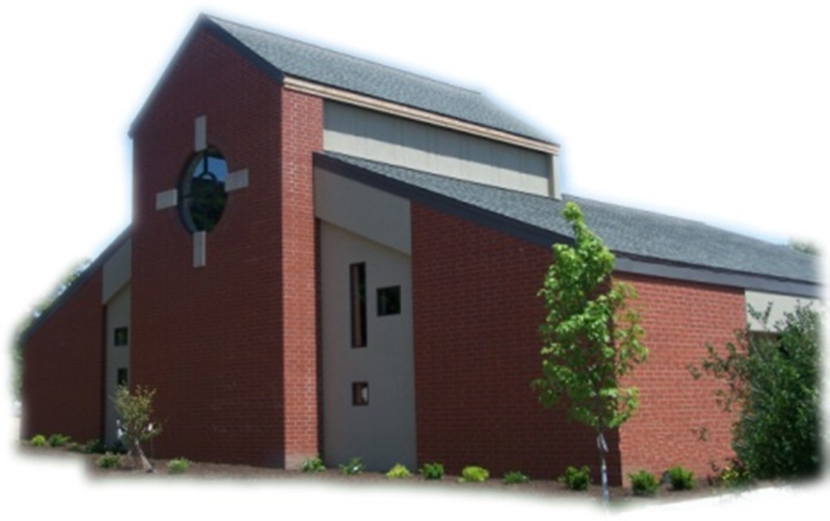

Sacramental Priest, Rev. Robert “Bud” Grant Email: grantrobert@sau.edu
Priest Moderator, Rev. Dale Mallory Email: malloryd@diodav.org

Parish Life Coordinator, Deacon Dan Freeman
Cell - 563-320-2462 Email: wiltonstmary@diodav.org

Office Manager - Rosemary Sullivan Director of Religious Education – Hilary Henke
Cell - 563-723-1050 / wiltonstmaryfin@diodav.org Cell - 563-260-5861 / wiltonstmarydre@diodav.org

Mass Time: Sunday – 8:30 a.m.
Religious Education Classes start at 9:30 am during the School year.

Website: https://www.stmarywilton.org Facebook Page - https://www.facebook.com/stmarysofwilton
Today’s Readings – 10-26-25. We are a needy people. We each stand before God as someone in need. No matter how well off we are, how healthy we are, or how satisfied we are with our lives, we are all in need of God’s saving mercy. If we look at ourselves honestly, we see that we are far from perfect, that we in fact are sinful and always in need of forgiveness. May we, like the tax collector in today’s Gospel, be aware of our neediness so that no matter our situation in life we too may humbly pray, “O God, be merciful to me a sinner.” Question of the Week - In what senses am I poor, in need of God’s grace? Do I recognize this poverty when I pray?

Daylight Savings Time ends November 2nd. Fall back an hour!

St. Mary Parish Schedule:
- Sun Oct 26th Mass. NO RE Classes. Volunteer Ministries Sign up. Deacon gone.
- Sun Nov 2nd Mass – All Souls’ Day. RE Classes. 1st Grade – Gift Bearers.
- Sun Nov 2nd Youth Hayrack Ride & Bonfire from 3-6 pm.
- Tue Nov 4th Faith Formation at 5:30 pm.
- Sun Nov 9th Mass. Dedication St. John Latern. RE Classes. Recognition of Veterans.
    - Parish & Finance Councils after Mass. Mass Training – Grades 4-5.
- Wed Nov 12th Liturgy Committee at 5:30 pm. (Advent Postcards)

Christian Initiation Classes – Helping those Becoming Catholic or Joining the Catholic Church. Candidates, Sponsors, & Friends invited. All sessions are in the Parish Hall. Everyone is invited.
- Wed Nov 5th 5:30 pm Denise & Dennis Intro. to Sacraments, Baptism / Confirmation
- Sun Nov 16th 9:45 am Katy & Jim Marriage, Divorce/Annulment, & Holy Orders.
- Sun Nov 30th 9:45 am Amanda & Dyllin Liturgical Year – Advent, Christmas, Lent, etc.

Lay Mass Ministries and Altar Servers – Everyone is asked to sign up again even though you have previously signed up. Training will be held in November. Advanced Altar Servers sign up in October. We will begin an Advanced Altar Server training class for all those who want to intentionally minister to God and to their parish.

2025-26 Annual Diocesan Appeal – Please consider a gift.. Thank you for your generosity!

Saint for October 28th – Saint Simon and Jude – Apostles. Feast of Saints Simon and Jude, Apostles. Simon, also called the Canaanite or 'Zealot,' and Jude, also known as Thaddeus, son of James, who at the Last Supper asked the Lord about His manifestation. Jesus replied, 'If anyone loves me, he will keep my word, and my Father will love him, and we will come to him and make our home with him.

Youth Hayrack Ride & Bonfire – Sunday afternoon, November 2nd from 3 – 6 pm at the Jeremy Lawlor farm, located at 865 230th Street, Stockton, IA 52769. All current Confirmation students, High School Students from St. Mary and a friend and parents are invited. Fun, Food, Fellowship, and Faith activities will be provided. Please respond to Dennis Sass’s text messages.

Parish Vocation Ministry – Bishop Walsh has asked us to identify 3 – 4 parishioners of St. Mary to serve on our Vocations Committee who will guide our parish in promoting and supporting vocations specifically here at St. Mary through diocesan support. Please contact Deacon Dan to volunteer for this critical mission.

All Saints, Saturday, November 1st is NOT a Holy Day of Obligation this year.

Thanksgiving Food Drive - The Religious Ed classes would like to provide a Thanksgiving meal to families in need in the Durant and Wilton communities and are accepting donations of nonperishable items. Examples of menu items are shown below. However, give what you can! Please place items in the boxes in the Gathering Area. All Donations Will Be Accepted now through November 16th. Food will then be sorted into meals and presented by the children at Mass on November 23rd. Items to donate; Canned Ham, Stuffing Mix, Instant Mashed Potatoes, Cans or Packets of Gravy, Canned Vegetables, Boxed Mac and Cheese, Canned Fruit, and Canned Soups.

Coping with Rural Life Stress Resources – Mental Health Resources:
- Iowa State University Extension and Outreach, Stress on the Farm. Website - https://www.extension.iastate.edu/humansciences/farmstress.
- Iowa’s Center for Agricultural Safety and Health, Farm Stress Resources. Focuses on suicide prevention. Website - https://icash.public-health.uiowa.edu/farm-stress-resources/.
- Iowa Farm Bureau provides Resources to Cope with Farm and Rural Stress. Website - https://www.iowafarmbureau.com/Stress-Mental-Health-Resources.
- Call Father Bud or me. We are good listeners.
Crisis Emergency Phone: 855-581-8111 or call 988 for those contemplating suicide. Trained counselors are available to meet in person – call 800-772-2758. Mobile outreach is also offered.

2025 Christmas card for The Catholic Messenger - Youths in grades K-6 of the Davenport Diocese are invited to create a Christmas Card for the Messenger Annual Contest. The artwork should focus on the religious nature of Christmas. Please submit original artwork only, no black and white drawings. Complete drawings on white, 8 ½- by 11-inch paper using colored pencil, crayon, marker or paints. If you use the color yellow, it should be a deeper shade or surrounded by a dark color because yellow is hard to reproduce. Messenger staff members will judge the entries based on originality and the ability to convey what Christmas means to Catholics. On the back of the artwork, include the following information about the artist: first and last name, age, grade, home address, school (public, private or home school and location) and parish (name and city). Please do not fold entries. Any information omitted could be grounds for disqualification. Winning entries will be featured in the Dec. 18th Catholic Messenger. Mail all entries to The Catholic Messenger, 780 W. Central Park Ave., Davenport, IA 52804-1901. Entries must be postmarked by Nov. 19th

Thanksgiving Dinner – A Dinner on Thanksgiving Day will be sponsored by the Mill Sports Lounge, the Candy Kitchen, and the Axe & Oak Whiskey House at the Axe & Oak Whiskey House , 117 West 4th Street, downtown Wilton. Turkey, ham, mashed potatoes and gravy, dressing, buttered corn and pumpkin pie will be served starting at 11 am until 1 pm. Beverages will include iced tea, coffee, water or milk. Come alone or bring the family, all are welcome. We will accept free will donations. 100% of the donations, plus some matching funds, will go to the Wilton “Shop with a Cop: program. Anyone interested in helping us prepare the dinner, serve, bus tables or help clean up can contact Fred Grunder at 563-343-0040 or email at fkgrunder@gmail.com.

2025 Respect Life Novena October is Respect Life Month. Join Catholics nationwide praying a special novena for the protection of human life from conception to natural death. Each day of the novena features a different pro-life prayer intention which is accompanied by a short reflection and suggested actions to help build a culture of life. October 22-30. Sign up to get daily intentions, brief reflections, and more. Sign up at www.respectlife.org/respect-life-month-novena.

Prayer Chain Request - please contact Colleen at 563-260-2212 or collienichols@yahoo.com.

Coffee & Donuts during Religious Ed. Sundays after Mass. There is a sign-up board in the Gathering Area for preparation, serving, and cleanup. Please sign up early and often.

Questions about our Faith – here’s your chance to ask any question pertaining to the Catholic Church and our Catholic Faith that you are curious about. Simply email your question to wiltonstmary@diodav.org and it will be answered in the Bulletin anonymously.

Parish Directory – Anyone who would like to have their picture in the Cell Phone Directory App should submit a picture to Deacon Dan to wiltonstmary@diodav.org or text to – 563-320-2462.

Prayers are requested for Cameron Costello and all the Seminarians of the Davenport Diocese. We also pray for the 11 men in Diaconate Formation to be Ordained July 2027.

The Coming Home Network was established to help non-Catholic Christians, clergy and laity to make the journey home to full communion with the Catholic Church. https://chnetwork.org/.
Protecting God’s Children - To report child abuse contact the Iowa Dept. of Human Services Child Abuse hotline: 800-362-2178 and if clergy involved or church personnel also notify Alicia Owens, Victim Assistance Coordinator, 563-349-5002; vac@diodav.org or PO Box 232, Bettendorf, IA.

New Parishioners: Please complete the Registration form online at https://www.stmarywilton.org/ or to request a form after Mass. The completed form may be placed in the Contribution Basket or given to Deacon Dan. See the contact information on the Bulletin to contact me with any questions.
Envelopes – If you are not receiving Parish Contribution Envelopes, please contact Deacon Dan.

Rachels’s Vineyard - a safe place to heal hearts broken by abortion. Supportive, confidential, and non-judgmental space where women and men can share, release and reconcile painful emotions. Each weekend is run by volunteers who care deeply about you. Many of the facilitators have suffered the same loss. For more information or to register call Teresa at 563-542-8378.

Mass Intention for Sunday, November 2, 2025 – Margaret Gough
Lay Mass Ministers for Sunday, November 2, 2025.
Announcer & 1st Reading – Lucy Costello 2nd Reading – Judy Freeman
EMHC – Dennis Sass & Denise Timmerman Gift Bearers – 1st Graders
Ushers – Tom Kelley, Fred Grunder & 1st Graders
Servers – Natalie Koopmann, Tillie Marolf, & Amelia Costello

Sacraments - to schedule participation in any of these please contact Deacon Dan:
- Baptism – A prep class required for family’s first child. Contact Deacon Dan 1 month prior.
- Confession – email Father Bud at grantrobert@sau.edu for times prior/after Mass.
- Marriage – contact Deacon Dan a minimum of 7 months prior to the proposed ceremony.
- Anointing – Anyone having surgery or experiencing illness may ask for the Rite of Anointing of the Sick. Father Bud will anoint immediately after Mass. Contact Deacon Dan.
- Funeral Preparation – please contact Deacon Dan. A great booklet is available to help.

Meal Train Ministry - Our meal train ministry helps parishioners who have recently had a baby, those who have recently lost a loved one, are going through an illness or rough time, or those who are temporarily homebound and need assistance with meals. If you'd like more information, would like to nominate a parishioner, or would like to be put on the list to make meals when able, please contact Sarah Costello at 563-210-3977 or email slcostello09@gmail.com.

2025-26 Parish Leadership Team
Trustees: (2 year term)
Denise Timmerman 563-349-3880 denisetimmerman13@gmail.com
Henry Bentley 563-340-3111 henrybentley1961@outlook.com
Parish Council: (2 year term)
Damon Boorn (24) President/At Large 563-260-9816 damon.boorn@gmail.com
Jessica Williams (25) 563-320-3699 jess_99@yahoo.com
Kathy Keese (22) Secretary/At Large 563-260-4904 Kskeese5@gmail.com
Taci Lilienthal (25) 563-343-1144 taci.lilienthal@gmail.com
Jeremiah Costello (23) Faith Form. 563-370-2065 Jeremiahecostello@gmail.com
Scott Wolf Cemetery 563-370-3734 srwolf64@gmail.com
Jim Gavin Bldg. & Grounds 563-506-5112 gavinjames@netwtc.net
Dennis Sass Liturgy 319-430-2063 dwsass51@gmail.com
Finance Council: (4 year term)
Phil Keese (22) 563-260-4905 plkeese5@gmail.com
Andrea Shaffer (24) 563-299-5632 shafferauto06@gmail.com
Eric Thornton (25) 563-299-4624 eric6982@hotmail.com

