Saint Mary Catholic Church
701 East Third Street, Wilton, IA 52778

29th Sunday of Ordinary Time
October 19, 2025

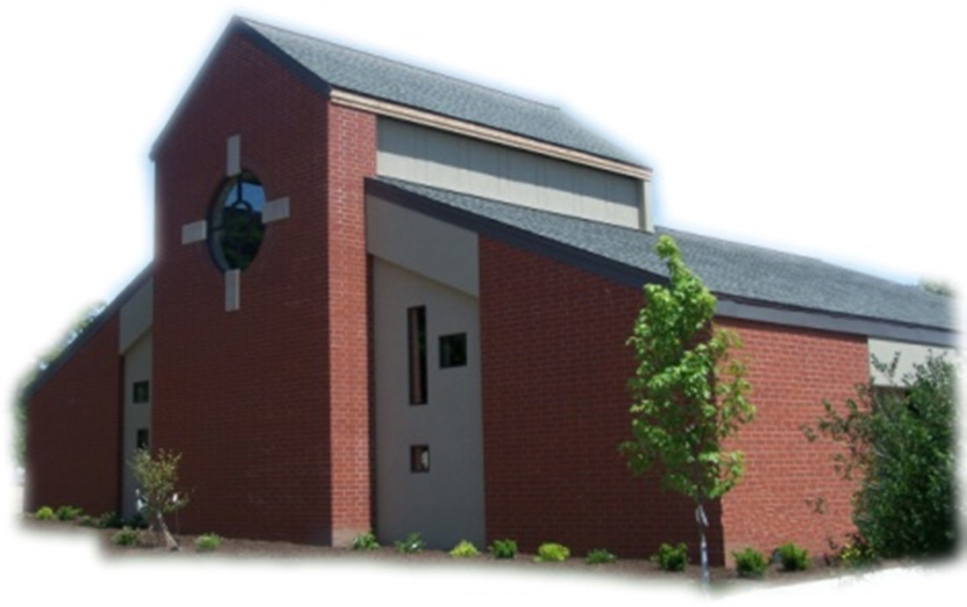

Sacramental Priest, Rev. Robert “Bud” Grant Email: grantrobert@sau.edu
Priest Moderator, Rev. Dale Mallory Email: malloryd@diodav.org

Parish Life Coordinator, Deacon Dan Freeman
Cell - 563-320-2462 Email: wiltonstmary@diodav.org

Office Manager - Rosemary Sullivan Director of Religious Education – Hilary Henke
Cell - 563-723-1050 / wiltonstmaryfin@diodav.org Cell - 563-260-5861 / wiltonstmarydre@diodav.org

Mass Time: Sunday – 8:30 a.m.
Religious Education Classes start at 9:30 am during the School year.

Website: https://www.stmarywilton.org Facebook Page - https://www.facebook.com/stmarysofwilton
Today’s Readings – 10-19-25. Many athletes can tell you how important stamina is to their success. In the closing minutes of a game, it can often come down to who still has the energy to do their best. Often our faith requires stamina as well. Beaten down by tragedies and disappointments, is our faith strong enough to enable us to persist in loving God and loving neighbor, to pursue justice and peace, to continue to build the kingdom? May hope, which we celebrate this Jubilee Year, sustain our stamina to the end of our days. Question of the Week - As this is the Jubilee Year of Hope, can I remain hopeful that God will address my needs and use that hope to help me persist in prayer? Can I promise to do so for ten minutes each day this week?

St. Mary Parish Schedule:
- Sun Oct 19th Mass. RE Classes. Volunteer Ministries Sign up. World Mission Sunday.
        - Mass Ministries – by Confirmation Students.
- Sun Oct 26th Mass. NO RE Classes. Volunteer Ministries Sign up. Deacon gone.
- Sun Nov 2nd Mass – All Souls’ Day. RE Classes. 1st Grade – Gift Bearers.
- Sun Nov 2nd Youth Hayrack Ride & Bonfire from 3-6 pm.
- Tue Nov 4th Faith Formation at 5:30 pm.
- Sun Nov 9th Mass. Dedication St. John Latern. RE Classes. Recognition of Veterans.
    - Parish & Finance Councils meet after Mass. Mass Training – Grades 4-5.
- Wed Nov 12th Liturgy Committee at 5:30 pm. (Advent Postcards)
- Sun Nov 16th Mass. RE Classes. Mass Ministry – Grades 4-5. Mass Lay Ministry Training.

Christian Initiation Classes – Helping those Becoming Catholic or Joining the Catholic Church. Candidates, Sponsors, & Friends invited. All sessions are in the Parish Hall. Everyone is invited.
- Sun Oct 19th 9:45 am Katy & Jim New Testament & Communion of Saints.
- Sun Nov 2nd 9:45 am Denise & Dennis Intro. Sacraments, Baptism / Confirmation
- Sun Nov 16th 9:45 am Katy & Jim Marriage, Divorce/Annulment, & Holy Orders.

Lay Mass Ministries and Altar Servers – Everyone is asked to sign up again even though you have previously signed up. Training will be held in November. We will begin an Advanced Altar Server training class for all those who want to intentionally minister to God and to their parish.

2025-26 Annual Diocesan Appeal – Our Goal is $21,727 for the 2025-26 year. We ask that you prayerfully consider your support. If we exceed this amount as a parish, 100% of the additional funds will be returned to us, allowing us to further our mission and ministries, and continue making a lasting impact on our parishioners and the wider community. ADA Envelopes and pencils are placed in the pews so that you can complete your pledge form. Thank you for your generosity! www.davenportdiocese.org/annual-diocesan-appeal.

Saint for October 19th – Saints John de Brébeuf and Isaac Jogues, Priests and Martyrs, and their Companions. This group of martyrs, often referred to as the North American Martyrs, includes several Jesuits and lay companions who were martyred in the 17th century while evangelizing the indigenous peoples in what is now Canada and the northern United States.

Youth Hayrack Ride & Bonfire – Sunday afternoon, November 2nd from 3 – 6 pm at the Jeremy Lawlor farm, located at 865 230th Street, Stockton, IA 52769. All current Confirmation students, High School Students from St. Mary and a friend and parents are invited. Fun, Food, Fellowship, and Faith activities will be provided. Please respond to Dennis Sass’s text messages.

2025 Respect Life Novena October is Respect Life Month. Join Catholics nationwide praying a special novena for the protection of human life from conception to natural death. Each day of the novena features a different pro-life prayer intention which is accompanied by a short reflection and suggested actions to help build a culture of life. October 22-30. Sign up to get daily intentions, brief reflections, and more. Sign up at www.respectlife.org/respect-life-month-novena.

Observe World Mental Health Day: October 10.
Coping with Rural Life Stress Resources – Mental Health Resources:
- Iowa State University Extension and Outreach, Stress on the Farm. Provides guidebooks for farm families and friends and for professionals who interact regularly with farmers and their families. Website - https://www.extension.iastate.edu/humansciences/farmstress.
- Iowa’s Center for Agricultural Safety and Health, Farm Stress Resources. Focuses on suicide prevention. Website - https://icash.public-health.uiowa.edu/farm-stress-resources/.
- Iowa Farm Bureau provides Resources to Cope with Farm and Rural Stress. Website - https://www.iowafarmbureau.com/Stress-Mental-Health-Resources.
- Call Father Bud or me. We are good listeners.
Crisis Emergency Phone: 855-581-8111 or call 988 for those contemplating suicide. Trained counselors are available to meet in person – call 800-772-2758. Mobile outreach is also offered.

JPII Retreat for 8th–10th Graders - All students in grades 8 - 10 are invited to take part in the Pope John Paul II Retreat at Sacred Heart Cathedral in Davenport on Nov. 8–9, 2025. Registration is open https://davenportdiocese.org/jpii-retreat. Cost is $50 and includes meals and lodging. Contact Deacon Ryan Burchett at 563-271-0608 or retreats@diodav.org for information.

Coffee & Donuts during Religious Ed. Sundays after Mass. There is a sign-up board in the Gathering Area for preparation, serving, and cleanup. Please sign up early and often.

Church Teaching & Tradition: Step Theology Online – Connecting the Catholic intellectual life to the life of the Church: For this year’s Synodal focus on Church Teaching & Tradition, take some time to learn more about the Catholic Faith. Classes begin October 20 and now 50% Off of the standard cost of $99! Diocese of Davenport has partnered with https://mcgrath.nd.edu/online-courses/step/ to offer online formation for the people of the diocese. If you have any questions or would like more information, please visit our https://davenportdiocese.org/ff-step or contact Trevor Pullinger at pullinger@davenportdiocese.org. Offerings - 1) Foundations of Catholic Belief Summer Session **Great Beginner Course**. 2) American Catholicism Since Vatican II: The Challenges of Change. 3) Apocalypse Then – Apocalypse Now: Reading the Book of Revelation.
4)Catholic Social Teaching. 5)History of Christianity: The Early Middle Ages

Questions about our Faith – here’s your chance to ask any question pertaining to the Catholic Church and our Catholic Faith that you are curious about. Simply email your question to wiltonstmary@diodav.org and it will be answered in the Bulletin anonymously.

Parish Directory – Anyone who would like to have their picture in the Cell Phone Directory App should submit a picture to Deacon Dan to wiltonstmary@diodav.org or text to – 563-320-2462.

Prayers are requested for Cameron Costello and all the Seminarians of the Davenport Diocese. We also pray for the 11 men in Diaconate Formation to be Ordained July 2027.

Protecting God’s Children - To report child abuse contact the Iowa Dept. of Human Services Child Abuse hotline: 800-362-2178 and if clergy involved or church personnel also notify Alicia Owens, Victim Assistance Coordinator, 563-349-5002; vac@diodav.org or PO Box 232, Bettendorf, IA.

New Parishioners: Please complete the Registration form online at https://www.stmarywilton.org/ or to request a form after Mass. The completed form may be placed in the Contribution Basket or given to Deacon Dan. See the contact information on the Bulletin to contact me with any questions.
Envelopes – If you are not receiving Parish Contribution Envelopes, please contact Deacon Dan.

The Coming Home Network was established to help non-Catholic Christians, clergy and laity to make the journey home to full communion with the Catholic Church. https://chnetwork.org/.

Fighting to break free from pornography? Get Help! https://integrityrestored.com/ or https://www.strive21.com/, or https://www.covenanteyes.com/. Call 563-334-4505 for a local group.

Mass Intentions for the deceased are $5.00 each. Please indicate who the Mass is for, who requested it, and how many Masses are requested. We will try to honor requested Mass dates.

Mass Intention for Sunday, October 26, 2025 – Leonard Gough
Lay Mass Ministers for Sunday, October 26, 2025.
Announcer & 1st Reading – Natalie Koopmann 2nd Reading & Prayers of Faithful – Renee Cooley
EMHC – Jacqueline Grotzky, Amanda Rockow, & Dennis Sass
Gift Bearers – Jean & Jay Semsch Ushers – Rick Janney & Terry Martz
Servers – Colin & Connor Thornton & Elsie DeLong

Sacraments - to schedule participation in any of these please contact Deacon Dan:
- Baptism – A prep class required for family’s first child. Contact Deacon Dan 1 month prior.
- Confession – email Father Bud at grantrobert@sau.edu for times prior/after Mass.
- Marriage – contact Deacon Dan a minimum of 7 months prior to the proposed ceremony.
- Anointing – Anyone having surgery or experiencing illness may ask for the Rite of Anointing of the Sick. Father Bud will anoint immediately after Mass. Contact Deacon Dan.
- Funeral Preparation – please contact Deacon Dan. A great booklet is available to help.

Meal Train Ministry - Our meal train ministry helps parishioners who have recently had a baby, those who have recently lost a loved one, are going through an illness or rough time, or those who are temporarily homebound and need assistance with meals. If you'd like more information, would like to nominate a parishioner, or would like to be put on the list to make meals when able, please contact Sarah Costello at 563-210-3977 or email slcostello09@gmail.com.

2025-26 Parish Leadership Team

Trustees: (2 year term)
Denise Timmerman 563-349-3880 denisetimmerman13@gmail.com
Henry Bentley 563-340-3111 henrybentley1961@outlook.com

Parish Council: (2 year term)
Damon Boorn (24) President/At Large 563-260-9816 damon.boorn@gmail.com
Jessica Williams (25) 563-320-3699 jess_99@yahoo.com
Kathy Keese (22) Secretary/At Large 563-260-4904 Kskeese5@gmail.com
Taci Lilienthal (25) 563-343-1144 taci.lilienthal@gmail.com
Jeremiah Costello (23) Faith Form. 563-370-2065 Jeremiahecostello@gmail.com
Scott Wolf Cemetery 563-370-3734 srwolf64@gmail.com
Jim Gavin Bldg. & Grounds 563-506-5112 gavinjames@netwtc.net
Dennis Sass Liturgy 319-430-2063 dwsass51@gmail.com

Finance Council: (4 year term)
Phil Keese (22) 563-260-4905 plkeese5@gmail.com
Andrea Shaffer (24) 563-299-5632 shafferauto06@gmail.com
Eric Thornton (25) 563-299-4624 eric6982@hotmail.com

