Saint Mary Catholic Church
701 East Third Street, Wilton, IA 52778

28th Sunday of Ordinary Time
October 12, 2025

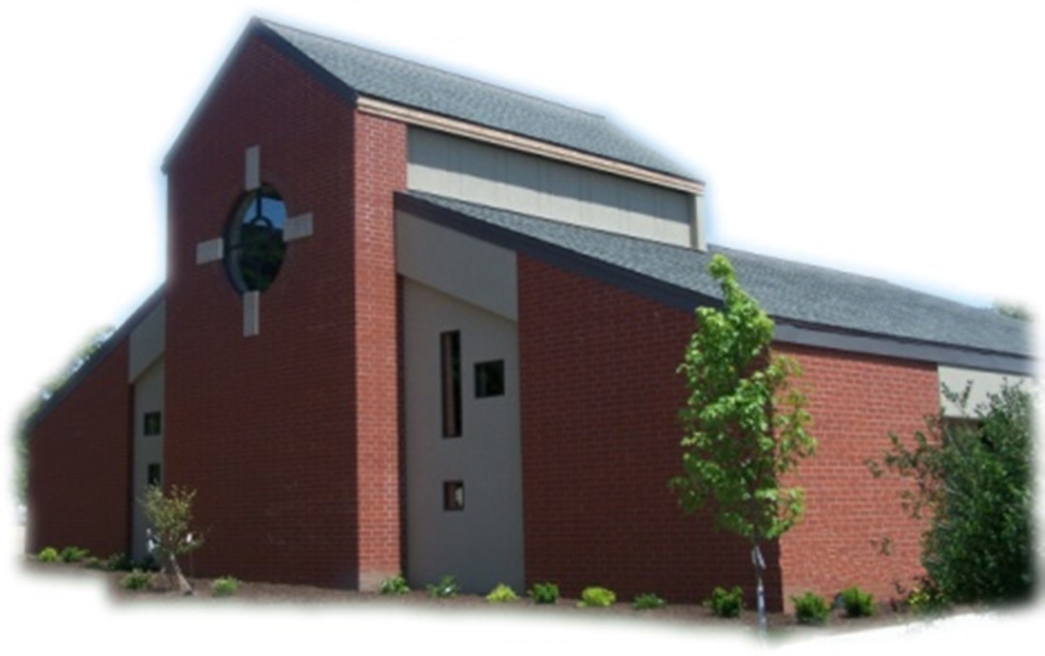

Sacramental Priest, Rev. Robert “Bud” Grant Email: grantrobert@sau.edu
Priest Moderator, Rev. Dale Mallory Email: malloryd@diodav.org

Parish Life Coordinator, Deacon Dan Freeman
Cell - 563-320-2462 Email: wiltonstmary@diodav.org

Office Manager - Rosemary Sullivan Director of Religious Education – Hilary Henke
Cell - 563-723-1050 / wiltonstmaryfin@diodav.org Cell - 563-260-5861 / wiltonstmarydre@diodav.org

Mass Time: Sunday – 8:30 a.m.
Religious Education Classes start at 9:30 am during the School year.

Website: https://www.stmarywilton.org Facebook Page - https://www.facebook.com/stmarysofwilton
Today’s Readings – 10-12-25. We gather as a community of faith to worship God, to thank God for the blessings we’ve received, and to be nourished by the Eucharist. It is quite fitting that we give thanks to God when we celebrate the Eucharist, since eucharistia is Greek for thanksgiving. Today’s readings can remind us how appropriate it is to give thanks to God, just as we would thank a neighbor who does something special for us. Let us be a thankful people, expressing a spirit of gratitude throughout our lives. Question of the Week - How can I, like the Samaritan, take the extra step to show my gratitude to God?

Bingo Thank You to Amanda Rockow for organizing Bingo, and for her many helpers including Confirmation Students, NCYC students, many adult helpers and Raffle Donors. Thank you also to our Games Sponsors: Jean & Jay Semsch, Gina & Steve Holladay, Axe & Oak Whiskey House, Cindy & Jim Gavin, Brammeier Standard Service, Wilton Family Dental, Thornton Family, TNT Tuckpointing & Building Restoration, Shaffer Automotive, and ARB Roofing Company and More.
Around 60 showed up to play. Approximately $1200 was raised for youth activities.
play. Approximately $1200 was raised for youth activities.

St. Mary Parish Schedule:
- Sun Oct 12th Mass. RE Classes. Volunteer Ministries Sign up.
    - Parish & Finance Councils meet after Mass. Mass Training–Confirmation Students.
- Sun Oct 19th Mass. RE Classes. Volunteer Ministries Sign up.
    - Mass Ministries – by Confirmation Students.
- Sun Oct 26th Mass. NO RE Classes. Volunteer Ministries Sign up. Deacon gone.
- Sun Nov 2nd Mass. RE Classes. 1st Grade – Gift Bearers.
- Sun Nov 2nd Youth Hayrack Ride & Bonfire from 3-6 pm. Details to follow.
- Wed Nov 5th Faith Formation at 5:30 pm.
- Sun Nov 9th Mass. Dedication St. John Latern. RE Classes.
    - Parish & Finance Councils after Mass. Mass Training – Grades 4-5.
- Wed Nov 12th Liturgy Committee at 5:30 pm. (Advent Postcards)

Christian Initiation Classes – Helping those Becoming Catholic or Joining the Catholic Church. Candidates, Sponsors, & Friends invited. All sessions are in the Parish Hall. Everyone is invited.
- Sun Oct 19th 9:45 am Katy & Jim Jepsen New Testament & Communion of Saints.
- Sun Nov 2nd 9:45 am Denise & Dennis #34 Intro. Sacraments, Baptism / Confirmation
- Sun Nov 16th 9:45 am Katy & Jim Jepsen Marriage, Divorce/Annulment, & Holy Orders.

Lay Mass Ministries and Altar Servers – Everyone is asked to sign up again even though you have previously signed up. Training will be held in November. Advanced Altar Servers sign up in October. We will begin an Advanced Altar Server training class for all those who want to intentionally minister to God and to their parish.

2025-26 Annual Diocesan Appeal – Our Goal is $21,727 for the 2025-26 year. We ask that you prayerfully consider your support. If we exceed this amount as a parish, 100% of the additional funds will be returned to us, allowing us to further our mission and ministries, and continue making a lasting impact on our parishioners and the wider community. ADA Envelopes and pencils are placed in the pews so that you can complete your pledge form. Thank you for your generosity! www.davenportdiocese.org/annual-diocesan-appeal.

2025 Respect Life Novena October is Respect Life Month. Join Catholics nationwide praying a special novena for the protection of human life from conception to natural death. Each day of the novena features a different pro-life prayer intention which is accompanied by a short reflection and suggested actions to help build a culture of life. October 22-30. Sign up to get daily intentions, brief reflections, and more. Sign up at www.respectlife.org/respect-life-month-novena.

Coffee & Donuts during Religious Ed. Sundays after Mass. There is a sign-up board in the Gathering Area for preparation, serving, and cleanup. Please sign up early and often.

Observe World Mental Health Day: October 10.
Coping with Rural Life Stress Resources – Mental Health Resources:
- Iowa State University Extension and Outreach, Stress on the Farm. Provides guidebooks for farm families and friends and for professionals who interact regularly with farmers and their families. Website - https://www.extension.iastate.edu/humansciences/farmstress.
- Iowa’s Center for Agricultural Safety and Health, Farm Stress Resources. Focuses on suicide prevention. Website - https://icash.public-health.uiowa.edu/farm-stress-resources/.
- Iowa Farm Bureau provides Resources to Cope with Farm and Rural Stress. Website - https://www.iowafarmbureau.com/Stress-Mental-Health-Resources.
- Call Father Bud or me. We are good listeners.
Crisis Emergency Phone: 855-581-8111 or call 988 for those contemplating suicide. Trained counselors are available to meet in person – call 800-772-2758. Mobile outreach is also offered.

JPII Retreat for 8th–10th Graders - All students in grades 8 - 10 are invited to take part in the Pope John Paul II Retreat at Sacred Heart Cathedral in Davenport on Nov. 8–9, 2025. This overnight retreat gives young people the chance to grow in their faith through inspiring talks, prayer, small group discussion, and time for fun and fellowship. The weekend is designed to help teens take ownership of their faith and to learn more about the life and witness of Pope John Paul II. Registration is open https://davenportdiocese.org/jpii-retreat. Cost is $50 and includes meals and lodging. Contact Deacon Ryan Burchett at 563-271-0608 or retreats@diodav.org for information.

Church Teaching & Tradition: Step Theology Online – Connecting the Catholic intellectual life to the life of the Church: For this year’s Synodal focus on Church Teaching & Tradition, take some time to learn more about the Catholic Faith. Classes begin October 20 and now 50% Off of the standard cost of $99! Diocese of Davenport has partnered with https://mcgrath.nd.edu/online-courses/step/ to offer online formation for the people of the diocese. If you have any questions or would like more information, please visit our https://davenportdiocese.org/ff-step or contact Trevor Pullinger at pullinger@davenportdiocese.org. Offerings:
- Foundations of Catholic Belief Summer Session **Great Beginner Course**
- American Catholicism Since Vatican II: The Challenges of Change
- Apocalypse Then – Apocalypse Now: Reading the Book of Revelation
- Catholic Social Teaching
- History of Christianity: The Early Middle Ages

Saint for October 12th – Commemoration of the 4,966 martyrs and confessors of the faith, who, during the Vandal persecution in Africa, were either bishops, priests, or deacons of the Church of God. Along with faithful laity, they were exiled to a terrible desert by order of the Arian King Hunneric out of hatred for the Catholic truth, and after suffering various tortures, they gloriously attained martyrdom. Among them were bishops Cyprian and Felix, preeminent priests of the Lord.

Questions about our Faith – here’s your chance to ask any question pertaining to the Catholic Church and our Catholic Faith that you are curious about. Simply email your question to wiltonstmary@diodav.org and it will be answered in the Bulletin anonymously.

Parish Directory – Anyone who would like to have their picture in the Cell Phone Directory App should submit a picture to Deacon Dan to wiltonstmary@diodav.org or text to – 563-320-2462.

Prayers are requested for Cameron Costello and all the Seminarians of the Davenport Diocese. We also pray for the 11 men in Diaconate Formation to be Ordained July 2027.

Protecting God’s Children - To report child abuse contact the Iowa Dept. of Human Services Child Abuse hotline: 800-362-2178 and if clergy involved or church personnel also notify Alicia Owens, Victim Assistance Coordinator, 563-349-5002; vac@diodav.org or PO Box 232, Bettendorf, IA.

New Parishioners: Please complete the Registration form online at https://www.stmarywilton.org/ or to request a form after Mass. The completed form may be placed in the Contribution Basket or given to Deacon Dan. See the contact information on the Bulletin to contact me with any questions.
Envelopes – If you are not receiving Parish Contribution Envelopes, please contact Deacon Dan.

The Coming Home Network was established to help non-Catholic Christians, clergy and laity to make the journey home to full communion with the Catholic Church. https://chnetwork.org/.

Eagles’ Wings – 5816 Telegraph Rd., Davenport, IA 52804. Contact marcia@eagleswings.com or Phone 563-324-7263 for more information. Register online @ www.eagleswings.ws
- Saturday, October 18th - 9:30 AM – Noon. “Little Known Apparitions of Mary II.” Cost is $35.

Fighting to break free from pornography? Get Help! https://integrityrestored.com/ or https://www.strive21.com/, or https://www.covenanteyes.com/. Call 563-334-4505 for a local group.

Our Lady of the Prairie – Retreat at 2664 145th Avenue, Wheatland, Iowa 52777. Details and register at www.theprairieretreat.org, or email – olpretreat@gmail.com, or call 563-374-1092.
- Wed., October 15th at 6:00-8:00 p.m. ONLINE ONLY: Come Forth: How the story of Lazarus can offer you new life by Rev. James Martin, SJ. “Martin dives deep into the Gospel story to reveal how Jesus's greatest miracle can help each of us experience the new life that God promises. Come Forth is a spiritual masterpiece.” — Richard Rohr, OFM, author of The Universal Christ. Cost is $20

Mass Intentions for the deceased are $5.00 each. Please indicate who the Mass is for, who requested it, and how many Masses are requested. We will try to honor requested Mass dates.

Mass Intention for Sunday, October 19, 2025 – Ken Grunder
Lay Mass Ministers for Sunday, October 19, 2025.
Announcer & 1st Reading – Ahren Gross 2nd Reading – Amanda Vasey
EMHC – Rick Janney & Judy Freeman Gift Bearers – Terry Martz & Colleen Nichols
Ushers – Colleen Nichols & Fred Grunder Servers – Amelia Costello, Tillie Marolf & Savannah Tucker

Sacraments - to schedule participation in any of these please contact Deacon Dan:
- Baptism – A prep class required for family’s first child. Contact Deacon Dan 1 month prior.
- Confession – email Father Bud at grantrobert@sau.edu for times prior/after Mass.
- Marriage – contact Deacon Dan a minimum of 7 months prior to the proposed ceremony.
- Anointing – Anyone having surgery or experiencing illness may ask for the Rite of Anointing of the Sick. Father Bud will anoint immediately after Mass. Contact Deacon Dan.
- Funeral Preparation – please contact Deacon Dan. A great booklet is available to help.

Meal Train Ministry - Our meal train ministry helps parishioners who have recently had a baby, those who have recently lost a loved one, are going through an illness or rough time, or those who are temporarily homebound and need assistance with meals. If you'd like more information, would like to nominate a parishioner, or would like to be put on the list to make meals when able, please contact Sarah Costello at 563-210-3977 or email slcostello09@gmail.com.

