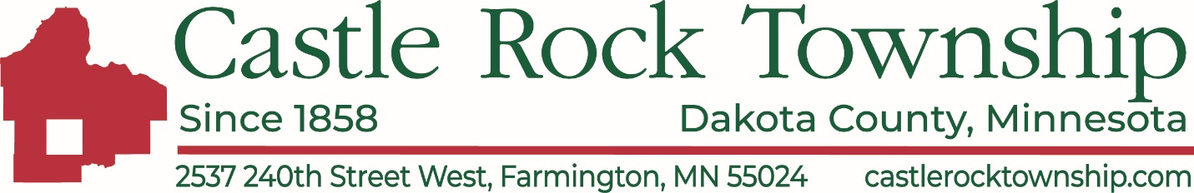

Minutes September 14, 2026 – Setting the Levy

Meeting commenced at 4:55 pm, Board of Supervisors present: Norb Kuhn, Pete Schaefer, Brian Haskin, Russ Zellmer, Jerry Larson and Andrew Tiede.

Norb called meeting to order at 4:57 p.m.

Board of audit review for the spreadsheet breaking down all expenses. We will go forward with levy at next meeting on September 22, 2026. Jaylene sent Andrew the spreadsheet and Andrew said it all looked good. Jerry asked if we are approving the levy or budget. Andrew said this is just a review of the financial document. The public vote will be on September 22, 2026. Norb said the public voted on it at the annual meeting. Andrew said if the public already voted then we just need to certify the budget and send it along. Pete mentioned that he remembered if we do everything on the list, we need 46% and thought the annual meeting vote was 30%. Jerry said we explained to the residents that we need 46% to approve all the bills and the public approved 30%.

Jaylene found the meeting notes from March 11, 2026, Board of Supervisors meeting that said: “Motion to approve to increase the budget by 30%=Kelly Elvestad; Allen Magyre 2nd - Aye 19, Nay 9. Motion passes.

Meeting adjourned at 5:10 p.m.

