**7th-12th Level Supply List**

* Clear Lunchbox
* Clear Reusable Water Bottle
* 1 Pack of Paper Clips
* 1 Pack of Medium Binder Clips
* 1 Bottle of Hand Sanitizer
* 3 Boxes of Tissue
* 1 Pack of Paper Towels
* 1 Pack of Sanitizing Wipes
* Gardening Gloves
* Big over-shirt
* Wide Brimmed Hat

**6th Level Supply List**

* Clear Lunchbox
* Clear Reusable Water Bottle
* 2 Packs of Glue Sticks
* Pencil Case
* 1 Pack of Paper Clips
* 1 Pack of Medium Binder Clips
* 1 Bottle of Hand Sanitizer
* 3 Boxes of Tissue
* 1 Pack of Paper Towels
* 1 Pack of Sanitizing Wipes
* Girls-Plastic Spoons
* Boys-Plastic Forks

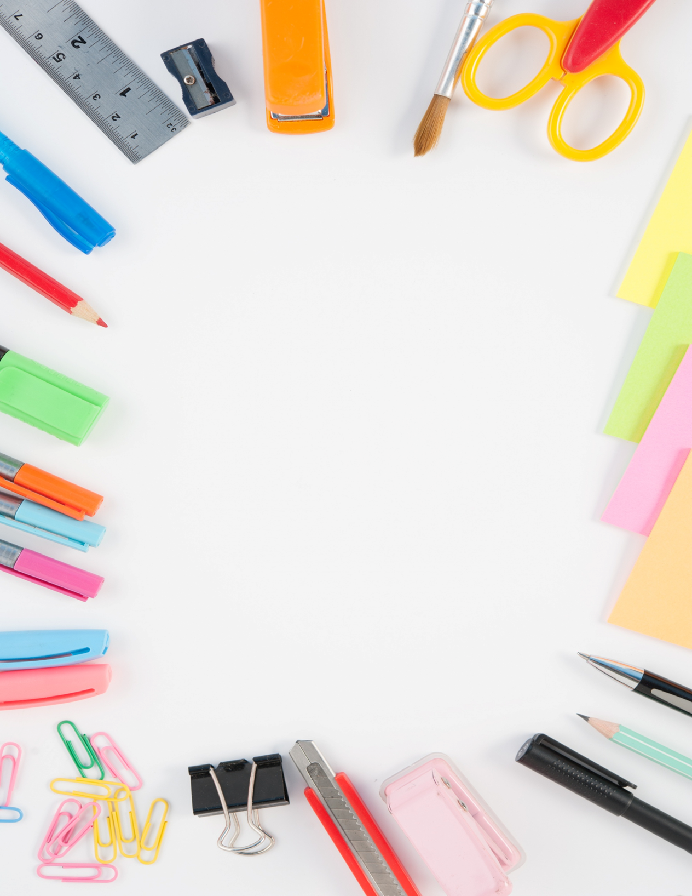

**5th Level Supply List**

* Clear Lunchbox
* Clear Reusable Water Bottle
* 1 Pack of Glue Sticks
* 1 Bottle of Glue
* 1 Pack of Regular Markers
* Pencil Case
* 1 Pack of Paper Clips
* 1 Pack of Medium Binder Clips
* 1 Pack of Post-its
* 1 Bottle of Hand Sanitizer
* 3 Boxes of Tissue
* 1 Paper Towel
* 1 Pack of Sanitizing Wipes
* Girls-Plastic Spoons
* Boys-Plastic Forks

**4th Level Supply List**

* Clear Lunchbox
* Clear Reusable Water Bottle
* 1 Pack of Glue Sticks
* 1 Pack of White out Tape (No liquid please)
* 1Binder Pencil Pouch
* 1 Pack of Paper Clips
* 1 Pack of Medium Binder Clips
* 1 Bottle of Hand Sanitizer
* 3 Boxes of Tissue
* 1 Paper Towel
* 1 Pack of Sanitizing Wipes
* Girls-Plastic Spoons
* Boys-Plastic Forks

**3rd Level Supply List**

* Clear Lunchbox
* Clear Reusable Water Bottle
* Pencil Case
* 1 Pack Glue Sticks
* 1 Pack Binder Clips
* 1 Pack Paper Clips
* 1 Bottle of Hand Sanitizer
* 3 Boxes of Tissue
* 2 Rolls of Paper Towels
* 1 Pack of Sanitizing Wipes
* Girls-Plastic Spoons
* Boys-Plastic Forks

**2nd Level Supply List**

* Clear Lunchbox
* Clear Reusable Water Bottle
* 1 Pack of Glue Sticks
* 1 Bottle of Elmer’s Glue
* 1 Pack of Washable Markers
* Pencil Case
* Bandaids
* 1 Bottle of Hand Sanitizer
* 3 Boxes of Tissue
* 2 Rolls of Paper Towels
* 1 Pack of Sanitizing Wipes
* Girls-Plastic Spoons
* Boys-Plastic Forks

**1st Level Supply List**

* Clear Lunchbox
* Clear Reusable Water Bottle
* 1 Pack of Glue Sticks
* 1 Bottle of Elmer’s Glue
* Crayon Pouch (No Crayon box)
* Two-Sided Tape
* Bandaids
* 1 Bottle of Hand Sanitizer
* 3 Boxes of Tissue
* 2 Rolls of Paper Towels
* 1 Pack of Sanitizing Wipes
* Girls-Plastic Spoons
* Boys-Plastic Forks

Kindergarten Supply List

* Clear Lunchbox
* Clear Reusable Water Bottle
* 2 Packs Jumbo Crayons 8 ct.
* 1 Pack Large Crayons 16 ct.
* 1 Bottle of Elmer’s Glue
* Pencil Case
* Girls-Plastic Spoons
* Boys-Plastic Forks
* Geometric Sponge Painting Shapes
* Bandaids
* 1 Bottle of Hand Sanitizer
* 3 Boxes of Tissue
* 2 Rolls of Paper Towels
* 1 Pack of Sanitizing Wipes
* Kinder Mat 1” Sleeping Mat
* Blanket
* Extra Uniform

**Pre-K Supply List**

* Clear Lunchbox
* Clear Reusable Water Bottle
* Pencil Case
* Jumbo Crayons 8 ct.
* Jumbo Crayons 16 ct.
* Markers
* Elmers White Glue
* 2 Boxes of Tissues
* 2 Character Bandaids
* Kinder Mat 1” Sleeping Mat
* Blanket
* Stuffed Animal for Nap Time
* Extra Uniform (In case of accidents)