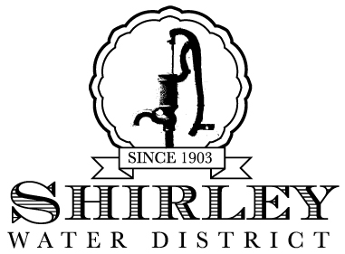
Superintendent
Brian D. Boomgaarden

Water Commissioners
Milton E. Westover
Kevin Johnston
Donald Farrar Jr.
124 Ayer Road
Shirley, Massachusetts 01464-2518
Telephone: 978-425-2245 Fax: 978-425-6669 www.shirleywater.com

Board of Commissioners Meeting
AGENDA
Wednesday, April 8, 2026 at 2:00 pm
Call to Order

Introduction of Guests

Approve Minutes for the Commissioners Meeting held on March 11, 2026

Superintendent’s Report

Old Business:

- Updates on ongoing projects:

Homeland Security & Technology Upgrades
Shirley Fire Dept.- Comm. Equipment on Hatch Tank
ADU and 40B Projects
Water Service Tie-In Moratorium
FY27 Budget

● Debt Collections
● Treasurers Report

New Business:
● Remembering Water Commissioner Milton E. Westover
● Discussion of 3rd Member for Board of Water Commissioners

Any Business not anticipated by the Board

Payroll & Accounts Payable Warrants

Adjourn Meeting

Posted on April 6, 2026 at 1:30pm at: Shirley Water District, Shirley Town Hall, Shirley Post Office and Lancaster Town Hall

By: Rhonda Caissie, District Clerk, Shirley Water District

