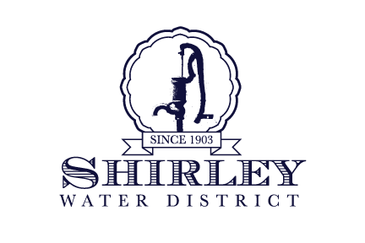
Public Water Supply ID #2270000
CONSUMER CONFIDENCE REPORT
Presented by the
SHIRLEY WATER DISTRICT

Calendar Year 2025

The Shirley Water District is pleased to present to you this year's Annual Water Quality Report. This report is designed to educate you, the consumer, about the quality of your water and the services we provide to maintain the highest quality possible. We hope you will find this information useful and easy to understand; however, if you have any questions or comments about this report, contact District Manager Brian Boomgaarden at 978-425-2245 or via
e-mail: boomer@shirleywater.com. Our commissioners’ meetings are held on the first Wednesday of each month at 2:00 P.M., at the district office, 124 Ayer Road, where you are welcome to attend and address any concerns or questions.

Delete text and
insert image here.

Where Does Your Water Come From?

Where Does Your Water Come From?
The Water District pumps its water from three ground water sources. The Patterson Well (Source Code #2270000-03G), located at 17 Patterson Road, is a 50’ deep gravel packed well, which was put into service in 1977. It currently pumps an average of 87 million gallons per year and is our primary source of water. The Catacunemaug Well (Source Code #2270000-02G), located at 23 Catacunemaug Road, was installed in 1950. This is also a 50’ deep gravel packed well and produces approximately 43 million gallons annually. The Walker Well (Source Code #2270000-04G), 15 Patterson Road, was put into service in 2012. It too is a 50’ gravel packed well, producing 33 million gallons a year.

These three sources pump the water throughout the distribution system via approximately 39 miles of water main. Simultaneously, the Districts’ three sources of storage are also being filled. One storage facility is located on Majors Hill, off of Center Road. This concrete reservoir has a storage capacity of 650,000 gallons. The second storage facility, located off of Farrar Lane, is a 750,000-gallon hydropillar, which was put into service in 2003. The third facility, located on Grant Way in Lancaster, is also a 750,000-gallon hydropillar.

In addition to our own water sources, we also have interconnections with Devens and the Department of Corrections (DOC). These connections were established to benefit all three public water supplies in the event of an emergency.
Water Treatment
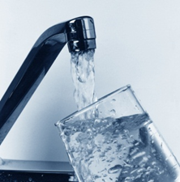
To effectively maintain a high quality of water it is necessary for most water suppliers to treat their water. Many drinking water sources throughout the New England area are naturally corrosive (i.e.; they have a pH of less than 7.0). As a result of this corrosiveness water tends to corrode and dissolve the metal piping it flows through, both in the water distribution system and the interior plumbing of homes. This not only damages pipes but can also add harmful metals, such as lead and copper, to the water. As part of this treatment process, potassium hydroxide (also known as KOH or caustic potash) is added to the water in Shirley as it is being pumped out of the wells and into the distribution system. The purpose of this addition is to raise the pH of the water to a non-corrosive level. As a result, the potential for harmful metals to leach into the water from customers' interior plumbing is greatly reduced. All chemicals used in this process are approved for water treatment by one of the following organizations: National Sanitation Foundation (now known as NSF International), or UL, both accredited by the American National Standards Institute (ANSI). Chemicals also have to meet performance standards established by the American Water Works Association.
Some ground water sources contain microorganisms, some of which can cause people to become sick. To eliminate disease-causing organisms, it is (Treatment- cont’d on page 2)
1

(Treatment– cont’d)
necessary to disinfect the water. Disinfection does not sterilize the water but it does destroy harmful organisms. Sterilization kills all microorganisms, even though most are not harmful, and is too costly to use on a routine basis. The Shirley Water District adds sodium hypochlorite (chlorine) as its primary disinfectant. Chlorine destroys organisms by penetrating cell walls and reacting with enzymes. Disinfection with chlorine has been proven effective at ensuring that the water is free of harmful organisms and safe to drink. here.

Substances Found In Water

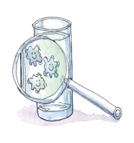
Sources of drinking water (both tap water and bottled water) include rivers, lakes, streams, ponds, reservoirs, springs and wells. As water travels over the surface of the land or through the ground, it dissolves naturally occurring minerals, and in some cases, radioactive material. It can pick up substances resulting from the presence of animal or from human activity. Contaminants that may be present in source water include:

Microbial contaminants - such as viruses and bacteria, which may come from sewerage treatment plants, septic systems, agricultural livestock operations and wildlife.

Inorganic contaminants – such as salts and metals, which can be naturally-occurring or result from urban storm water runoff, industrial, or domestic wastewater discharges, oil and gas production, mining or farming.

Pesticides and herbicides – which may come from a variety of sources such as agricultural, urban storm water runoff and residential uses.

Organic chemical contamination – including synthetic and volatile organic chemicals, which are by-products of industrial processes and petroleum production, and can also come from gas stations, urban storm water runoff and septic systems.

Radioactive contaminants – which can be naturally occurring or be the result of oil and gas production and mining activities.

In order to ensure that tap water is safe to drink, the U.S. Environmental Protection Agency (EPA) and the Massachusetts Department of Environmental Protection (MassDEP) prescribe regulations that limit the amount of certain contaminants in water provided by public water systems. Food and Drug Administration (FDA) and Massachusetts Department of Public Health (DPH) regulations establish limits for contaminants in bottled water that must provide the same protection for public health.

All drinking water, including bottled water, may reasonably be expected to contain at least a small amount of some contaminants. The presence of contaminants does not necessarily indicate that water poses a health risk. More information about contaminants and potential health effects can be obtained by calling the EPA’s Safe Drinking Water Hotline at 800.426.4791.

Source Water Assessment Program

The Source Water Assessment and Protection (SWAP) Program, established under the federal Safe Drinking Water Act, requires every state to inventory land uses within the recharge areas of all public water supply sources. Upon
(SWAP– cont’d on page 3)

(SWAP– cont’d)
completion, a detailed report is provided to each public water supply identifying land uses that may be potential sources of contamination. In 2003, the MassDEP conducted this inventory at Catacunemaug and Patterson wells. A
susceptibility ranking of high was assigned to both of these wells using the information collected during the assessment. A copy of the complete report may be viewed at the Water District office or at:
http://www.mass.gov/eea/docs/dep/water/drinking/swap/cero/2270000.pdf
2

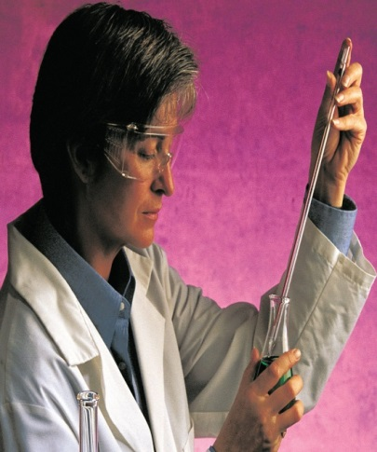
Water Quality Testing

The following tables list all the drinking water contaminants that we detected during the 2024 calendar year or during the most recent sampling period within the past five years. These were the only contaminants detected in all the monitoring required by the state. The presence of these contaminants in the water does not necessarily indicate that the water poses a health risk. Unless otherwise noted, the data presented in this table is from testing done January 1-December 31, 2024. The state requires us to monitor for certain contaminants less than once per year because the concentrations of these contaminants are not expected to vary significantly from year to year. Some of the data, though representative of the water quality, is more than one year old.

Terms and abbreviations used in the water quality tables:

Maximum Contaminant Level (MCL) - The “Maximum Allowed” is the highest level of a contaminant that is allowed in drinking water. MCLs are set as close to the MCLGs as feasible using the best available treatment technology.
Maximum Contaminant Level Goal (MCLG) - The “Goal” is the level of a contaminant in drinking water below which there is no known or expected risk to health. MCLGs allow margin of safety.
Maximum Residual Disinfectant Level (MRDL) – The highest level of a disinfectant (chlorine, chloramines, chlorine dioxide) allowed in drinking water. There is convincing evidence that addition of a disinfectant is necessary for control of microbial contaminants.
Maximum Residual Disinfectant Level Goal (MRDLG) – The level of a drinking water disinfectant (chlorine, chloramines, chlorine dioxide) below which there is no known or expected risk to health. MRDLGs do not reflect the benefits of the use of disinfectants to control microbial contaminants.
Parts per million (ppm) or Milligrams per liter (mg/l) - One part per million corresponds to one minute in two years or a single penny in $10,000.
Parts per billion (ppb) or Micrograms per liter (ug/l) - One part per billion corresponds to one minute in 2,000 years, or a single penny in $10,000,000.
Parts per trillion (ppt) or nanograms per liter (ng/L) - One part per trillion corresponds to one minute in 4,000 years, or a single penny in $100,000,000.
Action Level (AL) - The concentration of a contaminant, which, if exceeded, triggers treatment or other requirements which water systems must follow.
Massachusetts Office of Research and Standards Guideline (ORSG) – This is the concentration of a chemical in drinking water, at or below which, adverse health effects are unlikely to occur after chronic (lifetime) exposure. If exceeded, it serves as an indicator of the potential need for further action.
Secondary Maximum Contaminant Level (SMCL) – These standards are developed to protect the aesthetic (taste, color & odor) qualities of drinking water and are not health based.
Unregulated Contaminants – Unregulated contaminants are substances without MCLs for which EPA requires monitoring. For some of these substances the Massachusetts Office of Research and Standards has developed state guidelines or secondary MCLs.

Regulated  Contaminants | Date(s) Collected | Highest Detect or Highest Quarterly RAA | Range  Detected | MCL or MRDL | MCLG  or MRDLG | Violation (Y/N) | Possible Source(s) of Contamination
Disinfectants and Disinfection Byproducts
Chlorine (ppm) | Monthly | 0.16 | 0.09 - 0.170 | 4 | 4 | No | Water additive used to control microbes
Total  Trihalomethanes  (TTHMs) (ppb) | 12/08/2025 | 1.7 | 1.7 | 80 | ---- | No | Byproduct of drinking water chlorination
Nitrate | 5/6/2025 | 0.55 | 0.56 – 1.43 | 10 | 10 | No | Runoff from fertilizer use; leaching from septic tanks; sewage; erosion of natural deposits
Water Quality Test Results
Lead and Copper | Date  Collected | 90th  Percentile** | Action Level (AL) | MCLG | # of Sites Sampled | # of Sites above AL | Exceeds AL (Y/N) | Possible Sources
Lead (ppb) | 9/23/2025 | 0.002 | 15 | 0 | 20 | 0 | N | Corrosion of household plumbing
Copper (ppm) | 9/23/2025 | 0.328 | 1.3 | 1.3 | 20 | 0 | N | Corrosion of household plumbing
** Lead and copper compliance is based on the 90th percentile value, which is the highest level found in 9 out of every 10 homes sampled.

Regulated Contaminant | Date(s) Collected | Detect Result or Range  (ppt) | Quarterly Average  (ppt) | MCL | Violation | Possible Sources | Health Effects
PFAS6  (ppt) | Jan. - Oct. | 0 to 3 | 8-18 | 20 | No | Discharges and emissions from industrial and manufacturing sources associated with the production or use of these PFAS, including production of moisture and oil resistant coatings on fabrics and other materials. Additional sources include the use and disposal of products containing these PFAS, such as fire-fighting foams. | Some people who drink water containing these PFAS in excess of the MCL may experience certain adverse effects. These could include effects on the liver, blood, immune system, thyroid, and fetal development. These PFAS may also elevate the risk of certain cancers.
Unregulated and Secondary Contaminants | Date(s) Collected | Highest Detect | Average | MCL | ORSG | Possible Source(s) of  Contamination
Inorganics
Sodium (ppm) | 7/22/2025 | 18.8 | 18.8 | ---- | 20 | Natural sources; runoff from use as salt on roadways; by-product of treatment process
Sulfate (ppm) | 10/12/2021 | 10.40 | 8.75 | 250 | ---- | Natural sources

(Water Quality Results, Unregulated– cont’d on page 5)

Chemical  (CASRN) | Date(s) Collected | Detect Result or Range  (ppt) | Average Detected  (ppt) | ORSG | Possible Sources | Health Effects
Perfluorobutancesulfonic Acid (PFBS)  (375-73-5) | Jan. – Oct. | ND-3.6 | 2 | N/A | Manmade chemical; used in products to make them stain, grease, heat and water resistant | Some people who drink water containing these PFAS in excess of the MCL may experience certain adverse effects. These could include effects on the liver, blood, immune system, thyroid, and fetal development. These PFAS may also elevate the risk of certain cancers.
Perfluorododecanoic acid (PFDoA) (307-55-1) | Jan. – Oct. | ND | ND | N/A | Manmade chemical; used in products to make them stain, grease, heat and water resistant
Perfluorohexanoic acid (PFHxA) (307-24-4) | Jan. – Oct. | ND-13 | 6.3 | N/A | Manmade chemical; used in products to make them stain, grease, heat and water resistant
(Water Quality Results, Unregulated– cont’d)
Monitoring Violation Associated with Total Trihalomethanes

Date of Violation: | 8/31/2025 | Contaminant: | Total Trihalomethanes
Explanation: | We are required to monitor your drinking water for specific contaminants on a regular basis. Results of regular monitoring are an indicator of whether or not your drinking water meets health standards. The Water District was scheduled to collect a sample for Total Trihalomethanes
Planned Corrective Actions or Actions Taken |  |  | Scheduled Completion Date | Action Completed (Y/N)
After being notified from The Department of Environmental Protection these samples were taken on 10/22/2025.This brought the Shirley Water District Back into Compliance with the DEP. |  |  | 10/22/2025 | Y

Monitoring Violation Associated with Haloacetic Acids

Date of Violation: | 8/31/2025 | Contaminant | Haloacetic acids
Explanation: | We are required to monitor your drinking water for specific contaminants on a regular basis. Results of regular monitoring are an indicator of whether or not your drinking water meets health standards. On 10/22/2025 we were notified by DEP we had missed the sample date for Haloacetic Acids which should have been between 8/1/2025 and 8/31/2025.
Planned Corrective Actions or Actions Taken |  |  | Scheduled Completion Date | Action Completed (Y/N)
After being notified from The Department of Environmental Protection these samples were taken on 10/22/2025.This brought the Shirley Water District Back into Compliance with the DEP. |  |  | 10/22/2025 | Y

Monitoring Violation Associated with PFAS6

Date of Violation: | 9/30/2025 | Contaminant | PFAS6
Explanation: | We are required to monitor your drinking water for specific contaminants on a monthly basis. Results of regular monitoring are an indicator of whether or not your drinking water meets health standards. In September we were Scheduled for DEP PFAS sampling for Walker Well. We did take samples for the EPA in September but there were also Samples due for the DEP which were not taken.
Planned Corrective Actions or Actions Taken |  |  | Scheduled Completion Date | Action Completed (Y/N)
There were no corrective actions taken, we take samples at Walker Well monthly. The samples for April were taken and continued thru 2025. |  |  | NA | Y

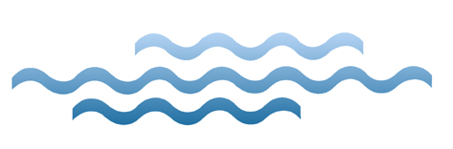
Lead and Copper in Drinking Water

If present, elevated levels of lead can cause serious health problems, especially for pregnant women and young children. Lead in drinking water is primarily from materials and components associated with service lines and home plumbing. The Shirley Water District is responsible for providing high quality drinking water, but cannot control the variety of materials used in plumbing components. When your water has been sitting for several hours, you can minimize the potential for lead exposure by flushing your tap for 30 seconds to 2 minutes before using water for drinking or cooking. If you are concerned about lead in your water, you may wish to have your water tested. Information on lead in drinking water, testing methods, and steps you can take to minimize exposure is available from the Safe Drinking Water Hotline or at http://www.epa.gov/safewater/lead.

Cross Connections

The Shirley Water District makes every effort to ensure that the water delivered to your home and business is clean, safe, and free of contamination. Our staff works very hard to protect the quality of the water delivered to our customers from the time the water is extracted via our gravel packed wells from underground aquifers, throughout the entire treatment and distribution system. But what happens when the water reaches your home or business? There is still a need to protect the water quality from contamination caused by a cross-connection.
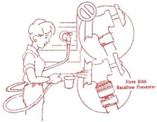

What is a cross-connection?
A cross-connection occurs whenever the drinking water supply is or could be in contact with potential sources of pollution or contamination. Cross-connections exist in piping arrangements or equipment that allow the drinking water to come in contact with non-potable liquids, solids, or gases (hazardous to humans) in event of a backflow.

What is backflow?
Backflow is the undesired reverse of the water flow in the drinking water distribution lines. This backward flow of water can occur when the pressure created by equipment or a system, such as a boiler or air-conditioning, is higher than the water pressure inside the water distribution line (backpressure), or when the pressure in the distribution line drops due to routine occurrences such as water main breaks or heavy water demand causing the water to flow
backward inside the water distribution system (back siphonage). Backflow is a problem that many water consumers are unaware of. And every water customer has a responsibility to help prevent them.
(Cross-conn. – cont’d on page 7)

(Cross-conn. – cont’d)
What you can do to help prevent a cross-connection
Without the proper protection something as simple as a garden hose has the potential to contaminate or pollute the drinking water lines in your house. In fact, over half of the country’s cross-connection incidents involve
unprotected garden hoses. There are very simple steps that you, as a drinking water user, can take to prevent such hazards:

- Never submerge a hose in soapy water buckets, pet watering containers, pool, tubs, sinks, drains, or chemicals.
- Never attached a hose to a garden sprayer without the proper backflow preventer.
- Buy and install a hose bibb vacuum breaker on every threaded water fixture. The installation can be as easy as attaching a garden hose to a spigot. This inexpensive device is available at most hardware stores and home-improvement centers.
- Identify and be aware of potential cross-connections to your water line.
- Buy appliances and equipment with a backflow preventer.
- Buy and install backflow prevention devices or assemblies for all high and moderate hazard connections.

Water Restriction

THE SHIRLEY WATER DISTRICT IS IN A LEVEL 3 CRITICAL DROUGHT.

Mandatory Water Use Restrictions In Effect, The Commissioners, acting under the authority granted to them under the enabling act (Chapter 17 of the Acts of 1939, as amended), as well as any authority arising under the Massachusetts General Laws, reserve the right to restrict or regulate water use upon Declaration of Water Supply emergency issued by the Department of Environmental Protection under M.G.L. c.40, §41A, as amended. Declaration of a State of Water Supply Conservation Massachusetts Emergency Management Agency

The drought management task force will designate regions in Massachusetts as normal or levels of drought from a level 1 to as high as level 4. The Water District will use Calendar based water restrictions which take effect from May 1st to September 30th or by monitoring stream flows to implement base line water restrictions, which are no non-essential use between the hours of 9am and 5pm. The baseline water restrictions take place regardless of a higher drought level status.

The Board of Water Commissioners may declare a State of Water Supply Conservation upon a determination by a majority vote of the Board that a shortage of water exists, and conservation measures are appropriate to protect the water supply and to ensure an adequate supply of water to all water consumers. Such a declaration could be caused by a major source failure, or a large water main break that may be difficult to recover from with high system demand. Restricted Water Uses A declaration of a State of Water Supply conservation may include one or more of the following restrictions, conditions, or requirements limiting the use of water as necessary to protect the water supply.

- The applicable restrictions, conditions or requirements shall be included in the public notice required in Section 4.
- Level 1 (Mild Drought) 1 day per week watering, after 5pm, or before 9am (to minimize evaporative losses)
- Level 2(Significant Drought) Limit outdoor watering to hand-held hoses or watering cans, to be used only after 5pm or before 9am.
- Level 3 (Critical Drought) Ban on all nonessential outdoor water use.
- Level 4 (Emergency Drought) Ban on all nonessential outdoor water use.

Restricted Nonessential Outdoor Water Uses 1. Irrigation of lawns via automatic irrigation systems or sprinklers 2. Filling of swimming pools 3. Washing of vehicles, except in a commercial car wash or as necessary for safety. 4. Washing exterior building surfaces, parking lots, driveways or sidewalks except as necessary to apply surface treatments such as paint, preservatives, stucco, pavement or cement. Uses allowed when mandatory restrictions are in place 1. Irrigation to establish a new lawn and new plantings during the months of May and September. 2. Irrigation of public parks and recreational fields before 9am and after 5pm. 3. Irrigation of gardens, flowers and ornamental plants by means of a hand-held hose or drop irrigation system. 4. Irrigation of lawns by means of a hand-held hose. (Restrictions– cont’d on page 8)
(Restrictions– cont’d)
Water uses NOT subject to mandatory restrictions
1. For health and safety reasons
2. By regulation
3. For the production of food and fiber
4. For the maintenance of livestock
5. To meet the core functions of a business (for example, irrigation by golf courses as necessary to maintain tees, greens, and minimal fairway watering, or irrigation by plant nurseries as necessary to maintain stock).

Public Notification of a State of Water Supply conservation: Notification of any provision, restriction, requirement, or condition imposed by the Water District as part of a State of Water Supply conservation shall be published in a newspaper of general circulation within the District, or by such other means reasonably calculated to reach and inform all users of water of the State of Water Supply conservation. Any restriction imposed under section 3 shall not be effective until such notification is provided. In addition, such Notification shall be posted at the District headquarters in an area accessible to the public. Notification of the State of Water Supply Conservation shall also be simultaneously provided to the Massachusetts Department of Environmental Protection. Termination of a State of Water Supply a State of Water Supply Conservation may be terminated by a majority vote of the Board of Water Commissioners upon determination that the water supply shortage no longer exists. Public notification of such termination shall be given in a manner provided in the preceding section. Compliance with DEP Orders Upon notification to the public that a declaration of a State of Water Supply Emergency has been issued by the Department of Environmental Protection, or the Board of Water Commissioners, no person shall violate any provision, restriction, requirement or condition of any order approved or issued by the DEP pursuant to such declaration or intended to alleviate or bring about the end of such State of Emergency. Fines that will be imposed upon failure to comply. 1st offense – written warning, 2nd offense - $100.00, 3rd offense - $200.00 4th offense - $500.00 Any continued offense will be multiple of $500 and/or termination of service as directed by the Board of Water Commissioners. Each day of violation shall constitute a separate offense with violations resetting the beginning of each calendar year.

Tips for Conserving
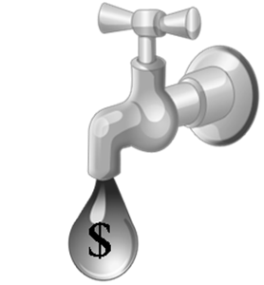

A typical household uses approximately 260 gallons of water per day. If all households installed water-efficient fixtures and appliances (such as low flow toilets and efficient clothes washers), water use would be reduced by 30 percent. The following are some helpful conservation efforts inside the home, in addition to changing fixtures and appliances:

• Don’t use toilet as a wastebasket.
• Reduce the water level per flush by installing a toilet displacement device, such as a
plastic bottle weighted with pebbles and water, in older toilets (prior to 1992).
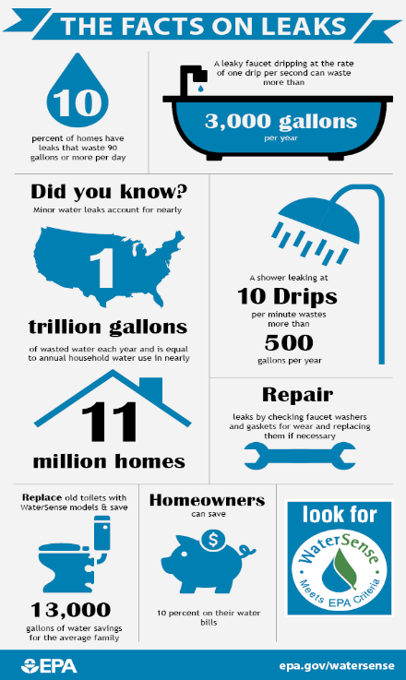
• Check toilets for leaks by putting a few drops of food coloring in your toilet tank. If the color begins to appear in the bowl without flushing, you have a leak. An undetected toilet leak could be costing you up to $100 per day. (Conserving– cont’d on page 8)

(Conserving– cont’d)
• Don’t let the sink run while brushing teeth or shaving. On average, you will save more than five gallons of water, which equals upwards of $40 per month.

For saving outside the home, consider the following:
• Most lawns can survive extended dry periods without watering – they will turn brown, but will revive once the rain returns. If you want to water, give established lawns and shrubs a maximum of one inch of water per week. If there has been an inch of rain in the week, you don’t need to water. Use an inexpensive rain gauge to measure rain and watering efforts.
• If you step on your lawn and the grass spring back, it does not need to be watered.
• Don’t over water plants. Overwatering too much result in shallow roots, weed growth, disease and fungus.
• The best time to water your lawn is early morning (4 to 6 AM). Avoid watering at mid-day to prevent high evaporation and sun-burned grass.
• Unattended hoses can use 10 gallons or more per minute. Use shut-off nozzles to save water. Also, if you have an in-ground irrigation system, use a rain shut-off device that prevents the system from operating during rainstorms.
Sources: U.S. EPA and AWWA

Water District Staff & Numbers

Operating Personnel
Brian Boomgaarden, Superintendent
Connor Boomgaarden, Water Tech. I
Board of Water Commissioners
Kevin A. Johnston, Member
Donald E. Farrar, Jr Member
Dave Swain, Member
Office Personnel
Rhonda Caissie, Treasurer/Clerk
Jenni Guthrie, Collector/ Admin.
Brenda Perreault Office/Assistant

Office Hours Monday through Friday: 9 AM-1PM
Phone: 978.425.2245 ***** Fax: 978.425.6669
E-mail: boomer@shirleywater.com On the web: www.shirleywater.com
For emergencies after normal business hours, contact Ayer-Shirley Regional Dispatch at 978-772-8200, extension 0, and your call will be forwarded to District personnel.

Other Numbers & Web Sites

MassDEP Drinking Water Program - www.mass.gov/eea/agencies/massdep/water/drinking/
Worcester Tel: 508.792.7650 www.epa.gov/safewater/
Boston Tel: 617-292-5885 www.h2ouse.org/ (cool site with water saving hints)
EPA Drinking Water Hotline: 800.426.4791

