Old Roaring River Baptist Church

PO Box 126, Traphill, NC 28685

orrbc28685@gmail.com

Pastor James Pardue

Pastor’s Cell Phone: 336-428-7581
Church Phone: 336-957-4698

Welcome to God’s House!
Let us enter to worship and depart to serve!

November 23rd, 2025

Welcome To All Our First Time Visitors!

Thank you for joining us today and being a part of our worship service. We are thrilled to
have you with us and pray that the Lord will bless you for coming this way today. - Pastor James & Congregation

Last Week’s Message……………………….…… Brother Obed Missal ….. “Grace”

Week’s Text ..……………………………………………… II Corinthians 12 : 1 – 10

Congratulations to all the Birthday and Anniversary Individuals!!!

Birthdays: | Day | Date: | Anniversaries: | Day | Date:
Mary Foster | Sun | Nov 2 | Mike & Patty Hutchison | Wed | Nov 5
Dila Sidden | Sun | Nov 2 | Ed & Julia Trivette | Thurs | Nov 6
Tracy Crouse | Tues | Nov 4 | Jimmy & Janie Johnston | Thurs | Nov 13
Rebekah Loredo | Sat | Nov 8 | Walter & Wanda Hutchinson | Sun | Nov 16
Jayden Hutchison | Mon | Nov 17
Hailey Lassiter | Tues | Nov 18
Karen Pardue | Thurs | Nov 20
James Pardue | Mon | Nov 24
Rita Sidden | Mon | Nov 24
John McGrady | Sat | Nov 29

Announcements

Please plan to stay for our Thanksgiving Meal in the Fellowship Building immediately following service today.

No service this Wednesday, November 26th

The Bible tells us to pray without ceasing (I Thess 5:17) and that the effectual fervent prayer of a righteous man availeth much (James 5:16). Please keep one another, and the folks on our prayer list, in your constant prayers in your daily devotions.
Prayer Request List:

Upcoming Week:
Pastor James – Shoulder Rec. / Foot 12/15 | UNSAVED
Beverly Lassiter – Surgery Recovery | Our Country (Leaders & Military)
Tracy Crouse – Hernia Surgery Recovery | Missionaries:
Larry Foster – Colon Cancer Surgery 11/24 | Thru the Bible Radio – Worldwide
Jerry Brooks – Surgery 12/02 | GBI Radio, Inc.
Rosanna Spicer – Knee Surgery 12/8 | Gideons International
Marian King – Upcoming Surgery | Larry Key – Crossing the Streets Min
Bobby McGrady – PET Scan | David Harrelson – Rock of Ages Min
Tony Carver – Heart Surgery Recovery | Obed Missal – India
David Harrelson – Knee | Ebenezer Garden Children’s Home
Evelyn Sidden – Physical Therapy

Illness Recovery:
Vicky Cleary – Hospice | Dorothy Pardue – Stroke | Edie Wicks – Dementia
Matt Daye – Parkinson's | Jerry Sidden – Hand | Barney Vaughn – Heart
Barry Hutchinson – Foot | Shirley Watts – Heart
Rebekah Loredo – Wreck | Aaron Walker – Liver

Cancer List:
Edward Allen | Ann Chandler | Linda Hutchison | Curtis Pruitt
Tammy Baity | Randy Crabb | Luke Jackson | Earl Rolland
Cheryl Bork | Michelle Davis | Bruce Jennings | Rosie Royal
Billy Joe Bowers | Ralph Faw | Sharon Keys | Pat Russell
Kathy Carpenter | Nathan Greer | Dr Steve Laws | Dalton Sheets
Candy Carter | Darlene Handy | Tammy McBride | Wilma Shew
Stephanie Cartwright | Blake Hickman | Wade Mounce | Penny Thibeault
Ed Caudle | Drew Holcomb | Libby Price | Missy White

Shut-Ins:
Alvin Caudle – Westwood Hills | Evelyn Sidden – Parkwood
Ryan Marlow – Hospital | Lillie Spicer – Home
Martha Myers – Westwood Hills | Ruth Vaughn – Westwood Hills

Military:
Lucas Baker | Jerome Crouse | Samuel Lewczyk
Jackson Bell | Kerston Denny | Cody McKinney
Chad Billings | Robert Patrick Heater | Colby Nelson

Nursery Schedule:

Date | Person # 1 | Person # 2
Sunday, October 26, 2025 | Rosezetta Spicer | Nan Pilkington
Sunday, November 2, 2025 | Pat Sidden | Susanne Reavis
Sunday, November 9, 2025 | Brooke Hutchison | Jayden Hutchison
Sunday, November 16, 2025 | Rosezetta Spicer | Nan Pilkington
Sunday, November 23, 2025 | Pat Sidden | Susanne Reavis
Sunday, November 30, 2025 | Brooke Hutchison | Jayden Hutchison
Sunday, December 7, 2025 | Rosezetta Spicer | Nan Pilkington
Sunday, December 14, 2025 | Pat Sidden | Susanne Reavis
Sunday, December 21, 2025 | Brooke Hutchison | Jayden Hutchison
Sunday, December 28, 2025 | Rosezetta Spicer | Nan Pilkington

Notes:

----------------------------------------------------------------------------------------

----------------------------------------------------------------------------------------

----------------------------------------------------------------------------------------

----------------------------------------------------------------------------------------

----------------------------------------------------------------------------------------

----------------------------------------------------------------------------------------

----------------------------------------------------------------------------------------

** Please note that all activities at Old Roaring River Baptist Church are under 24-hour surveillance on all premises of the grounds and building and is being recorded seven days per week for security purposes.

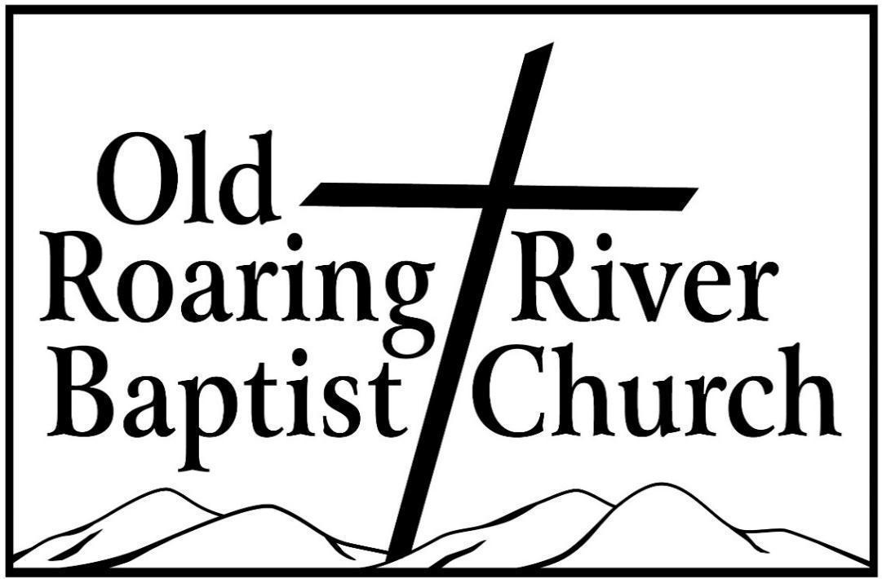

13932 Longbottom Road
Traphill, NC 28685
Pastor James Pardue

November 23rd, 2025

Sunday School ……….………………………………………………. 10:00 AM

Sunday Morning Worship ……….……….….…………………….… 11:00 AM
Choir Practice Wednesdays...……….…….….………………………... 7:00 PM

Wednesday Night Prayer Meeting ……..…………………………...… 7:30 PM

Church Website ………………………………………………... orrbc.org
Old Roaring River Baptist Church Hour …………………..Sun, 5:30 PM

1560 AM WYZD Dobson, NC 95.3 FM WYZD Dobson, NC

1060 AM WCOK Sparta, NC 107.3 FM WCOK Sparta, NC

Parking Lot Service (All Services) ………….….…………....... 106.3 FM



