Old Roaring River Baptist Church

PO Box 126, Traphill, NC 28685

orrbc28685@gmail.com

Pastor James Pardue

Pastor’s Cell Phone: 336-428-7581
Church Phone: 336-957-4698

Welcome to God’s House!
Let us enter to worship and depart to serve!

October 25th, 2026

Welcome To All Our First Time Visitors!

Thank you for joining us today and being a part of our worship service. We are thrilled to
have you with us and pray that the Lord will bless you for coming this way today. - Pastor James & Congregation

Last Week’s Message………........ Bro. David Harrelson ... The Power of the Cross
Week’s Text ….…………………………….….……….………... I Corinthians 1 : 18

Congratulations to all the Birthday and Anniversary Individuals!!!

Birthdays: | Day | Date: | Anniversaries: | Day | Date:
Amy Freeman | Thurs | Oct 1 | Brandon & Rebekah Loredo | Fri | Oct 9
Chase Johnson | Mon | Oct 5 | Mike & Rosanne Spicer | Mon | Oct 12
Jimmy Hutchinson | Fri | Oct 9 | Dennis & Janice McGrady | Wed | Oct 14
Marlene Key | Fri | Oct 9 | James & Karen Pardue | Sun | Oct 25
Robert McDaniel | Sat | Oct 10 | Kent & Amy Freeman | Mon | Oct 26
Judy Swaim | Sun | Oct 11 | John & Debbie McGradyr | Mon | Oct 26
Mary Hutchinson | Mon | Oct 19 | Jamey Jr & Eden Cranford | Wed | Oct 28
Linda Sidden | Wed | Oct 21
Margie Hutchison | Wed | Oct 28
Patty Hutchison | Fri | Oct 30

Announcements

Wednesday Night Choir Practice at 7:00 pm; Bible Study at 7:30 pm

Please make plans to attend Business Conference on Wednesday, November 18th beginning at 7:30 pm.

The Bible tells us to pray without ceasing (I Thess 5:17) and that the effectual fervent prayer of a righteous man availeth much (James 5:16). Please keep one another, and the folks on our prayer list, in your constant prayers in your daily devotions.
Prayer Request List:

Upcoming Week:
Billie Sidden Family | UNSAVED
Pat Sidden – Cataract Surgery 10/27 | Our Country (Leaders & Military)
Roseanna Spicer – Melanoma Removal Rec. | Missionaries:
Mary Hutchinson – Knee Replacement Rec. | Thru the Bible Radio – Worldwide
Reagan King – MRI Results | GBI Radio, Inc.
Rebekah Loredo – Foot Surgery TBD | Gideons International
Ed Trivette – Test Results | Larry Key – Crossing the Streets Min
Amanda Smith – Brain Tumor | David Harrelson – Rock of Ages Min
Josiah Zacharius – Wreck (Internal injuries) | Obed Missal – India
Joyce Thomas – Heart Attack Recovery | Ebenezer Garden Children’s Home
Mike Roope – Wreck

Illness Recovery:
Nettie Bell – Shoulder | Evelyn Sidden (Jerry’s) | Bennie Waugh – Liver
Stephen Bork – Stroke | Larry Swaim – Foot Amp | Wesley Weaver – Kidney
Robin McGrady – Infusions | Mike Spicer – Leg Amp.

Cancer List:
Edward Allen | Ann Chandler | Rex Johnson | Dalton Sheets
Jim Billings | Serena Childress | Sharon Keys | Wilma Shew
Cheryl Bork | Patricia Fowler | Rev. Gene Koger | Penny Thibeault
Billy Joe Bowers | Nathan Greer | Dr Steve Laws | Dustin Trivette
Wanda Bowman | Darlene Handy | Nancy Lyon | Michelle Trivette
Kathy Brown | Merritt Hare | Jackie Parsons
Kathy Carpenter | Linda Hutchison | Curtis Pruitt
Ed Caudle | Luke Jackson | Earl Rolland

Parkinson’s List:
Roger Brooks | Bonnie Luttenbacher | Jeri Trivette

Shut-Ins:
Jerry Brooks – Wilkes Health & Rehab | Evelyn Sidden – Parkwood
Alan Holbrook – Home | Lillie Spicer – Home
Martha Myers – Westwood Hills

Military:
Lucas Baker | Jerome Crouse | Cody McKinney
Jackson Bell | Samuel Lewczyk | Colby Nelson
Chad Billings

Notes:

----------------------------------------------------------------------------------------

----------------------------------------------------------------------------------------

----------------------------------------------------------------------------------------

----------------------------------------------------------------------------------------

----------------------------------------------------------------------------------------

----------------------------------------------------------------------------------------

----------------------------------------------------------------------------------------

----------------------------------------------------------------------------------------

----------------------------------------------------------------------------------------

----------------------------------------------------------------------------------------

----------------------------------------------------------------------------------------

----------------------------------------------------------------------------------------

----------------------------------------------------------------------------------------

----------------------------------------------------------------------------------------

----------------------------------------------------------------------------------------

----------------------------------------------------------------------------------------

----------------------------------------------------------------------------------------

----------------------------------------------------------------------------------------

Please note that all activities at Old Roaring River Baptist Church are under 24-hour surveillance on all premises of the grounds and building and is being recorded seven days per week for security purposes.

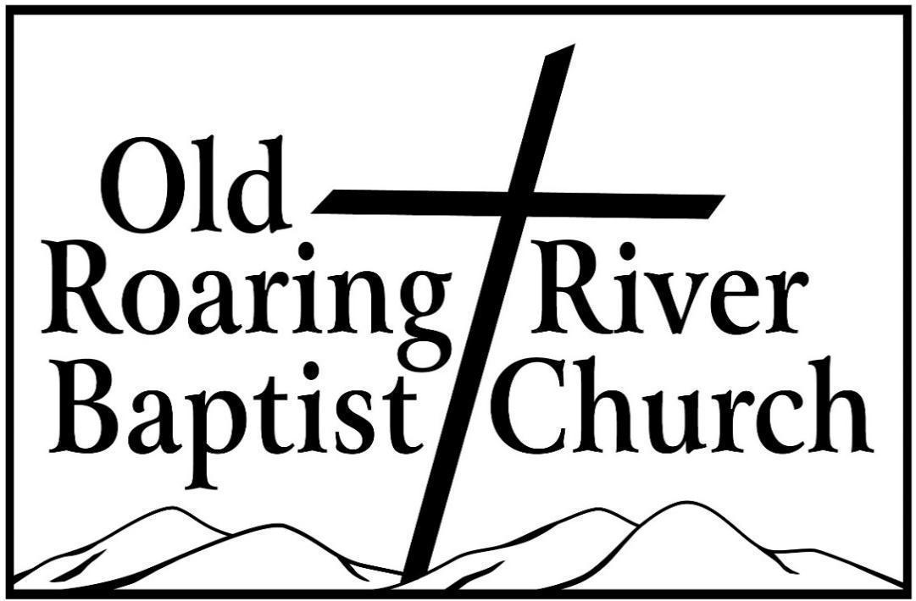

13932 Longbottom Road
Traphill, NC 28685
Pastor James Pardue

October 25, 2026

Sunday School ……….………………………………………………. 10:00 AM

Sunday Morning Worship ……….……….….…………………….… 11:00 AM
Choir Practice Wednesdays...……….…….….………………………... 7:00 PM

Wednesday Night Prayer Meeting ……..…………………………...… 7:30 PM

Church Website ………………………………………………... orrbc.org
Old Roaring River Baptist Church Hour …………………..Sun, 5:30 PM

1560 AM WYZD Dobson, NC 95.3 FM WYZD Dobson, NC

1060 AM WCOK Sparta, NC 107.3 FM WCOK Sparta, NC

Parking Lot Service (All Services) ………….….…………....... 106.3 FM



