Old Roaring River Baptist Church

PO Box 126, Traphill, NC 28685

orrbc28685@gmail.com

Pastor James Pardue

Pastor’s Cell Phone: 336-428-7581

**Church Phone: 336-957-4698**

## Welcome to God’s House!

**Let us enter to worship and depart to serve!**

**October 5th, 2025**

**Welcome To All Our First Time Visitors!**

*Thank you for joining us today and being a part of our worship service. We are thrilled to*

*have you with us and pray that the Lord will bless you for coming this way today. - Pastor James & Congregation*

# Last Week’s Message…………………………..………………… What Faith Can Do

# Week’s Text ..…………………….... Mark 11 : 22 ; Hebrews 11 : 1 ; Hebrews 11 : 6

# 

***Congratulations to all the Birthday and Anniversary Individuals!!!***

|  |  |  |  |  |
| --- | --- | --- | --- | --- |
| **Birthdays:** | **Day** | **Date:** | **Anniversaries:** | **Date:** |
| Amy Freeman | Wed | Oct 1 | Brandon & Rebekah Loredo | Oct 9 |
| Chase Johnson | Sun | Oct 5 | Mike & Rosanne Spicer | Oct 12 |
| Jimmy Hutchinson | Thurs | Oct 9 | Dennis & Janice McGrady | Oct 14 |
| Marlene Key | Thurs | Oct 9 | Ronnie & Tammy McBride | Oct 18 |
| Robert McDaniel | Fri | Oct 10 | Jordyn & Nick Goulding | Oct 20 |
| July Swaim | Sat | Oct 11 | Justin & Leigha Pruitt | Oct 21 |
| Shirley Watts | Fri | Oct 17 | James & Karen Pardue | Oct 25 |
| Mary Hutchinson | Sun | Oct 19 | Kent & Amy Freeman | Oct 26 |
| Linda Sidden | Tues | Oct 21 | John & Debbie McGrady | Oct 26 |
| Margie Hutchison | Tues | Oct 28 | Jamey Jr & Eden Cranford | Oct 28 |
| Patty Hutchison | Thurs | Oct 30 |  |  |

**Announcements**

Please see announcements on the back of bulletin.

*The Bible tells us to pray without ceasing (I Thess 5:17) and that the effectual fervent prayer of a righteous man availeth much (James 5:16). Please keep one another, and the folks on our prayer list, in your constant prayers in your daily devotions.*

**Prayer Request List:**

**Upcoming Week:**

|  |  |
| --- | --- |
| Brenda Ratcliff Family | **UNSAVED** |
| Marian King – Pneumonia / Collapsed Lung | **Our Country (Leaders & Military)** |
| Joyce Robinson – Gallbladder Surg. 10/6 | **Missionaries:** |
| Kathy Moffet – Heart Ablation 10/27 | Thru the Bible Radio – Worldwide |
| Pastors & Speakers filling in for Bro. James | GBI Radio, Inc. |
|  | Gideons International |
|  | Larry Key – Crossing the Streets Min |
|  | David Harrelson – Rock of Ages Min |
|  | Obed Missal – India |
|  | Ebenezer Garden Children’s Home |
|  |  |

**Illness Recovery:**

|  |  |  |
| --- | --- | --- |
| Nettie Bell – Fall | Matt Daye – Parkinson's | James Pardue – Shoulder |
| Wes Bowers – Knee | Barry Hutchinson – Foot | Jerry Sidden – Fall |
| Jerry Brooks – Surgery | Rebekah Loredo – Wreck | Barney Vaughn – Heart |
| Vicky Cleary – Hospice | Dorothy Pardue – Stroke | Shirley Watts – Heart |

**Cancer List:**

|  |  |  |  |
| --- | --- | --- | --- |
| Edward Allen | Ed Caudle | Blake Hickman | Libby Price |
| Tammy Baity | Ann Chandler | Drew Holcomb | Curtis Pruitt |
| Cheryl Bork | Randy Crabb | Linda Hutchison | Earl Rolland |
| Billy Joe Bowers | Michelle Davis | Luke Jackson | Rosie Royal |
| Mitch Bray | Ralph Faw | Bruce Jennings | Wilma Shew |
| Kathy Carpenter | Nathan Greer | Sharon Keys | Penny Thibeault |
| Candy Carter | Darlene Handy | Tammy McBride | Missy White |
| Stephanie Cartwright | Frank Handy | Wade Mounce |  |

**Shut-Ins:**

|  |  |
| --- | --- |
| Alvin Caudle – Westwood Hills | Evelyn Sidden – Parkwood |
| Ryan Marlow – Hospital | Lillie Spicer – Home |
| Martha Myers – Westwood Hills | Ruth Vaughn – Westwood Hills |

**Military:**

|  |  |  |
| --- | --- | --- |
| Lucas Baker | Jerome Crouse | Samuel Lewczyk |
| Jackson Bell | Kerston Denny | Cody McKinney |
| Chad Billings | Robert Patrick Heater | Colby Nelson |

**Announcements**

Wednesday Night Service : Choir Practice at 7:00 pm; Bible Study at 7:30 pm

All ladies are invited to attend a Women’s Study on Heaven each Sunday night until October 12th. The Study is being presented by Wanda Hutchinson and begins at 6:00 pm each week at Little Stone Mountain Baptist Church.

Please mark your calendars for Revival services beginning at 7:00 pm nightly from Monday, October 6th through Wednesday October 8th. Be much in prayer for Brother Seth Siceloff as he brings the message each night.

ORRBC will be participating in Traphill Elementary School’s Boo Palooza on Saturday, October 18th from 6:30 pm to 8:00pm. Please bring any candy donations to Robin Sebastian by Wednesday night, October 15th. She is also looking for volunteers to help work and decorate our table. If you have any questions or would like to help, please see Robin Sebastian.

Please make plans to attend a very special celebration on Sunday, October 19th. A 90th Birthday Bash will be held in the Fellowship Building in honor of Sister Evelyn Sidden (Jun 22nd), Bro. Willie Wyatt (Sept 11th), and Sister Shirley Watts (Oct 17th). Please help with a meal that will follow the service and the church will provide the cake.

Please make plans to attend our regularly scheduled Business Conference on Wednesday, Oct 22nd beginning at 7:30 pm.

A BBQ Fundraiser will be held for Rebekah Loredo on Saturday, November 1st at the Fellowship Building to help cover medical expenses from her recent car accident. There is a signup sheet on the communion table for workers and cake makers.

**Notes:**

**----------------------------------------------------------------------------------------**

**----------------------------------------------------------------------------------------**

**----------------------------------------------------------------------------------------**

**----------------------------------------------------------------------------------------**

**----------------------------------------------------------------------------------------**

**----------------------------------------------------------------------------------------**

**\*\* Please note that all activities at Old Roaring River Baptist Church are under 24-hour surveillance on all premises of the grounds and building and is being recorded seven days per week for security purposes.**

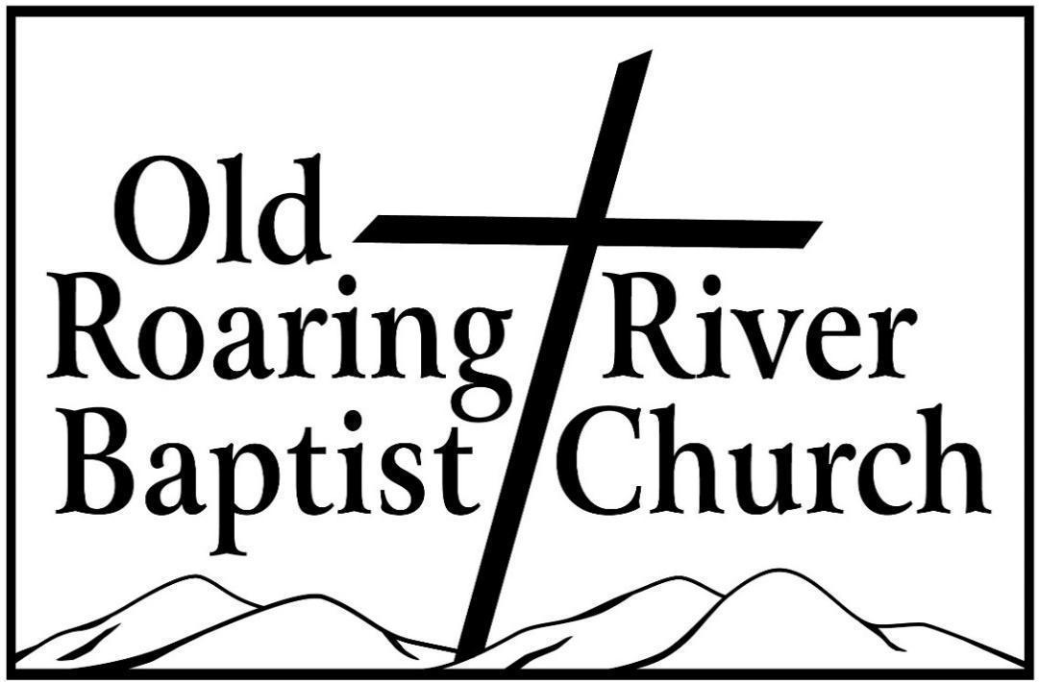

**13932 Longbottom Road**

**Traphill, NC 28685**

**Pastor James Pardue**

**October 5th, 2025**

# Sunday School ……….………………………………………………. 10:00 AM

# Sunday Morning Worship ……….……….….…………………….… 11:00 AM

Choir Practice Wednesdays...……….…….….………………………... 7:00 PM

# Wednesday Night Prayer Meeting ……..…………………………...… 7:30 PM

Church Website ………………………………………………... orrbc.org

Old Roaring River Baptist Church Hour …………………..Sun, 5:30 PM

1560 AM WYZD Dobson, NC 95.3 FM WYZD Dobson, NC

1060 AM WCOK Sparta, NC 107.3 FM WCOK Sparta, NC

Parking Lot Service (All Services) ………….….…………....... 106.3 FM

