Old Roaring River Baptist Church

PO Box 126, Traphill, NC 28685

orrbc28685@gmail.com

Pastor James Pardue

Pastor’s Cell Phone: 336-428-7581
Church Phone: 336-957-4698

Welcome to God’s House!
Let us enter to worship and depart to serve!

September 13th, 2026

Welcome To All Our First Time Visitors!

Thank you for joining us today and being a part of our worship service. We are thrilled to
have you with us and pray that the Lord will bless you for coming this way today. - Pastor James & Congregation

Last Week’s Message……………………………….. The Qualifications of a Deacon
Week’s Text ….…………………………….………….………… I Timothy 3 : 8 – 13

Congratulations to all the Birthday and Anniversary Individuals!!!

Birthdays: | Day | Date: | Anniversaries: | Day | Date:
Kolbey Foster | Tues | Sept 1 | Shane & Nicole Holeman | Sun | Sept 6
Ruth Vaughn | Tues | Sept 8 | Darin & Beverly Lassiter | Sun | Sept 6
Willie Waytt | Fri | Sept 11 | Tanner & Dila Sidden | Thurs | Sept 10
Benjamin Sebastian | Mon | Sept 14 | Dakota & Angel Johnson | Mon | Sept 21
Janice McGrady | Thurs | Sept 17 | Barney & Ruth Vaughn | Fri | Sept 25
Barry Hutchinson | Fri | Sept 18 | Jimmy Ray & Mary Hutchinson | Tues | Sept 29
Stella Gaffney | Sun | Sept 20 | Jerry & Evelyn Sidden | Wed | Sept 30
Dana Reynolds | Thurs | Sept 24
Quincy Jonnson | Tues | Sept 29
Jerry Sidden | Tues | Sept 29

Announcements
Wednesday night Choir Practice at 7:00 pm and Bible Study at 7:30 pm

Grandparents Day : Sunday September 13th during the Sunday School hour in the Fellowship building. Please make plans to attend this special event for all of the grandparents.

Revival : Sunday Oct 4th at 6:00 pm with Bro. Jerry Pardue; Monday Oct. 5 – Wednesday Oct 7 at 7:00 pm with Bro. Brian Cardwell. Special singing each night. Please make plans to join us for these services.
The Bible tells us to pray without ceasing (I Thess 5:17) and that the effectual fervent prayer of a righteous man availeth much (James 5:16). Please keep one another, and the folks on our prayer list, in your constant prayers in your daily devotions.
Prayer Request List:

Upcoming Week:
Ruth Vaughn – Hospice / Stomach Cancer | UNSAVED
Dana Leopold – Coma | Our Country (Leaders & Military)
Karen Pardue – Back / Shots / Fall | Missionaries:
Wes Bowers – 9/18 Kidney Stone Procedure | Thru the Bible Radio – Worldwide
Debbie McGrady (Bobby’s) – Hernia Surgery | GBI Radio, Inc.
Gaye Billings | Gideons International
Wesley Weaver | Larry Key – Crossing the Streets Min
Merritt Hare – Cancer | David Harrelson – Rock of Ages Min
Wanda Bowman – Tests | Obed Missal – India
 | Ebenezer Garden Children’s Home

Illness Recovery:
Josephine Caudle – Stroke | Robin McGrady – Infusions | Ed Trivette – Intestines
Sharon Holbrook – Strokes | Evelyn Sidden (Jerry’s) | Bennie Waugh – Liver
Joe Hutchinson – Wreck | Larry Swaim – Foot Amp
Rebekah Loredo – Foot Surg | Mike Spicer – Leg Amp.

Cancer List:
Edward Allen | Ann Chandler | Rex Johnson | Dalton Sheets
Jim Billings | Patricia Fowler | Sharon Keys | Wilma Shew
Cheryl Bork | Nathan Greer | Rev. Gene Koger | Penny Thibeault
Billy Joe Bowers | Darlene Handy | Dr Steve Laws | Dustin Trivette
Kathy Brown | Linda Hutchison | Nancy Lyon | Michelle Trivette
Kathy Carpenter | Luke Jackson | Curtis Pruitt
Ed Caudle | Bruce Jennings | Earl Rolland

Parkinson’s List:
Roger Brooks | Bonnie Luttenbacher | Jeri Trivette

Shut-Ins:
Alan Holbrook – Home | Lillie Spicer – Home
Martha Myers – Westwood Hills | Ruth Vaughn – Westwood Hills / Hospice
Evelyn Sidden – Parkwood

Military:
Lucas Baker | Jerome Crouse | Cody McKinney
Jackson Bell | Samuel Lewczyk | Colby Nelson
Chad Billings

Notes:

----------------------------------------------------------------------------------------

----------------------------------------------------------------------------------------

----------------------------------------------------------------------------------------

----------------------------------------------------------------------------------------

----------------------------------------------------------------------------------------

----------------------------------------------------------------------------------------

----------------------------------------------------------------------------------------

----------------------------------------------------------------------------------------

----------------------------------------------------------------------------------------

----------------------------------------------------------------------------------------

----------------------------------------------------------------------------------------

----------------------------------------------------------------------------------------

----------------------------------------------------------------------------------------

----------------------------------------------------------------------------------------

----------------------------------------------------------------------------------------

----------------------------------------------------------------------------------------

----------------------------------------------------------------------------------------

----------------------------------------------------------------------------------------

Please note that all activities at Old Roaring River Baptist Church are under 24-hour surveillance on all premises of the grounds and building and is being recorded seven days per week for security purposes.

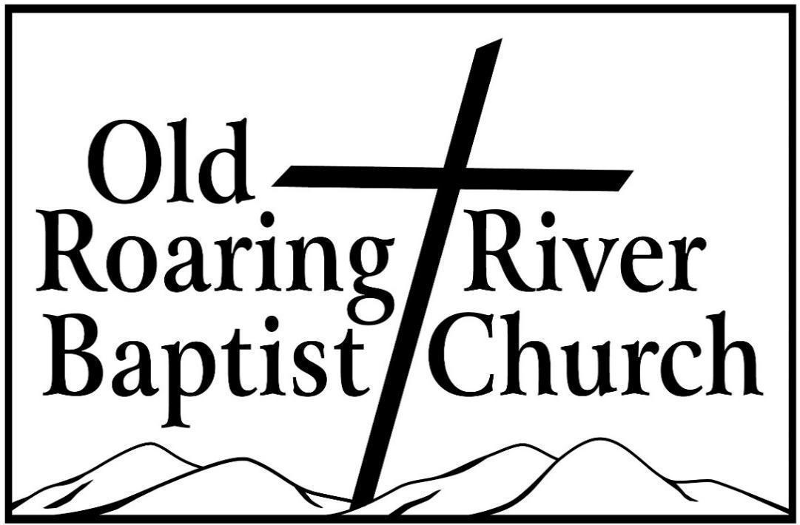

13932 Longbottom Road
Traphill, NC 28685
Pastor James Pardue

September 13, 2026

Sunday School ……….………………………………………………. 10:00 AM

Sunday Morning Worship ……….……….….…………………….… 11:00 AM
Choir Practice Wednesdays...……….…….….………………………... 7:00 PM

Wednesday Night Prayer Meeting ……..…………………………...… 7:30 PM

Church Website ………………………………………………... orrbc.org
Old Roaring River Baptist Church Hour …………………..Sun, 5:30 PM

1560 AM WYZD Dobson, NC 95.3 FM WYZD Dobson, NC

1060 AM WCOK Sparta, NC 107.3 FM WCOK Sparta, NC

Parking Lot Service (All Services) ………….….…………....... 106.3 FM



