Old Roaring River Baptist Church

PO Box 126, Traphill, NC 28685

orrbc28685@gmail.com

Pastor James Pardue

Pastor’s Cell Phone: 336-428-7581

**Church Phone: 336-957-4698**

## Welcome to God’s House!

**Let us enter to worship and depart to serve!**

**August 17, 2025**

**Welcome To All Our First Time Visitors!**

*Thank you for joining us today and being a part of our worship service. We are thrilled to*

*have you with us and pray that the Lord will bless you for coming this way today. - Pastor James & Congregation*

# Last Week’s Message…………………………..…………… Project Sunday School

# Week’s Text ..………………………………………………….…….

# 

***Congratulations to all the Birthday and Anniversary Individuals!!!***

|  |  |  |  |  |
| --- | --- | --- | --- | --- |
| **Birthdays:** | **Day** | **Date:** | **Anniversaries:** | **Date:** |
| Ed Trivette | Sat | Aug 9th | Larry & Mary Foster | Aug 11th |
| Raelyn Cranford | Mon | Aug 11th | Larry & Marlene Key | Aug 11th |
| Sally Holland | Tues | Aug 12th | Tom & Helen Johnson | Aug 14th |
| Greg Gant | Wed | Aug 13th | Charles & Marian King | Aug 27th |
| Evelyn C Sidden | Wed | Aug 13th |  |  |
| Darin Lassiter | Tues | Aug 19th |  |  |
| Nan Pilkington | Wed | Aug 20th |  |  |
| Peyton Zimmerman | Tues | Aug 26th |  |  |
| Jimmy Johnston | Tues | Aug 26th |  |  |

**Announcements**

Alter Prayer Sunday mornings at 9:45 am

Wednesday Night Services : Choir Practice @ 7:00 pm ; Bible Study @ 7:30 pm

Annual Church Picnic will be held on Sunday, August 31st at Stone Mountain State Park Hemlock Shelter. The Church will provide meat, bread, drinks and paper goods. Please help with sides and any and all desserts. We will meet at the shelter at 10:30 am.

Please make plans to attend a special joint service with Billings Hill on Thursday, September 11th beginning at 7:00 pm. There will be no service on Wednesday, September 10th.

*The Bible tells us to pray without ceasing (I Thess 5:17) and that the effectual fervent prayer of a righteous man availeth much (James 5:16). Please keep one another, and the folks on our prayer list, in your constant prayers in your daily devotions.*

**Prayer Request List:**

**Upcoming Week:**

|  |  |
| --- | --- |
| Rev. Roger Groce Family | **UNSAVED** |
| Vickie Cleary – Hospice | **Our Country (Leaders & Military)** |
| Shirley Watts – Heart | **Missionaries:** |
| Marian DiPietro – Baptist Hospital / Kidneys | Thru the Bible Radio – Worldwide |
| Karah Winters – Kidney Stones | GBI Radio, Inc. |
| Karen Pardue – Vasculitis | Gideons International |
| Kathy Moffet – Heart Ablation 10/27 | Larry Key – Crossing the Streets Min |
|  | David Harrelson – Rock of Ages Min |
|  | Obed Missal – India |
|  | Ebenezer Garden Children’s Home |
|  |  |
|  |  |

**Illness Recovery:**

|  |  |  |
| --- | --- | --- |
| Beverly Bauguess – Neck | Kathy Freeman – Lungs | Jerry Sidden – Hand |
| Matt Daye – Parkinson's | Joyce Robinson – Gallbladder |  |
|  |  |  |

**Cancer List:**

|  |  |  |  |
| --- | --- | --- | --- |
| Edward Allen | Ed Caudle | Frank Handy | Wade Mounce |
| Tammy Baity | Ann Chandler | Blake Hickman | Earl Rolland |
| Cheryl Bork | Randy Crabb | Drew Holcomb | Rosie Royal |
| Billy Joe Bowers | Tracy Crouse | Linda Hutchison | Wilma Shew |
| Mitch Bray | Michelle Davis | Luke Jackson | Penny Thibeault |
| Kathy Carpenter | Ralph Faw | Bruce Jennings | Missy White |
| Candy Carter | Nathan Greer | Sharon Keys |  |
| Stephanie Cartwright | Darlene Handy | Tammy McBride |  |

**Shut-Ins:**

|  |  |
| --- | --- |
| Alvin Caudle – Westwood Hills | Evelyn Sidden – Parkwood |
| Ryan Marlow – Home | Lillie Spicer – Home |
| Martha Myers – Westwood Hills | Ruth Vaughn – Westwood Hills |
| Dorothy Pardue – Home |  |

**Military:**

|  |  |  |
| --- | --- | --- |
| Lucas Baker | Jerome Crouse | Samuel Lewczyk |
| Jackson Bell | Kerston Denny | Cody McKinney |
| Chad Billings | Robert Patrick Heater | Colby Nelson |

**Notes:**

**----------------------------------------------------------------------------------------**

**----------------------------------------------------------------------------------------**

**----------------------------------------------------------------------------------------**

**----------------------------------------------------------------------------------------**

**----------------------------------------------------------------------------------------**

**----------------------------------------------------------------------------------------**

**----------------------------------------------------------------------------------------**

**----------------------------------------------------------------------------------------**

**----------------------------------------------------------------------------------------**

**---------------------------------------------------------------------------------------**

**---------------------------------------------------------------------------------------**

**----------------------------------------------------------------------------------------**

**----------------------------------------------------------------------------------------**

**----------------------------------------------------------------------------------------**

**----------------------------------------------------------------------------------------**

**---------------------------------------------------------------------------------------**

**---------------------------------------------------------------------------------------**

**----------------------------------------------------------------------------------------**

**\*\* Please note that all activities at Old Roaring River Baptist Church are under 24-hour surveillance on all premises of the grounds and building and is being recorded seven days per week for security purposes.**

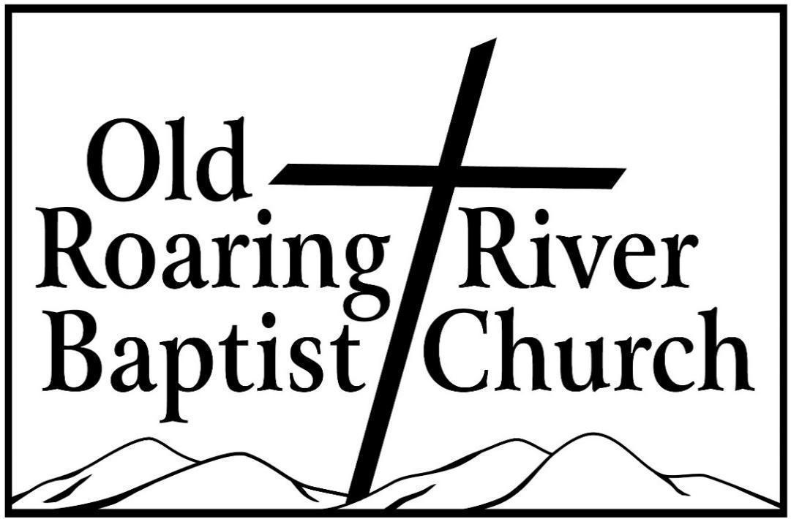

**13932 Longbottom Road**

**Traphill, NC 28685**

**Pastor James Pardue**

**August 17, 2025**

# Sunday School ……….………………………………………………. 10:00 AM

# Sunday Morning Worship ……….……….….…………………….… 11:00 AM

Choir Practice Wednesdays...……….…….….………………………... 7:00 PM

# Wednesday Night Prayer Meeting ……..…………………………...… 7:30 PM

Church Website ………………………………………………... orrbc.org

Old Roaring River Baptist Church Hour …………………..Sun, 5:30 PM

1560 AM WYZD Dobson, NC 95.3 FM WYZD Dobson, NC

1060 AM WCOK Sparta, NC 107.3 FM WCOK Sparta, NC

Parking Lot Service (All Services) ………….….…………....... 106.3 FM

