Old Roaring River Baptist Church

PO Box 126, Traphill, NC 28685

orrbc28685@gmail.com

Pastor James Pardue

Pastor’s Cell Phone: 336-428-7581

**Church Phone: 336-957-4698**

## Welcome to God’s House!

**Let us enter to worship and depart to serve!**

**August 3, 2025**

**Welcome To All Our First Time Visitors!**

*Thank you for joining us today and being a part of our worship service. We are thrilled to*

*have you with us and pray that the Lord will bless you for coming this way today. - Pastor James & Congregation*

# Last Week’s Message………………………………………………....... Christmas in July

# Week’s Text ..………………………………………………….…….…. Luke 2 : 1 - 21

# 

***Congratulations to all the Birthday and Anniversary Individuals!!!***

|  |  |  |  |  |
| --- | --- | --- | --- | --- |
| **Birthdays:** | **Day** | **Date:** | **Anniversaries:** | **Date:** |
| Ed Trivette | Sat | Aug 9th | Larry & Mary Foster | Aug 11th |
| Raelyn Cranford | Mon | Aug 11th | Larry & Marlene Key | Aug 11th |
| Sally Holland | Tues | Aug 12th | Tom & Helen Johnson | Aug 14th |
| Greg Gant | Wed | Aug 13th | Charles & Marian King | Aug 27th |
| Evelyn C Sidden | Wed | Aug 13th |  |  |
| Darin Lassiter | Tues | Aug 19th |  |  |
| Nan Pilkington | Wed | Aug 20th |  |  |
| Peyton Zimmerman | Tues | Aug 26th |  |  |
| Jimmy Johnston | Tues | Aug 26th |  |  |

**Announcements**

Welcome Brother Lucas Baker to the service today. Be much in prayer as he brings the message during the worship hour.

Wednesday Night Services : Choir Practice @ 7:00 pm ; Bible Study @ 7:30 pm

*The Bible tells us to pray without ceasing (I Thess 5:17) and that the effectual fervent prayer of a righteous man availeth much (James 5:16). Please keep one another, and the folks on our prayer list, in your constant prayers in your daily devotions.*

**Prayer Request List:**

**Upcoming Week:**

|  |  |
| --- | --- |
| Tim Childress Family | **UNSAVED** |
| Rev. Roger Groce – Hospice | **Our Country (Leaders & Military)** |
| Vickie Cleary – Hospice | **Missionaries:** |
| Shane Holeman | Thru the Bible Radio – Worldwide |
| Robin McGrady – Broken Wrist / Surg 8/5 | GBI Radio, Inc. |
| Marian King – Winston Hospital / Kidneys | Gideons International |
| Jerry Sidden – Hand Surgery Recovery | Larry Key – Crossing the Streets Min |
| Beverly Bauguess – MRI Results | David Harrelson – Rock of Ages Min |
| Joyce Robinson – Gallbladder Surgery | Obed Missal – India |
| Dorothy Pardue – Northern Hospital | Ebenezer Garden Children’s Home |
| Alice Pruitt |  |
|  |  |

**Illness Recovery:**

|  |  |  |
| --- | --- | --- |
| Matt Daye – Parkinson's |  |  |
| Kathy Freeman – Lungs |  |  |
| Pat Sidden – Surgery Rec. |  |  |

**Cancer List:**

|  |  |  |  |
| --- | --- | --- | --- |
| Tammy Baity | Ann Chandler | Blake Hickman | Earl Rolland |
| Cheryl Bork | Randy Crabb | Drew Holcomb | Rosie Royal |
| Billy Joe Bowers | Tracy Crouse | Linda Hutchison | Wilma Shew |
| Mitch Bray | Michelle Davis | Luke Jackson | Penny Thibeault |
| Kathy Carpenter | Ralph Faw | Bruce Jennings | Missy White |
| Candy Carter | Nathan Greer | Sharon Keys |  |
| Stephanie Cartwright | Darlene Handy | Tammy McBride |  |
| Ed Caudle | Frank Handy | Wade Mounce |  |

**Shut-Ins:**

|  |  |
| --- | --- |
| Alvin Caudle – Westwood Hills | Evelyn Sidden – Parkwood |
| Ryan Marlow – Home | Lillie Spicer – Home |
| Martha Myers – Westwood Hills | Ruth Vaughn – Westwood Hills |

**Military:**

|  |  |  |
| --- | --- | --- |
| Lucas Baker | Jerome Crouse | Samuel Lewczyk |
| Jackson Bell | Kerston Denny | Cody McKinney |
| Chad Billings | Robert Patrick Heater | Colby Nelson |

**Notes:**

**----------------------------------------------------------------------------------------**

**----------------------------------------------------------------------------------------**

**----------------------------------------------------------------------------------------**

**----------------------------------------------------------------------------------------**

**----------------------------------------------------------------------------------------**

**----------------------------------------------------------------------------------------**

**----------------------------------------------------------------------------------------**

**----------------------------------------------------------------------------------------**

**----------------------------------------------------------------------------------------**

**---------------------------------------------------------------------------------------**

**---------------------------------------------------------------------------------------**

**----------------------------------------------------------------------------------------**

**----------------------------------------------------------------------------------------**

**----------------------------------------------------------------------------------------**

**----------------------------------------------------------------------------------------**

**---------------------------------------------------------------------------------------**

**---------------------------------------------------------------------------------------**

**----------------------------------------------------------------------------------------**

**\*\* Please note that all activities at Old Roaring River Baptist Church are under 24-hour surveillance on all premises of the grounds and building and is being recorded seven days per week for security purposes.**

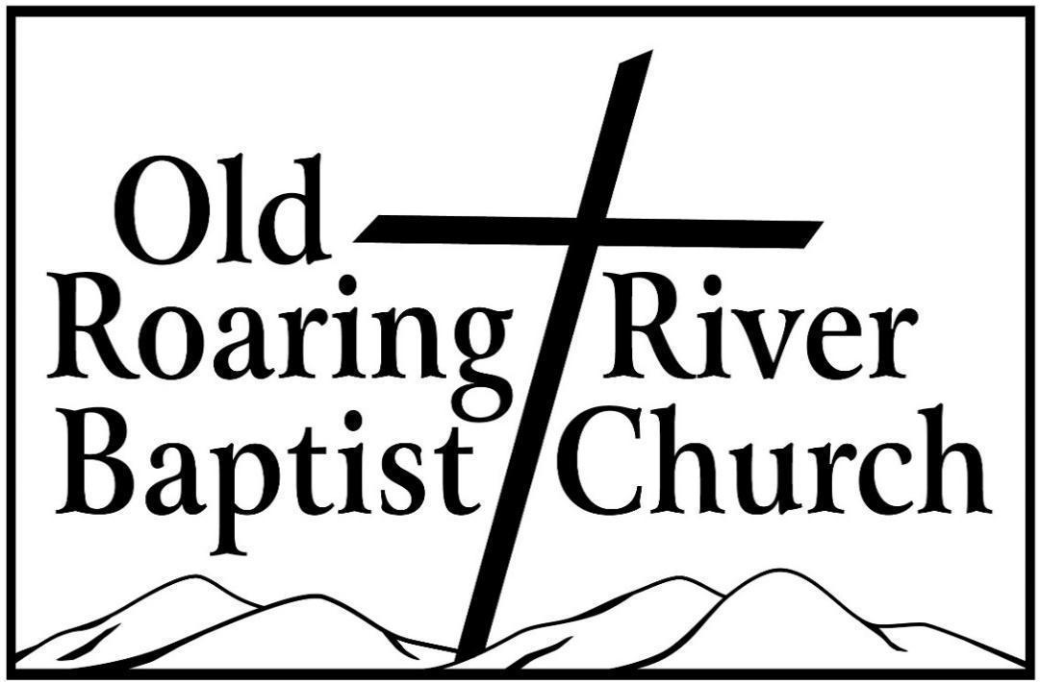

**13932 Longbottom Road**

**Traphill, NC 28685**

**Pastor James Pardue**

**August 3, 2025**

# Sunday School ……….………………………………………………. 10:00 AM

# Sunday Morning Worship ……….……….….…………………….… 11:00 AM

Choir Practice Wednesdays...……….…….….………………………... 7:00 PM

# Wednesday Night Prayer Meeting ……..…………………………...… 7:30 PM

Church Website ………………………………………………... orrbc.org

Old Roaring River Baptist Church Hour …………………..Sun, 5:30 PM

1560 AM WYZD Dobson, NC 95.3 FM WYZD Dobson, NC

1060 AM WCOK Sparta, NC 107.3 FM WCOK Sparta, NC

Parking Lot Service (All Services) ………….….…………....... 106.3 FM

