Old Roaring River Baptist Church

PO Box 126, Traphill, NC 28685

orrbc28685@gmail.com

Pastor James Pardue

Pastor’s Cell Phone: 336-428-7581
Church Phone: 336-957-4698

Welcome to God’s House!
Let us enter to worship and depart to serve!

July 19th, 2026

Welcome To All Our First Time Visitors!

Thank you for joining us today and being a part of our worship service. We are thrilled to
have you with us and pray that the Lord will bless you for coming this way today. - Pastor James & Congregation

Last Week’s Message………………………………… The Responsibilities of Men
Week’s Text ..…………………………………………………..… I Timothy 2 : 8

Congratulations to all the Birthday and Anniversary Individuals!!!

Birthdays: | Day | Date: | Anniversaries: | Day | Date:
Olive Thomas | Sat | July 4 | Clifton & Margie Hutchison | Wed | July 1
Marian King | Wed | July 8
Dennis McGrady | Thurs | July 9
Mike Hutchison | Thurs | July 16
Derek Hutchison | Mon | July 20
Kent Freeman | Tues | July 21
Angle Johnson | Fri | July 24
Jimmie Reavis | Fri | July 24
Tom Johnson | Tues | July 28
Josh Hutchison | Wed | July 29

Announcements

Wednesday night Choir Practice at 7:00 pm and Bible Study at 7:30 pm

Business Conference will be held on Wednesday, July 22, at 7:00 pm. Please note the special start time for this conference as we have some very important things to discuss with the church. Please make plans to attend.

The Bible tells us to pray without ceasing (I Thess 5:17) and that the effectual fervent prayer of a righteous man availeth much (James 5:16). Please keep one another, and the folks on our prayer list, in your constant prayers in your daily devotions.
Prayer Request List:

Upcoming Week:
Michelle Trivette – Mass Removal Surg Tues | UNSAVED
Mary Hutchinson – Congestive Heart Failure | Our Country (Leaders & Military)
Bob Johnson – Pancreatitis | Missionaries:
Oliver Edmonds – Eye Infection | Thru the Bible Radio – Worldwide
Heather Royal – Mass | GBI Radio, Inc.
Bennie Waugh – Cirrhosis of Liver | Gideons International
Jeri Trivette - Parkinsons | Larry Key – Crossing the Streets Min
 | David Harrelson – Rock of Ages Min
 | Obed Missal – India
 | Ebenezer Garden Children’s Home

Hospice:
Ruth Vaughn – Hospice

Illness Recovery:
Kolbey Foster - Ankle | Evelyn Sidden (Jerry’s) | Larry Swaim - Foot
Rebekah Loredo – Foot | Kenny Shatlye – Diabetes | Ed Trivette – Neuropathy
Robin McGrady – Infusions | Leora Sidden – Knee

Cancer List:
Edward Allen | Randy Crabb | Sharon Keys | Dalton Sheets
Cheryl Bork | Nathan Greer | Rev. Gene Koger | Wilma Shew
Billy Joe Bowers | Darlene Handy | Dr Steve Laws | Penny Thibeault
Kathy Brown | Linda Hutchison | Nancy Lyon | Michelle Trivette
Kathy Carpenter | Luke Jackson | Wade Mounce | Missy White
Ed Caudle | Bruce Jennings | Curtis Pruitt
Ann Chandler | Rex Johnson | Earl Rolland

Shut-Ins:
Alan Holbrook – Home | Evelyn Sidden – Parkwood
Martha Myers – Westwood Hills | Lillie Spicer – Home

Military:
Lucas Baker | Jerome Crouse | Colby Nelson
Jackson Bell | Samuel Lewczyk
Chad Billings | Cody McKinney

Notes:

----------------------------------------------------------------------------------------

----------------------------------------------------------------------------------------

----------------------------------------------------------------------------------------

----------------------------------------------------------------------------------------

----------------------------------------------------------------------------------------

----------------------------------------------------------------------------------------

----------------------------------------------------------------------------------------

----------------------------------------------------------------------------------------

----------------------------------------------------------------------------------------

----------------------------------------------------------------------------------------

----------------------------------------------------------------------------------------

----------------------------------------------------------------------------------------

----------------------------------------------------------------------------------------

----------------------------------------------------------------------------------------

----------------------------------------------------------------------------------------

----------------------------------------------------------------------------------------

----------------------------------------------------------------------------------------

----------------------------------------------------------------------------------------

Please note that all activities at Old Roaring River Baptist Church are under 24-hour surveillance on all premises of the grounds and building and is being recorded seven days per week for security purposes.

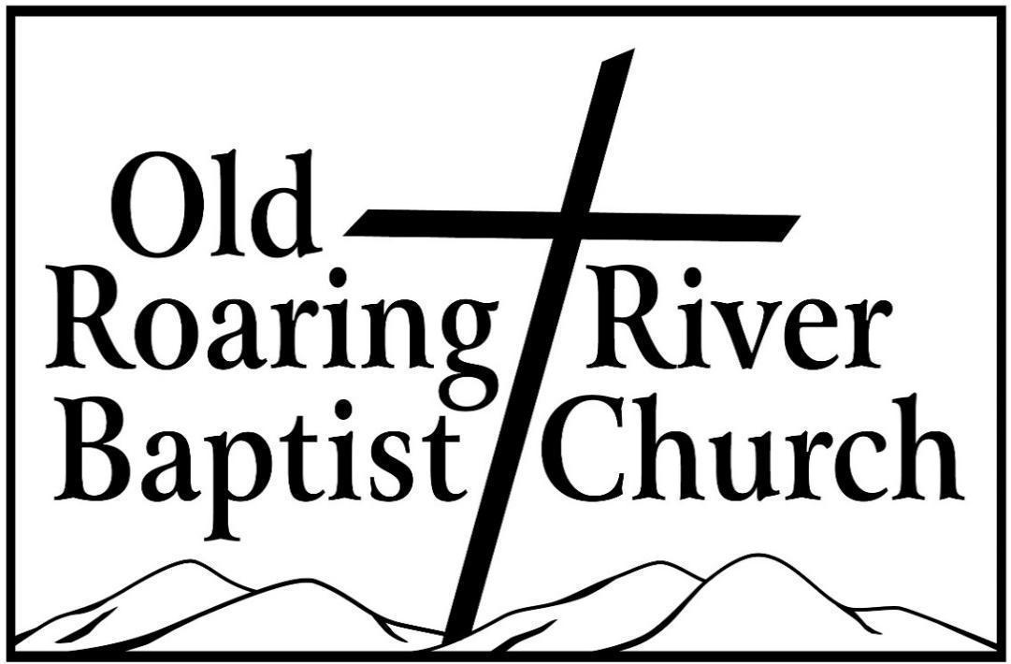

13932 Longbottom Road
Traphill, NC 28685
Pastor James Pardue

July 19th, 2026

Sunday School ……….………………………………………………. 10:00 AM

Sunday Morning Worship ……….……….….…………………….… 11:00 AM
Choir Practice Wednesdays...……….…….….………………………... 7:00 PM

Wednesday Night Prayer Meeting ……..…………………………...… 7:30 PM

Church Website ………………………………………………... orrbc.org
Old Roaring River Baptist Church Hour …………………..Sun, 5:30 PM

1560 AM WYZD Dobson, NC 95.3 FM WYZD Dobson, NC

1060 AM WCOK Sparta, NC 107.3 FM WCOK Sparta, NC

Parking Lot Service (All Services) ………….….…………....... 106.3 FM



