Year 3 Curriculum Newsletter Spring Term 2026: Mrs Lake (Smith Class) & Mrs Lenton (Adams Class)
English
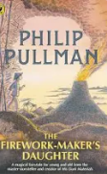

Reading
This term, the children will be reading non-fiction related to Ancient Egypt as well as The Firework Maker’s daughter by Philip Pullman. This is an adventure story set in Asia. Children will be challenged to engage in the text in a variety of ways, through drama, music, Shared Reading and discussion. When reading, the children will learn how to use hints and clues in the text to understand it. They will also learn to use what they have already read to predict what they think will happen next. They will learn to summarise the main points in the text and discuss the language used by the author. As always, understanding of vocabulary is essential.

Writing
We begin the term by reading and writing a Biography of Philip Pullman, the author of ‘A firework maker’s daughter’. We will write a list of instructions and write a Narrative with simple speech, setting and character descriptions. We will also write a letter from the perspective of the main character to her father. Through English learning, we will be learning about sentence punctuation, conjunctions, word types including prepositions, adverbials, direct speech and paragraphs. They will also use the vocabulary from reading to enhance their writing. To develop the children’s independent composition, we will also be working on the skills of editing and improving writing. Working individually and in pairs, children will try to assess how effective their writing is and make suggestions for how it could be improved.
Handwriting
Children are taught handwriting using the Debbie Hepplewhite handwriting programme. They will be practising handwriting daily, developing the use of patterns that form letters correctly. When children correctly write the letters in the six letter families, making sure they start and finish each letter in the right place, they will be taught how to join them together. When the children can write fluently, so that their work can be easily read by others, and so that the letters are consistent size and shape throughout the piece of writing, they will be awarded a pen licence.

Spelling
The children will be learning spelling through the use of Sounds Write (a phonics and spelling programme), building on their knowledge of phonics to help them spell increasingly difficult words. They will work on spelling words that have the same sound but different spellings. Some of the units focus on meanings of prefixes and suffixes which can be added to the beginning or end of a root word and change its meaning. Sometimes, the root word needs to change when prefixes and suffixes are added, and children will learn some of the rules for doing this. They will learn some homophones e.g. knight, night) as well as learn when to use the different spellings of each word (e.g. there, their, they’re). During lessons, children are encouraged to first use their knowledge of phonics to ‘sound out’ words.
Mathematics


During our maths sessions we will consolidate, extend and improve the children’s understanding of the
four rules of number. We will also apply these skills through other areas of Maths. We begin with understanding multiplication and division. The children will learn to solve problems and to multiply and divide two digits by one digit numbers. Following on from this, we will learn about and calculate in the areas of money, statistics and length and perimeter. Much will be enquiry based, solving real life problems. The children will continue to do work that involves fluency as well as reasoning and mastery. They will continue to also work on rapid recall of times tables and related division facts.

Science:
In the first half term, children learn about light. They will learn to recognise that they need light in order to see things and that dark is the absence of light. They will learn to notice that light is reflected from surfaces. They will also recognise that light from the sun is dangerous and that there are ways to protect their eyes. They will learn that shadows are formed when the light from a light source is blocked by an opaque object.

In the second half, we will learn about plants, including flowering plants, requirements for life and growth, water transportation in plants, pollination and seed dispersal.
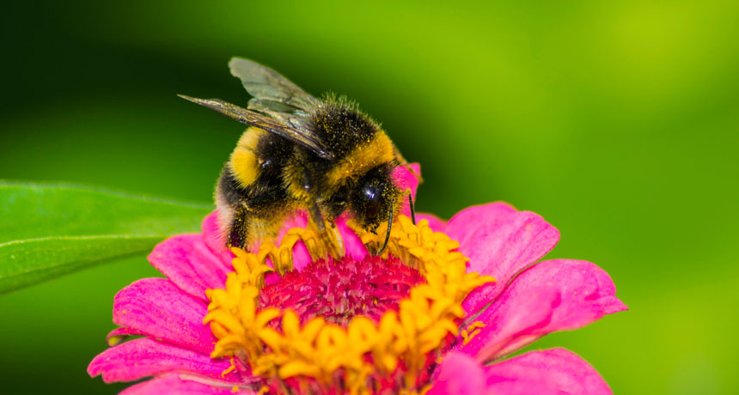
Working scientifically
- Plan an enquiry
- Predict the likely outcome with reasoning
- Take and record measurements and observations using appropriate apparatus
- Draw conclusions using the results
- Consider what they would like to discover next

Religious Education:
In the first Half Term, the children will be learning about non- religious Worldviews.

The key enquiry question will be: What is a Good Life? (non-religious Worldviews)

In the Second Half Term the children will learn about Christian Worldviews.
The key enquiry question will be: What is a Good Life? (Christian Worldviews)

The children will learn to:
- In this and the previous unit, pupils will apply their understanding of the concept of duty to the ways in which religious and non-religious people try to live a good life. Drawing on questions and methods from the human / social sciences, theology and philosophy, pupils will explore the life of St Francis of Assisi.
Art and Design : Art of Ancient Egypt ; Anglo Saxon Art
The children will look at Ancient Egyptian art such as paintings inside tombs and pyramids, sculptures and architecture. They will use lines to draw their own art from Ancient Egypt, including lots of detail, as well as make a sphinx out of clay. In doing so, the children will learn about the Ancient Egyptian gods and the power of the pharaohs. We will then learn to develop our techniques, including control and use of materials, with creativity, experimentation and an increasing awareness of different kinds of art, craft and design including looking at master pieces in metal, focusing particularly on Sutton Hoo, and studying The Bayeux Tapestry.
Design and Technology:
The children will research and investigate, design, use and evaluate a pop up book which includes linkage mechanisms for a child of their own age. The technical knowledge that they will learn is to apply their understanding of how to strengthen, stiffen and reinforce more complex structures and to understand and use mechanical systems in their products such as levers and linkages. Whilst making, they will cut, shape, join and finish their product,

Computing:
In the Spring Term, the children will learn about programming through the use of Code.org. The children will also take part in offline activities to learn about how programs work with the use of algorithms. On Code.org, the children will learn to write algorithms and debug.
The children will also learn how to use word as a tool for writing. They will learn different skills such as use of the shift key for Capital Letters, how to copy, paste and delete, use different font sizes, colours and text effects.( underline, bold etc) and how to insert images.

Geography:
Spatial Sense
This unit looks at compass directions and introduces the eight-point compass. The children will use the eight-point compass to describe their local area and will look at ordnance survey maps and the symbols they use. They will look for symbols representing places in their local area that they are
familiar with. Simple grid references will be introduced, and the children will learn how to locate places on a map using a letter and number grid reference. The skills of identifying direction, interpreting symbols and locating grid references will be applied in a number of contexts in the geography curriculum. Following a focus on geography skills, children will then study a region in a non-European country and contrast with their local area. When studying San Francisco, the children will look at both human and physical geographical features of the region. They will learn why the region is known for its fog and why cable cars are used to travel up and down the steep hills of the city.

After half term, the children will learn about human geography, including: types of settlement and land use, economic activity including trade links, and the distribution of natural resources including energy, food, minerals and water.

History:
After completing learning about Prehistoric Britain, comparing Stone Age, Bronze Age and Iron Age, using our Golden Threads of Homes and Settlements and Communication, the children will learn about the Anglo Saxons, Scots and the Vikings. We will then learn about Anglo Saxon England, the Scots and the Picts, who the Vikings were and where they came from as well as learning about Alfred the Great, Edward the Confessor and the Norman Invasion.
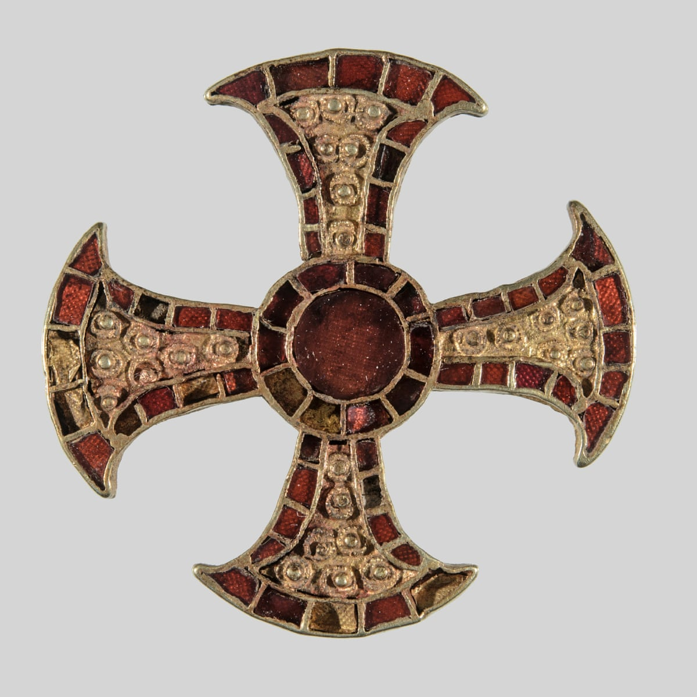

Languages:
The children will learn about the Spanish languages through games, role play, stories and songs.
Music:
This term, the children will be listening to ‘Winter’ by Vivaldi and ‘California dreaming’ by The Mama’s and the Papa’s. After exploring, investigating and practising, they will create pieces in small groups using motifs, which set words to rhythms. They will use untuned percussion in their compositions. They will then have an opportunity to perform their compositions and evaluate them.
The children will also listen to ‘Storm’ by Benjamin Britten, in a unit of work called ‘Sounds of the sea’. As a class, they will create and perform a piece inspired by ‘Storm’, using untuned/tuned percussion, body percussion and voice in rondo form, using changes in tempo and dynamics. The children will learn that Britten creates a calm mood in his piece Dawn by using a sustained tune.
Physical Education:
This term, the children will develop skills and fitness with Mr Hayes and Mr Makaka through circuit training and multi-sports.
Homework tasks:
The children will need to read at least five times a week for 20 minutes at a time and record comments in their Reading Records. By the end of year 3, the children are expected to be able to recall the times tables and related division facts for the 2, 3, 4, 5, 8 and 10 times tables, so there will times tables practise three times a week in class. The results of these will be sent home so that the children can practise them. The children will be given Maths, Spelling and Reading homework, which will enable them to practise skills they have been developing in class. All homework should be handed in on a Wednesday.

