Year 4 & 5 Curriculum: Mrs Hamilton (Newton), Mr Hammersley (Hawking)

and Mrs Milne (Sharman Class)

English
Reading
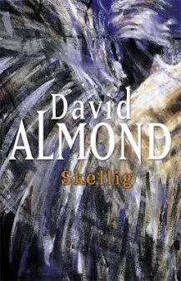
The children will be reading ‘Skellig’ by David Almond. Each week we will read sections of the text and develop the children’s comprehension skills. They will identify what characters might be thinking and feeling at different points in the story. To be able to do this they will need to use examples of what the characters have said and done as evidence to justify their ideas. Children will also be asked to predict what might happen in the next chapter or later in the book. Again, they will need to base their ideas on things that have already happened, some of these things may not have been written and they may only be hinted at. Children need to be able to find these hints and clues.
Writing
The children will learn how to write a narrative based on their previous analysis of ‘Skellig.’ When writing the narrative, the children will think about how to develop the characters and settings, good quality stories have a balance between the amount of talking, action and description. While writing their narrative, the children will need to keep reading and checking their work to make sure that their story is also balanced, without too much action or talking. Working individually and in pairs children will try to assess how effective their writing is and make suggestions for how it could be improved. They will also need to check their work for spelling and punctuation errors.
Grammar, punctuation and spelling rules will be taught separately to each year group. Children will be expected to apply this learning in their writing.
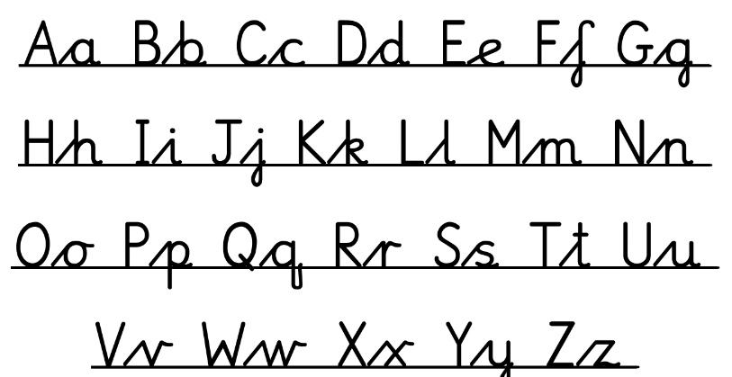
Handwriting
Children are taught handwriting using Debbie Hepplewhite materials. The diagonal line joins soften as the writer becomes increasingly fluent. The style is taught as separate letters at first and all the letters with their diagonal lead-in joins are taught to proficiency and automaticity before starting to join the letters into words.
Good handwriting is an essential skill and children must use joined handwriting to meet the Expected Standard at the end of year 6.

Spelling
This term, the children will be continuing to learn spelling through the spelling programme ‘Sounds Write.’ The children will build on their knowledge of phonics to help them spell increasingly difficult words. Each week we will focus on alternative ways of spelling different phonemes, whilst looking at the meaning of different prefixes and suffixes which can be added to the beginning or end of a root word and change its meaning.

Mathematics
In maths the children will be taught in separate year groups by their class teacher.
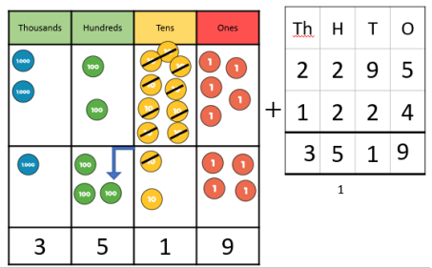
All of the children will be learning about numbers, the number system and place value. Then we will move onto the 4 operations - addition, subtraction, multiplication and division. In the second half term the children in year 4 will spend much of the time learning the multiples of 3, 6, 9, 7, 11 and 12 so that they should know all of the times table and division facts up to 12x12 by Christmas. The children in year 4 will also learn about area towards the end of the term, while the children in year 5 will move onto fractions.
Mrs Milne will also teach additional maths lessons to each year group on Mon and Tues afternoons. In these lessons the children will revisit learning from previous units, topics and terms to see what they have remembered and what needs to be retaught. The children will also be accessing personalised learning on Complete Maths. After completing a diagnostic assessment the programme identifies what each child needs to learn, based on the questions they were not able to answer correctly. This session will also include arithmetic skills.
For maths homework the children will continue to complete units on Complete Maths and there may also be some additional arithmetic sheets to practice the learning from the afternoon sessions.
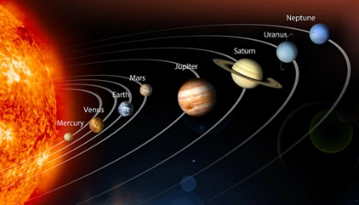
Science

In In the first half term the children will be learning about Astronomy. They will learn that the word astronomy comes from the Greek word astron meaning ‘star.’ Therefore, astronomy is the science that studies the laws of the stars and everything in universe beyond the Earth’s atmosphere. The substantive concepts of this unit are motion, force, energy, matter, and space. In this unit, the children will learn about the evolution of the universe, gravity, the solar system, lunar phases and about galaxies.

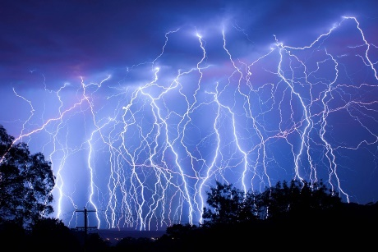
In the second half term the children will be learning about Meteorology:
In this unit, children will deepen their understanding of meteorology: the study of the weather. Building on the children’s existing schemas, the substantive concepts of this unit will focus on weather, climate, atmosphere and forecast. The disciplinary knowledge gained in this unit allows the children to think more like meteorologists, using data and diagrams to deduce and draw logical conclusions.

Working scientifically
Children will have lots of opportunities to plan their own investigations, particularly when learning about forces. In order to be able to answer scientific questions they will need to plan investigations which are fair, where some factors stay the same and only a limited number of factors are changed. They will use different equipment to take measurements and learn that measurements need to be repeated sometimes to know that they are accurate and reliable. Children will record the results of investigations in a variety of ways, for example tables, Venn diagrams, bar, and line graphs. Using the results, the children will be able to answer their initial question, draw conclusions and think about what they might investigate next.
Religious Education
This year we will be using a new curriculum for RE which has been written by the Lincoln Diocese.
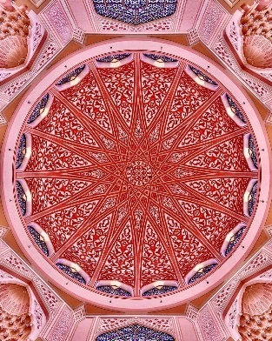
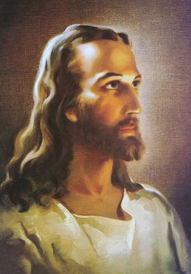
In the first half term we will be asking if creativity matters and focusing on music. Religious worldviews have stories and texts that talk about the origins of the universe; these are often called creation stories. We will be learning some of the different creation stories as part of this unit. The children will be learning that human beings are able to express their beliefs, values, ways of living and thoughts through creativity. Some religious people express themselves through music. Some religious people feel that music can be a distraction from worshipping God. We will be exploring creativity and creation in Christianity, Islam, Judaism and Sikhism before considering if creativity matters in religious worldviews.

In the second half term we will be continuing to think about creativity but focusing on art this time. The children will explore diverse ways in which religious people express their beliefs and values through art. They will learn that some religious people believe that God and important people in their worldviews should not be depicted visually. They will also consider philosophical questions about how humans communicate abstract, conceptual ideas, such as God, hope and truth.
Art and Design
Style in Art
This unit considers style in art by first considering how artists can use different techniques to alter their style. Children start by comparing different styles of brushwork demonstrated by Stubbs in Whistlejacket and by Munch in The Scream of Nature. They draw pears using contrasting techniques, creating visible marks in oil pastels in the manner of Van Gogh and smooth modelling using soft pastels in the manner of Stubbs. They go on to compare two radically different styles, Rococo and Modernism, analysing the differences they see in painting and chair design. This leads to a more detailed analysis of modernism, looking at abstract art of the 20th century and using their developing knowledge of colour theory to design and create their own abstract work using acrylic on canvas.
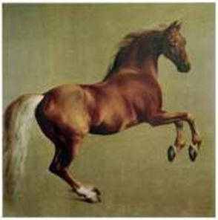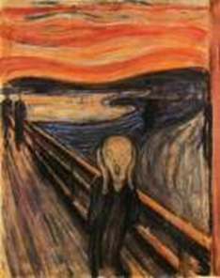

Islamic Art and Architecture
Children come to this unit with historical knowledge of the ‘Golden Age of Islam’ studied in history in Autumn A. They are first introduced to art from the Islamic world by first studying the Dome of the Rock in Jerusalem. In it they identify examples of Islamic style, including calligraphy, geometric and vegetal patterns made from tilework and mosaics. Then go on to consider these features in The Alhambra and the Taj Mahal, in particular noting the ornate plasterwork in the Nasrid Palaces at The Alhambra. Study of symmetrical designs, vegetal patterns and mosaics refers back to the influence of Byzantine art. The children use the Dome of the Rock, The Alhambra, the Taj Mahal and Hagia Sofia to identify different common features of Islamic architecture, including domes, minarets, arches and muqarnas. During the course of the unit the children create two works of art in Islamic style. At first, they use rulers and compasses to create repeating geometric designs which they decorate with brightly coloured inks. They then take their design and transfer it onto a clay tile, developing their skills in three-dimensional modelling.

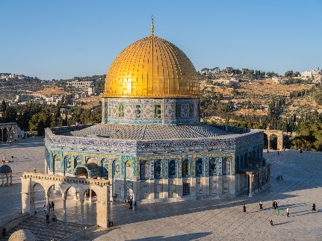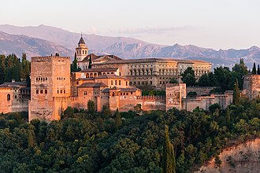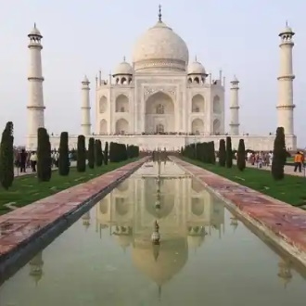

Computing
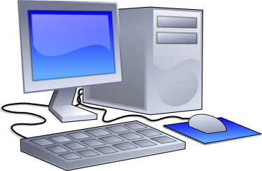
In the autumn term the children will focus on being safe online and consider how they use technology.
Media balance and well being – what makes a healthy media choice? Learn the "What? When? How Much?” framework for describing their media choices. Children will use this framework and their emotional responses to evaluate how healthy different types of media choices are. Begin to develop their own definition of a healthy media balance.
Private and personal information - Explain the difference between private and personal information. Explain why it is risky to share private information online. Identify the reasons why people share information about themselves online.
Digital footprint – Define the term "digital footprint" and identify the online activities that contribute to it. Identify ways they are -- and are not -- in control of their digital footprint. Understand what responsibilities they have for the digital footprints of themselves and others.
Relationships and communication - Define "social interaction" and give an example. Describe the positives and negatives of social interaction in online games. Create an online video game cover that includes guidelines for positive social interaction.
Cyberbullying - Reflect on the characteristics that make someone an upstanding digital citizen. Recognize what cyberbullying is. Show ways to be an upstander by creating a digital citizenship superhero comic strip.
A creators rights and responsibilities - Define "copyright" and explain how it applies to creative work. Describe their rights and responsibilities as creators. Apply copyright principles to real-life scenarios.

Design and Technology
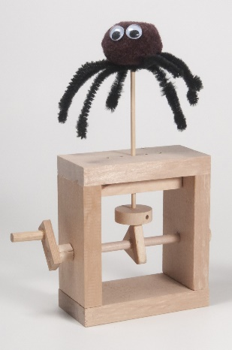
Building a cam toy.
The children will start by investigating how a cam mechanism works, what function it performs (looking at everyday examples), the different component parts within the mechanism and their function, and the structure within which a cam toys will sit and how this is made so that it is strong and stable. By this process of investigation they are undertaking the first stage of the design process: researching and investigating the product they will produce. They also learn about the use of cams by Ismail al-Jazari in 13th century which expressly builds on the students knowledge of the history of Baghdad and the Islamic Golden Age from their History unit. The children start by learning about how differently shaped cams effect the linear movement of the follower. They go on to use this information when they explicitly learn about the process of design, developing their own design criteria, considering the user, purpose/function and aesthetic appeal of their product. The children will select appropriate materials to build their cam toy in pairs. They will then evaluate their toy referring back to their design criteria.

Geography
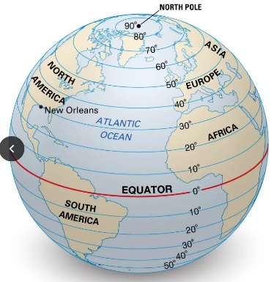
The Spatial Sense unit builds on children’s understanding of globes and maps. Latitude and longitude are taught to enable children to gain an understanding of how cartographers divide the world into segments to allow identification of locations using co-ordinates. Children will become familiar with the Prime Meridian line and will use co-ordinates to identify locations around the world. Children will also build on their knowledge of the Northern and Southern Hemispheres, from previous units, and will look at the Eastern and Western Hemispheres. Moving on with their understanding of maps from Year 4, children will look at scale again, and will use map scale to calculate distance between locations. Children will learn that relief maps show the height of land and will find out how on large scale maps, contours can be used to show land height. Children will draw a contour map for a locally relevant area of elevation.

Mountains
The children will be briefly looking at plate tectonics theory, touching on the reasons why mountains form. The detail of these processes will be taught in KS3. Children will also learn that a mountain range is a group of connected mountains and will study the Alps, The Himalayas, The Rockies and The Andes. Mount Kilimanjaro will also be studied as an example of a dormant volcano.

PSHE
Citizenship - Rights, rules and responsibilities
Children will begin to think about how the skills they are developing now might be used in later life, for example in the workplace. They will consider their hopes for the future and think about what steps they can take now to begin to build towards these. They will learn to reflect on the process of learning a new skill and think about what might help or hinder them when facing challenges. Through discussion and practice, children will develop their communication skills, such as listening, debating, explaining their views and acknowledging the views of others. Various influences on children’s decision making will be considered, including the media. They will also work on developing particular group work skills such as decision
making and chairing. They will further their understanding of how their own and others’ strengths and skills can complement each other as they work together. Children will learn to persevere at a task, developing resilience when faced with a range of problems, as well as how they might encourage others to persevere. They will evaluate their own and others’ work and give and receive positive and constructive feedback sensitively.
Myself and my relationships – My emotions
This unit will help develop children’s understanding and recognition of their own emotions and those of others, including how we might express and respond to those feelings.The children will identify an increasing range of feelings, including moods and mixed emotions, developing their language to describe them and learning how they might recognise them in themselves and others. They will consider what prompts different feelings in themselves and others and how they might avoid, or deal with, situations which make them upset, angry or become overwhelmed. They will explore ways to deal with different emotions, with a focus on worry, boredom and stress and how those emotions affect how we think, feel and behave. This includes how we might react to strong or overwhelming emotions, in ourselves and others, and ways to manage them.
Myself and my relationship – Antibullying
This unit will develop children’s understanding of the key characteristics of bullying and enable them to develop, explore and apply definitions of bullying to a range of situations including ‘cyberbullying’. They will learn about the differences in the way that girls and boys bully and will explore reasons why bullying happens, developing their understanding of prejudice driven bullying. They will begin to explore the negative role that stereotyping plays in prejudice driven bullying.

History
Baghdad
In the first half term the children look at the location of Baghdad as a crossing point for traders and also its proximity to the river Tigris. Children can use their prior knowledge of what factors lead to settlements developing in particular locations to understand why Caliph Al-Mansur built Baghdad. Their understanding of Rivers will help them to recognise the importance of the river Tigris. Children finish the unit with a powerful mental image of the waters of the river Tigris running black from the ink washed from books seized by the Mongols from the House of Wisdom.
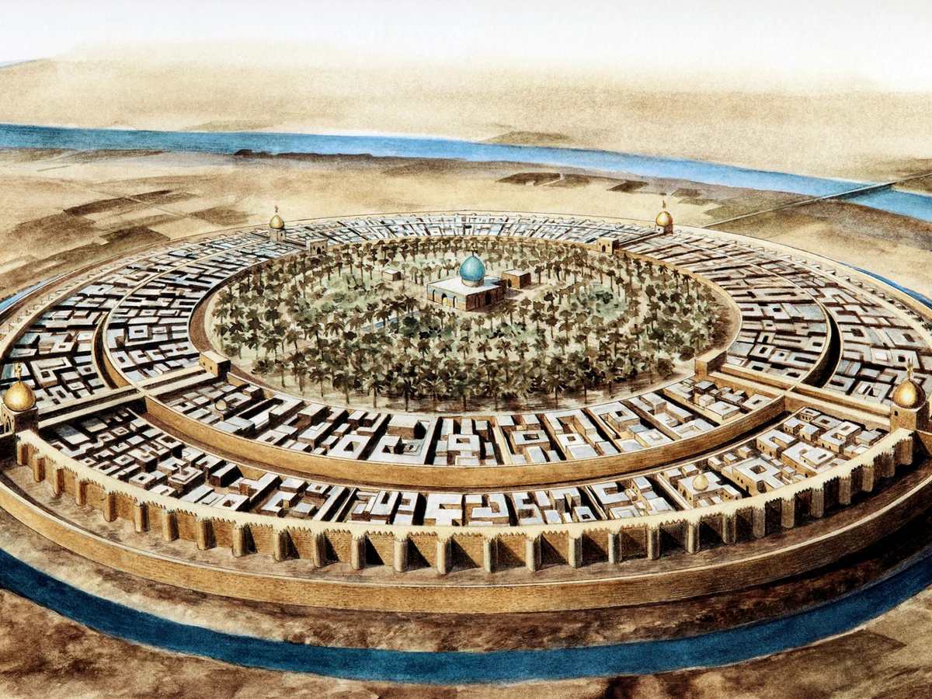

The Birth of the British Empire
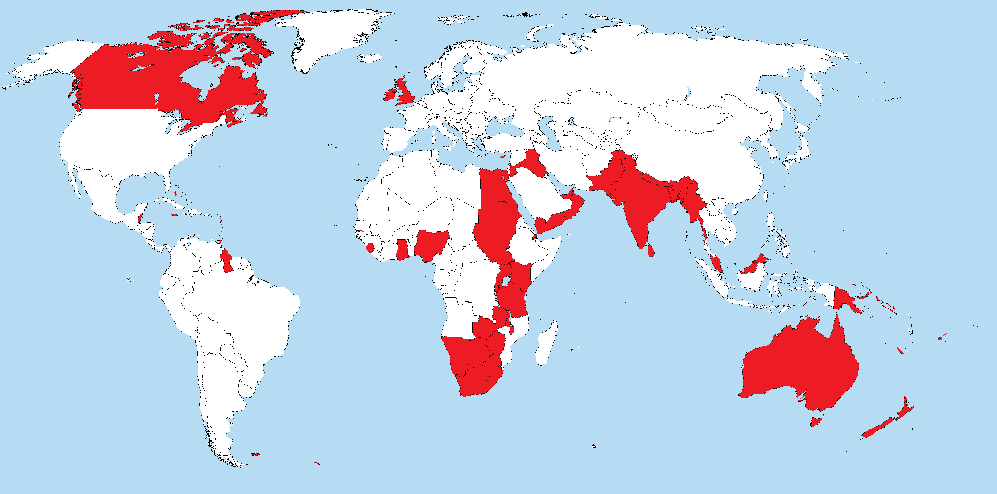
This unit will look at the role that the Empire played in global trade and how wealthy British people were able to benefit from this. The important concept of trade is studied across the curriculum, from trade in prehistoric Britain to global trade today. The children will look at where specific goods such as tea and chocolate came from and discuss how global trade allowed people to have access to things that they would not usually have. Children will learn about how Britain competed with, and sometimes even stole from, other nations to profit from these goods.
Physical Education

Pupils will learn to communicate, collaborate and compete with each other through a variety of physical activities and sports and learn how to evaluate and recognise their own success. Mr Hayes and Mrs Bisley will be teaching the children tag rugby and netball in the autumn term. In PE lessons children will be encouraged to compare their performances with previous ones and demonstrate improvement to achieve their personal best.
Children will have PE lessons on Tuesdays. Children will need to come to school wearing their PE kit - black or green shorts and a plain white T shirt. As the weather gets colder they will also need a black or plain dark tracksuit and shoes suitable for outdoor games.

Music
The children will analyse the piece, ‘The Lark Ascending’ by Vaughan Williams in order to identify the use of a pentatonic, free-flowing, legato, slow melody played by a solo violin over orchestral accompaniment to conjure up the flight of a lark in our imagination. They will utilize this learning when using a pentatonic scale to improvise over a drone to replicate the flight of a bird. Following this, they will formalise their improvisation into a composition in ternary form working in pairs to replicate the flight of a bird and a bee. They will then record these compositions in a graphic score and perform these to the rest of the class.

