Year 6 Autumn Curriculum: Mrs Tew (Derby Class) & Mr Stocking (Riley Class)
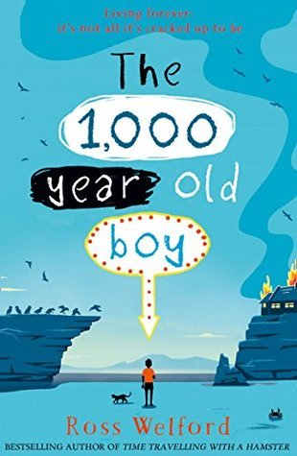
English
Reading
We will be studying 1000 year Old Boy by Ross Welford. The book will influence and inspire most of the writing we do in English. We will also be reading non-fiction related to the topics in other subjects, as well as looking at poetry written during and about the First World War. At the end of every day we will set aside time to read to pupils and this half term, we will be reading Private Peaceful. The children will increase their knowledge and understanding of new words and increase their reading fluency, both of which will help their comprehension and to be more confident in their use of higher order reading skills.
Writing
The children will begin by revising their existing learning on simple, compound and complex sentences. We will re-visit nouns, verbs and adjectives and go over phrases and clauses. These are the building blocks of good writers and will ensure that children have a firm foundation on which to further extend their knowledge. Pupils will learn to express themselves in a much more fluent and effective way. The first text type the children will study and practise will be a biography. They will look at how to make this writing effective and organised. In the second, third and fourth weeks of term, the children will learn about narrative writing, using the 1000 Year Old Boy to influence their work. Our attention will then turn to writing non-fiction as they prepare to produce a non-chronological report about the knowledge they have gained in History, learning about the First World War. After half term we will learn how to write a balanced argument. We will also learn how to write dialogue and explanation texts.
Handwriting
Handwriting and presentation remains a focus and will be taught explicitly. The children will have regular practice, with children who maintain a consistent joined style will be awarded a pen license. All children who need it will have support in order to improve their letter formation and joined handwriting.
Spelling
As well as learning how to spell common words appropriate for Year 6, the children will look at a variety of polysyllabic words, sometimes breaking them up into syllables, and using their knowledge of sounds and spelling rules in order to spell them accurately.

Mathematics
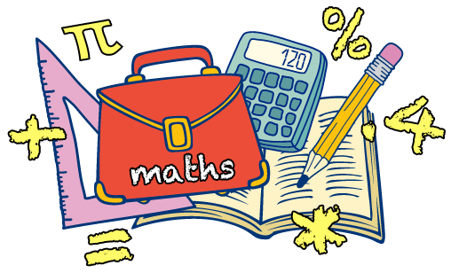
This term the focus in maths will be ensuring that all children are confident to read, write, order and compare numbers up to
10 000 000 and know the value of each digit within the number. Children should also be able to round any whole number to a required degree of accuracy, for example to the nearest 100, 1000 and 10,000. We will ensure that all children can add, subtract, multiply and divide a variety of numbers using a formal written method. If they get a remainder when dividing a number, children will be able to write it as a fraction or decimal and know whether or not the number should be rounded to the nearest whole number.
Children will spend most of the second half term learning about fractions. They will be taught how to use knowledge of common factors to simplify fractions and how to use common multiples to express pairs or groups fractions in the same denomination. They will then move on to comparing and ordering fractions, and adding and subtracting fractions with different denominators and mixed numbers. Children will also be taught how to multiply and divide fractions by whole numbers and fractions, converting answers to their simplest form.
If they are secure in their fraction knowledge we will move on to position and direction. The children will extend their knowledge of the first quadrant, to reading and plotting coordinates in all 4 quadrants. They will plot individual points, join points to draw lines and then shapes. Children will learn how to calculate the length of a line or the side of a shape, by using the coordinates of its two endpoints. When children can draw shapes accurately they will be taught how to translate them to a new position and use positional language to describe what they have done. They will also be taught how to reflect shapes in the x and y axes.

Science
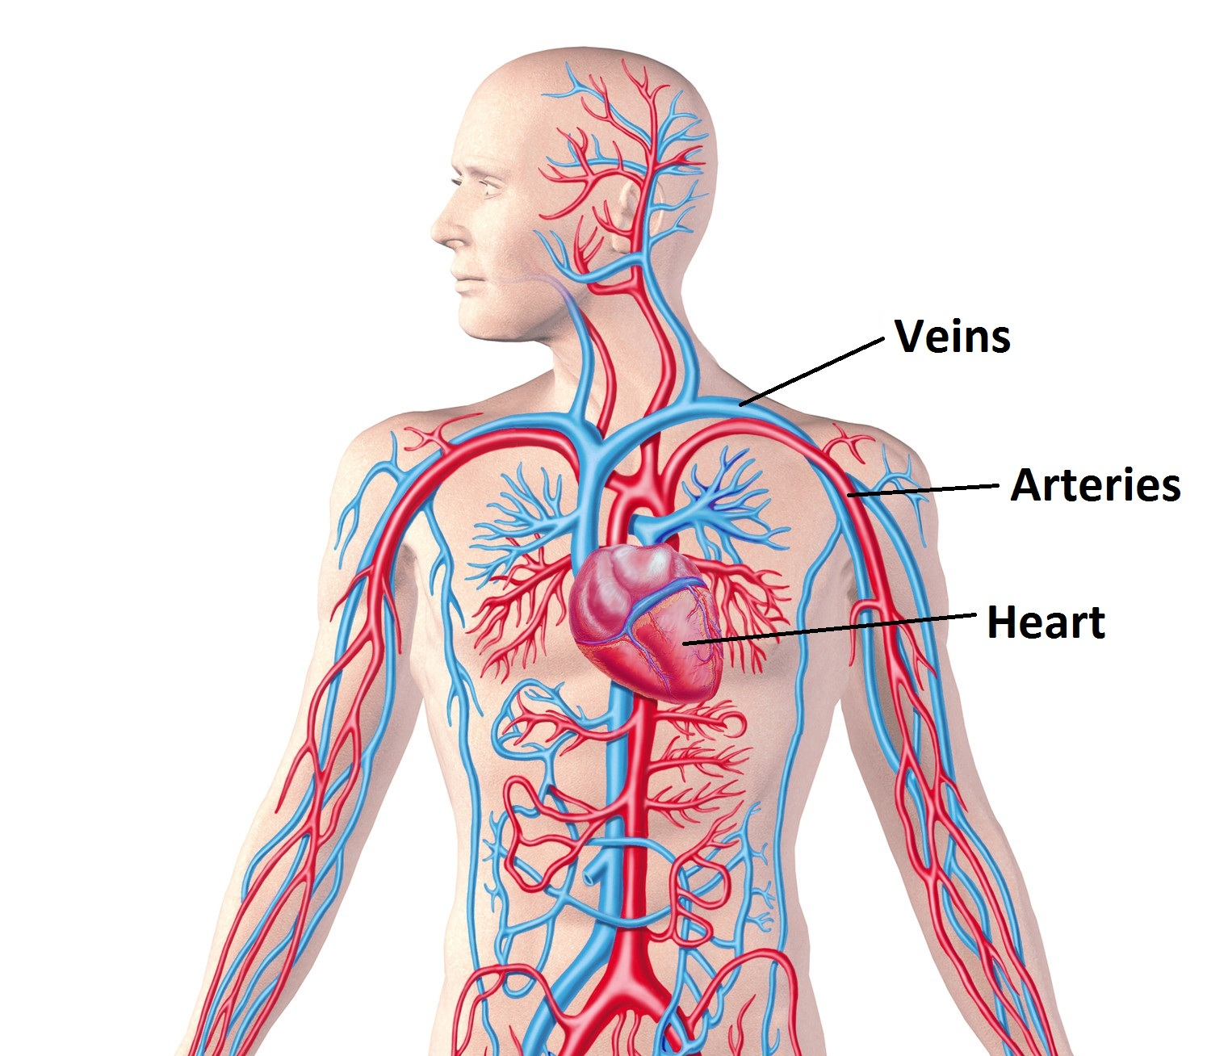
In the first half term the children will learn about animals including humans. They will be
able to identify and name the main parts of the human circulatory system, and describe
the functions of the heart, blood vessels and blood. They will be able to recognise and
describe the impact of diet, exercise, drugs and lifestyle on the way their bodies function.

After half term the children will begin learning about electricity. They will associate the
brightness of a lamp or the volume of a buzzer with the number and voltage of cells used in the circuit. They will be able to compare and give reasons for variations in how components function, including the brightness of bulbs, the loudness of buzzers and the on/off position of switches. Finally they will be taught the recognised symbols for representing a simple circuit and they will draw circuit diagrams.

Religious Education
Building on learning from KS1 and lower KS2, pupils explore in greater depth key Christians teachings and texts relating to what it means to be human. They apply this to the lived example of Anne Askew, a 16th century Protestant Christian who was eventually executed for her beliefs.

When covering this unit, the children will learn that:
- The Protestant Reformation happened across Europe in the sixteenth century
- Many people in England were either Protestant or Catholic Christians in the sixteenth century
- The Church of England was founded during this time by King Henry VIII
- Anne Askew was a Protestant Christian
- Many Protestant Christians questioned the teachings and traditions of the Catholic Church
- Some Protestant Christians were tortured and executed at this time for questioning Catholic
- teachings, including Anne Askew
- It was not easy being female in Christian society; many women experienced sexism

Building on learning from the previous term, pupils explore the experience of women in the
contemporary Anglican church to consider whether Christian worldviews always stay the same.
They use this learning and philosophical skills to answer the question, 'should a worldview always
stay the same?'

When covering this unit, the children will learn that:
- There are different denominations of Christian worldviews
- The experience of Christian women can be different depending on context
- Women were first ordained as priests in the Church of England in 1994 and as bishops in 2015
- Not all Church of England Christians believe that women should be priests or bishops
- Some Christian women today experience sexism
Art and Design
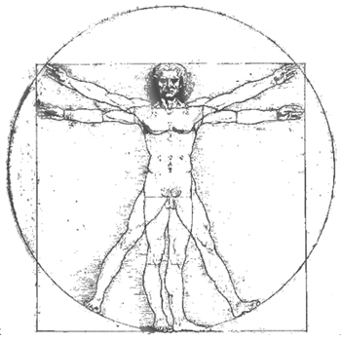

In the first half term the children are introduced to the art of the Italian renaissance by looking at The School of Athens by Raphael and Vitruvian Man by Leonardo da Vinci. They then investigate some of the work of Leonardo, looking in particular at his anatomical drawings and his painting technique used in the Mona Lisa and The Last Supper. They contrast the work of Leonardo with the paintings on the ceiling of the Sistine Chapel by Michelangelo.
Later in the unit they explore the concept of realism in the renaissance, looking again at the Mona Lisa and at the Arnolfini Portrait by Jan Van Eyck. They finish the unit by linking realism to the discovery of linear perspective. Children practise their drawing skills producing detailed observational drawings of their own hands and landscapes (using linear perspective).

In the second half term the children continue to study aspects of the renaissance, this time focusing on the architecture and the architect Brunelleschi who designed the dome of Florence cathedral. The children make detailed drawings of this famous building. They then study works of renaissance sculpture by Ghiberti and Donatello. Through these works they explore the concept of relief sculpture. The second half of the unit focusses on the work of Michelangelo. In the previous unit the children studied his painting, here they discover that primarily he considered himself to be a sculptor and explore his famous carvings the Pietà and David. They learn that he also worked as an architect and was partly responsible for the design for St Peter’s Basilica in Rome

Computing

In the autumn term the children will focus on being safe online and consider how they use technology. They will be asking questions like what does media balance mean for me? What is clickbait and how can I avoid it? How do gender stereotypes shape our experiences online? How do I keep online friendships safe? What is cyberbullying and what can I do to stop it?
What are the important parts of an online news article? They will consolidate all of their learning by creating an e safety poster or quiz.

Design and Technology
This term the children will be completing the ‘cook it’ part of our new DT curriculum. As part of this unit the children will be preparing scones and other delicious goodies to be shared with family members at our Harvest tea. Details about this will be sent out in a separate letter nearer the time.
Geography
In the Spatial Sense topic in the first half term the children will look at the lines that cartographers use to divide the world into sections in order to locate places accurately. They will study lines of longitude and latitude and the points at which they intersect; co-ordinates. Studying these lines will help children to understand that from our knowledge of the location of places, we can make educated guesses about the climate. Children will look at the Arctic and Antarctic Circles and will learn more about the climate in these regions. They will look at diagrams to explain why there are points in the year where the sun does not set, and other points where the sun does not rise. Building on knowledge of longitude, children will look at time zones and how they differ around the world. They will identify the Prime Meridian line and will learn it is a reference point for measuring time. Deepening knowledge of cartography and how maps are made, children will learn about map projection and how our round earth is represented on a flat piece of paper. They will understand that there are different approaches to map projection, each creating a slightly different end result.
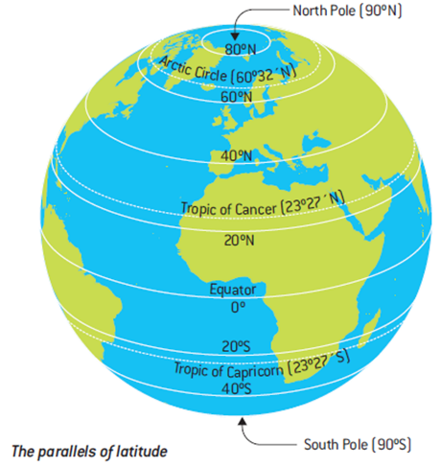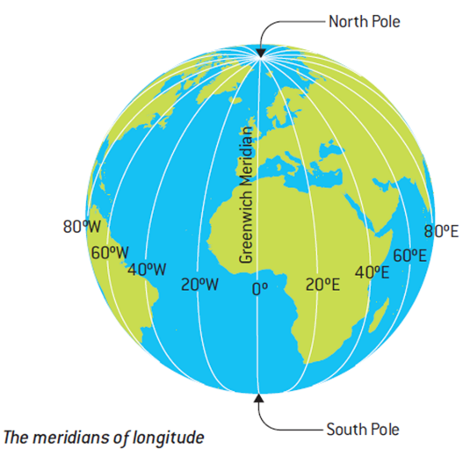
In the second half term the children explore some of the geographical issues facing us in Great Britain, including air pollution, flooding, waste and litter. They will use geographical data to look at regions of the UK affected by these issues. Children will learn that government departments such as DEFRA (Department for Food and Rural Affairs) use data on these issues to make policy decisions that can impact upon people and the local environment. To show their understanding, children can investigate how one of the issues studied impacts upon their local area, or they can complete a more general task explaining the environmental challenges we face in Britain.
PSHE
In the first half term we will be talking about rights, rules and responsibilities. The children will learn some of the basic rights of children and adults and consider why we have rules and laws. They will learn how a democracy works and about the role of
MPs and councillors.
We will also spend time thinking about our emotions. Children will be asked to judge if their feelings are appropriate and proportionate in different situations. We will also discuss how we might identify or recognize how someone else feels based on a variety of indicators such as facial expression, body language and voice tone, and consider how to respond. We will discuss what loneliness is and how feelings isolation might be managed. We will also introduce the children to mental ill health and some self-care techniques which they can use to help themselves.
Anti-bullying week will be in the second half term so the children will be considering responses to questions like: How does prejudice sometimes lead people to bully others? Can I respond to bullying assertively? (Both on and offline) How might bullying affect someone’s mental well being and behaviour? How and why might peers become colluders or supporters in bullying situations? What are my responsibilities for my own and others’ mental and physical wellbeing? What are some ways of reporting concerns and why is it important to persist? Can I identify, flag and report inappropriate content?
History
In the first half term the World War 1 unit focuses on developing two concepts: Empire and War. The children will begin this unit looking at the causes that led to the war. They will be able to use their existing knowledge of the British Empire to understand how the desire to create vast empires, and the growing conflict, distrust and dislike among European powers meant that the assassination of one person - Archduke Franz Ferdinand- was enough to spark a world war that took the lives of millions of people. The children will be able to apply their knowledge of previous wars to look at the similarities and differences between wars fought in the past and World War I. Children will have access to oral history to learn about life on the Western Front. This includes accounts from British soldiers as well as an Indian solider, recruited from the empire to fight for Britain. In contrast, the children will learn about the lives of those on the Home Front and the important role that women, and even children, played in supporting the war effort.
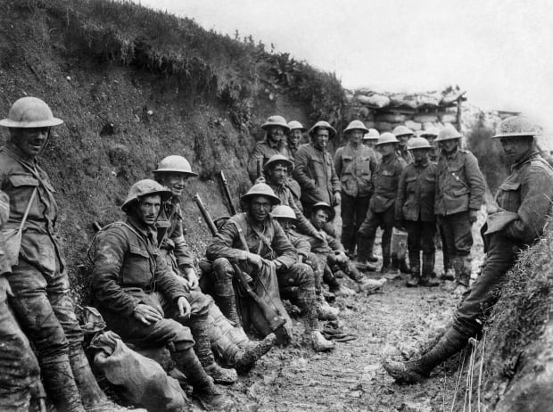

After half term the unit focuses on the concepts of feminism, suffrage, equality, and democracy and the children learn about the Suffragettes. This unit begins by looking at democracy in Britain up until the 19th century. Although Britain no longer had an absolute monarch, Parliament did not reflect the views of all people, or even a large majority of the population, as only the wealthy could vote. The children will learn about how and why the vote was extended to include more men, and how there were some people who believed that some women should also have the right to vote on the same terms as men. The children will learn about and compare the campaigns of the National Union of Women's Suffrage Societies- led by Millicent Fawcett- and the Women’s Social and Political Union lead by Emmeline Pankhurst. The children will also focus on at the anti-suffrage movement-and the reasons why people were opposed to allowing women to vote, including Queen Victoria. During this unit, children will be encouraged to use a range of primary sources to learn more about the thoughts, beliefs and experiences of people at the time.
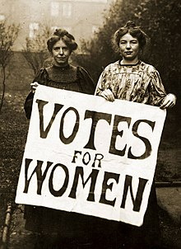
Physical Education

Pupils will learn to communicate, collaborate and compete with each other through a variety of physical activities and sports and learn how to evaluate and recognise their own success. Mr Hayes and Mrs Bizley will be teaching the children tag rugby and netball in the autumn term. In PE lessons children will be encouraged to compare their performances with previous ones and demonstrate improvement to achieve their personal best.
Both classes will have PE lessons on Mondays. Children will need to come to school wearing their PE kit - black or green shorts and a plain white T shirt. As the weather gets colder they will also need a black or plain dark tracksuit and shoes suitable for outdoor games.

Music
This unit introduces children to music which uses the voice and body percussion. They do this by focussing on the piece ‘Connect It’ by the contemporary British composer, Anna Meredith. Meredith writes for many different instruments including whole orchestras and she also creates and performs electronic music. In 'Connect It' a variety of rhythmic sounds and movements are passed between the performers. This musical effect is known as a canon. A canon is where two or more instruments, voices or sounds play the same music, but starting at different times. In this unit the children also listen to the song ‘Where is the love?’ by the Black Eyed Peas as an illustration of how different sections of music can be contrasted by a change in timbre. The group’s founding member, will.i.am said the song was originally born out of anxiety after the 9/11 attacks. The lyrics discuss many issues including terrorism, racism, gang crime, pollution, war and intolerance, with a call for love which appears in the chorus tying these elements together. The children use their investigation of timbre and canon to create their own composition over the course of the unit, creating rhythmic motifs using body percussion and the voice. They notate these motifs in a table and layer them together in a canon to create four simultaneous parts. They formalise this into a rhythmic composition in ternary form (made up of three parts, A B A) which makes use of contrasting timbre, tempo (speed) and dynamics (volume). At the end of the unit they record the piece in a graphic score and perform the composition.

