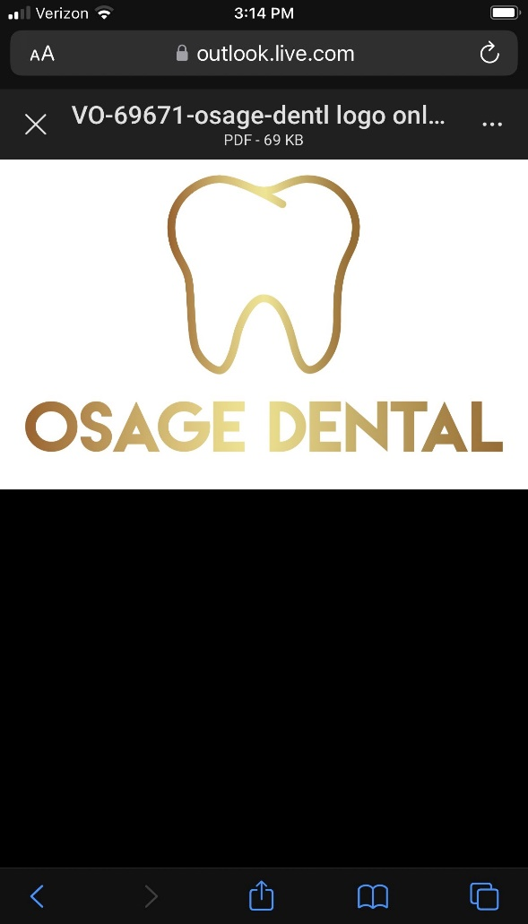

11441 Osage Street NW

Coon Rapids, MN 55433

(763)757-6600

**Records Release Form**

**Patient Name:** _____________________________________________ **Birthdate:** ____________

**Address:** _____________________________________________________________________________

I hereby authorize and request Osage Dental Associates to release and disclose via secure email to the undersigned or designated dental clinic any radiographs and/or patient records deemed pertinent concerning the above named patient(s).

In consideration of such disclosure and release on the part of the above named clinic, I release them from any liability arising from such disclosure.

**Please complete and return this form to:**

**Osage Dental Associates**

**Email:** [**OsageDentalFrontDesk@gmail.com**](mailto:OsageDentalFrontDesk@gmail.com)

**Fax: (763)757-3693**

**Please forward dental records to the following designated dental clinic:**

**Name: _______________________________________________________**

**Phone: _______________________________________________________**

**Email: ________________________________________________________**

Signature: _______________________________________________________ date: ________________