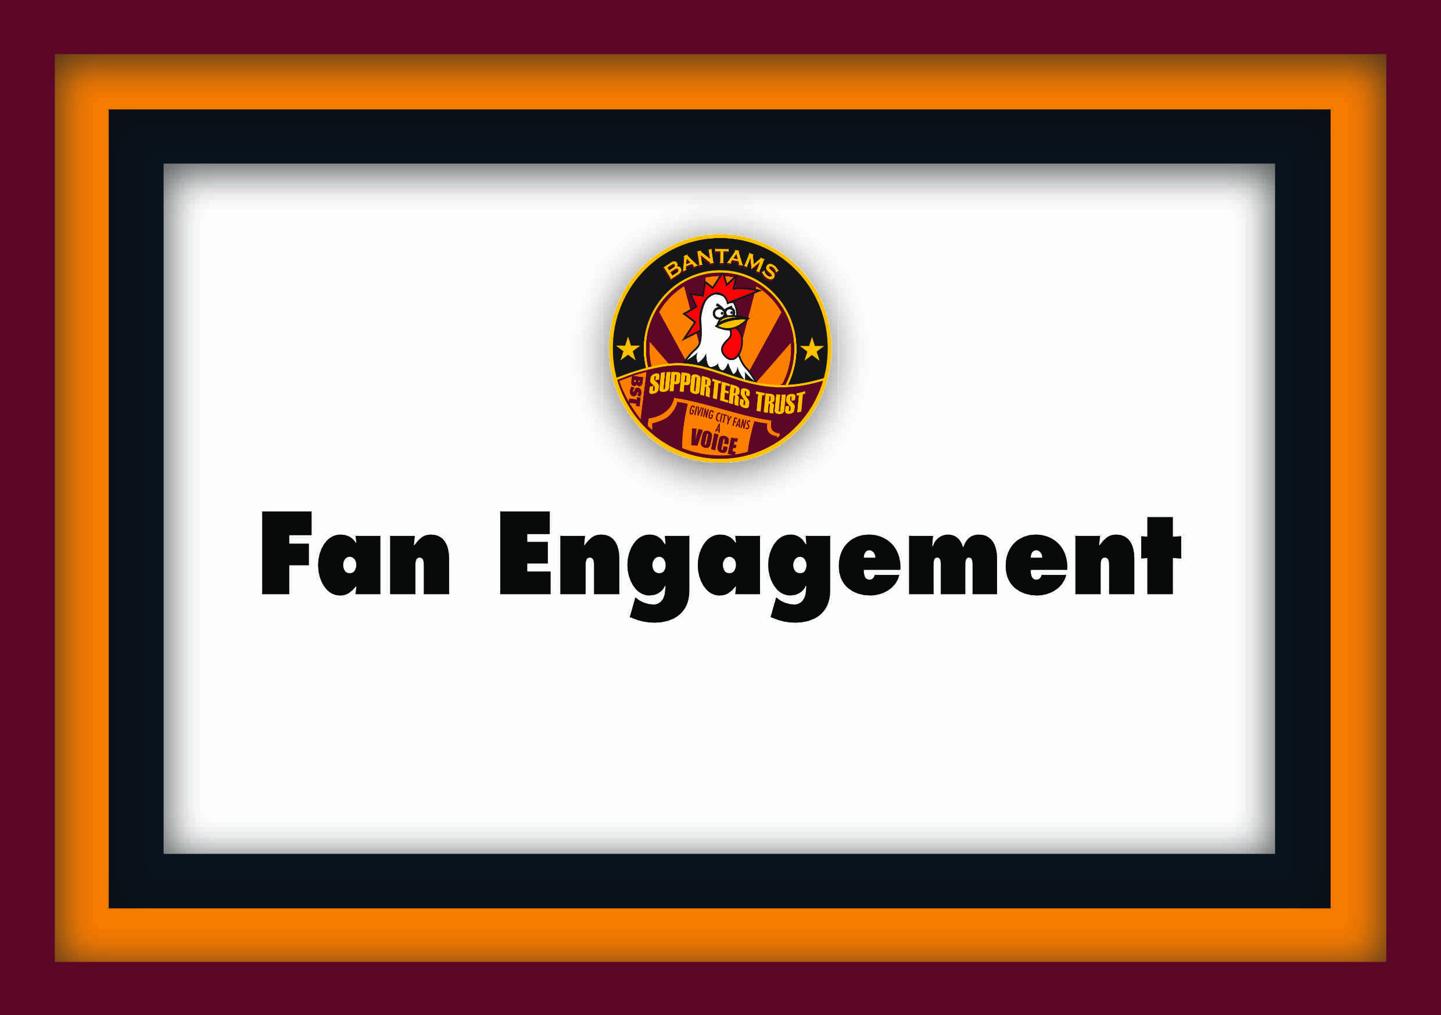

Report of Trust meeting with BCAFC

In attendance from the Club were, Liam Mould (LM) – Club Fan Engagement Officer. Representing the Trust there was, Manny Dominguez (MD) – Chair).

Apologies were given from Tony Deacon (JB), Helen Jeffery and Matthew Pickles (MP).

The Trust’s purpose to meet the Fan Engagement Officer was firstly to see the scope of LM’s role and how it meets a Trust’s desired role of what it looks like and how we can work together going forward.

Supporter Liaison Officer role
LM briefly informed us that his main requirement is to lead in maintaining gold in family excellence in the EFL by ensuring the operations activities on a match day go to plan, for example Billy’s Coup, staff on hand for advice and giving out fruit, half time activities, external group organisation and partners’ stalls, and the flags being put out, and a lot more.

Also he meets with existing supporters groups such as the Supporters’ Board, LGBT Bantams and Bangla Bantams.

We looked at the FSA guidance to the role of SLO. MD had good comments that LM had been visual on matchdays certainly in the main stand and that he was at the recent away match at Burton Albion, so certainly having a visual presence for fans to be on hand to see is a desired requirement.

MD commented that the main stand concourse does certainly look more colourful and welcoming for all.

The Club also has 2 disability Liaison Officers that can be seen around the stadium on matchdays also.

A concern that the Trust had was that there maybe too many other responsibilities to the job so that desired SLO or Fan Engagement roles could not be fully fulfilled, something that may have been an issue previously.

Fan Engagement Plan (FEP)
We looked at the FSA’s guidance for Supporter Engagement in the EFL, namely about rules adopted by the EFL in 2024. The FSA’s senior paid officials with a selection of Trust reps meet with senior EFL reps and have a structured dialogue quarterly throughout the year so recommendations get through and are adopted at EFL AGM’s and information cascaded to Clubs, so these papers benefit EFL clubs on a day to day basis.

The minimum fan engagement requirement is two meetings/fans’ forums a year. Our club goes over and above this. It also talks about a Fan Engagement Plan or FEP and complete an FEP Review.

In a nutshell the guidance is for both Clubs and fans groups to work together and to collaborate on things where possible. This is the ideal way.

Engagement Models
We looked at various models of supporters groups and how Clubs work with them.

The Club engages with various models of supporters groups. The most established are the Supporters Board and ourselves, the Supporters Trust.

The Supporters Board model has changed from its original set up that had a mixture of elected and selected/appointed members representing the widest number of supporters through representatives of various supporters groups and the Supporters Trust was represented in that body.

Over the years Supporters Boards have become Supporter Advisory Boards (SAB’s) perhaps more common in the Premier League and EFL Championship.

Bradford City’s Supporters Boards no longer has Trust representation on that body MD explained, as in recent years, its constitution changed, but now the Trust has a structured dialogue directly with the Club.

Going back to the various engagement models and the structures, the Club engages with, it has the Fans’ Forum twice a year and then has the Trust, which its aim is to meet quarterly and it has the Supporters Board which it meets monthly.

The Club also puts out occasional questionnaires to canvas opinion too.

The Club also has a strong focus on Equality, Diversity and Inclusion (EDI) that is discussed at the Club Governance meetings that have invited the Trust and Supporters Board reps to attend.

LM said that he is involved in working towards an EDI plan and through that they want to develop the Disability group and LGBT group into genuine bodies similar to associations. They also have initiated Responsible Bantams, Sustainable Bantams and Together Bantams from the EDI work as well.

The long-term aim LM said, is to bring these things into a Fans Advisory Panel which the Trust would be invited on as would the Supporters Board. MD was in favour of this broader advisory panel, citing the FSA recommendation of a having a ‘reserved seat’ for representatives of key independent, democratically structured supporters groups such as the Trust.

Trust Proposals within FEP
MD explained that we have had a number of proposals that had been agreed at the numerous structured dialogue meetings but have not fully appeared in the FEB document. Firstly there is a statement. There is a separate link to that on the website in the Fan Engagement area which is great but should really be in the FEP document. The Fan Engagement area isn’t very accessible on the Club website. LM said it was on the actual PDF doc. MD said he would check later.

Secondly is our quarterly arrangement- adding the four months of the year: August, November, Feb and May.

And finally, adding an amendment to the text on ‘Heritage Assets’ that we will be consulted also.

MD had shared 2 links to Club fan engagement plans – both Clubs are well established higher up the football pyramid – Championship side, Stoke City and Premier League Sunderland. Both these clubs have excellent Fan Engagement Plans that we should work to developing.

FEP Review: Mid season and end of Season Review.
We briefly discussed how we can work together to review the Fan Engagement plan. LM felt the mid-season review would repeat the pre-season review, so felt it wasn’t necessary.

Consultation
This neatly led us to the Trust perception of how the Club consults with us. We feel that we do get to have in depth conversation about the progress of the Club and we are vey grateful and feel this is very useful and good that it gives us such in-depth knowledge and overview, however, quite often, from a fans point of view, supporters are asking about situation after decisions have been made, and when we pre-empt when the Club are going to make a decision on something, for example, season tickets, there is very little to say on the matter, until its almost ready to be publicised when decisions have already been made and there is no going back.

Genuine consultation is when 2 parties discuss ideas and decisions are made together where the experience and knowledge of being a fan is taken into account to factor in that input. Quite often as fans we are chasing a moving feast asking why has this or that being done or not being done.

Matchday
Policing of matches and overcrowding – MD brought up experiences, particularly at Wigan were fans were held back in their seats after the match and more recently at Burton there was overcrowding, For the Wigan game, one supporter wrote to the opposite SLO about the incident and he got a detailed account from the ‘Silver Commander’ police officer.

LM suggested we can have a more in depth discussion about these incidents when we meet again in August for the meeting on safety and behaviour with Paula Watson (PW), the Director of Operations, Jonathon Heaton, the Clubs’ Safety Officer and the West Yorkshire Police Dedicated Football Officer for the Club, Aaron Dennis, in August.

B Block issues and proposal – We picked up a conversation from a previous meeting, where it was raised that issues are still rumbling.

LM was able to get an idea and MD proposed that we could work together to meet with the groups for a form of concession bargaining mediation meeting to find agreement.

Ideas for fan engagement events
MD firstly explained that some of the events that we have at the Club are too expensive for ordinary supporters to afford. The end of season dinner is a prime example at £80 per person.

LM countered that this the End of Season dinner aligns with the club’s pricing strategy when looking at increased costs across the operation while also noting a recent trend in a large selection of the supporter base leaning towards premium options. Comparing to retail, the club shop has items at a ‘higher’ price and items at a low-mid price, in order to appease everybody. A similar model is taking place with events now – with the introduction of the Events Pass – working out at £6 per event for u12s - a cheaper option for supporters to meet players at a cheaper price.

MD said we should go back to pie and pees events in the suites for supporters groups, veterans to meet the stars at very down to earth prices. Life is a constant battle to try not to spend due to rising costs. Older people can be more isolated these days. The Club could bring them together to talk about old times and memorable matches from the 60’s 70’s, 80’s and 90’s.

The Club could bring in speakers to talk about their experiences for Black history month or international women’s’ Day without a 3 course diner, just tea – coffee, a bar maybe and an assortment of finger food.

In years gone by the Trust was part of a Community Day that was held just before the season started, where we would get some of the stalls put out in the suites, and there was a bouncy castle outside and football tournament s on the pitch and events on the concourse in the main stand as well.

LM said he would take this on board.

Any other Business
MD raised about alterations on the concourse of the Midland road had aroused a lot of discussion and concern about losing their seats to a bigger away fan allocation. LM said there had been adequate communication about the extra security gate. LM said that there was an email sent to those with seats in that stand.

It can be raised for the next Structured Dialogue meeting to be held in May.

Next Meeting
It was agreed that the FEP end of season review meeting should be held towards the end of May.

