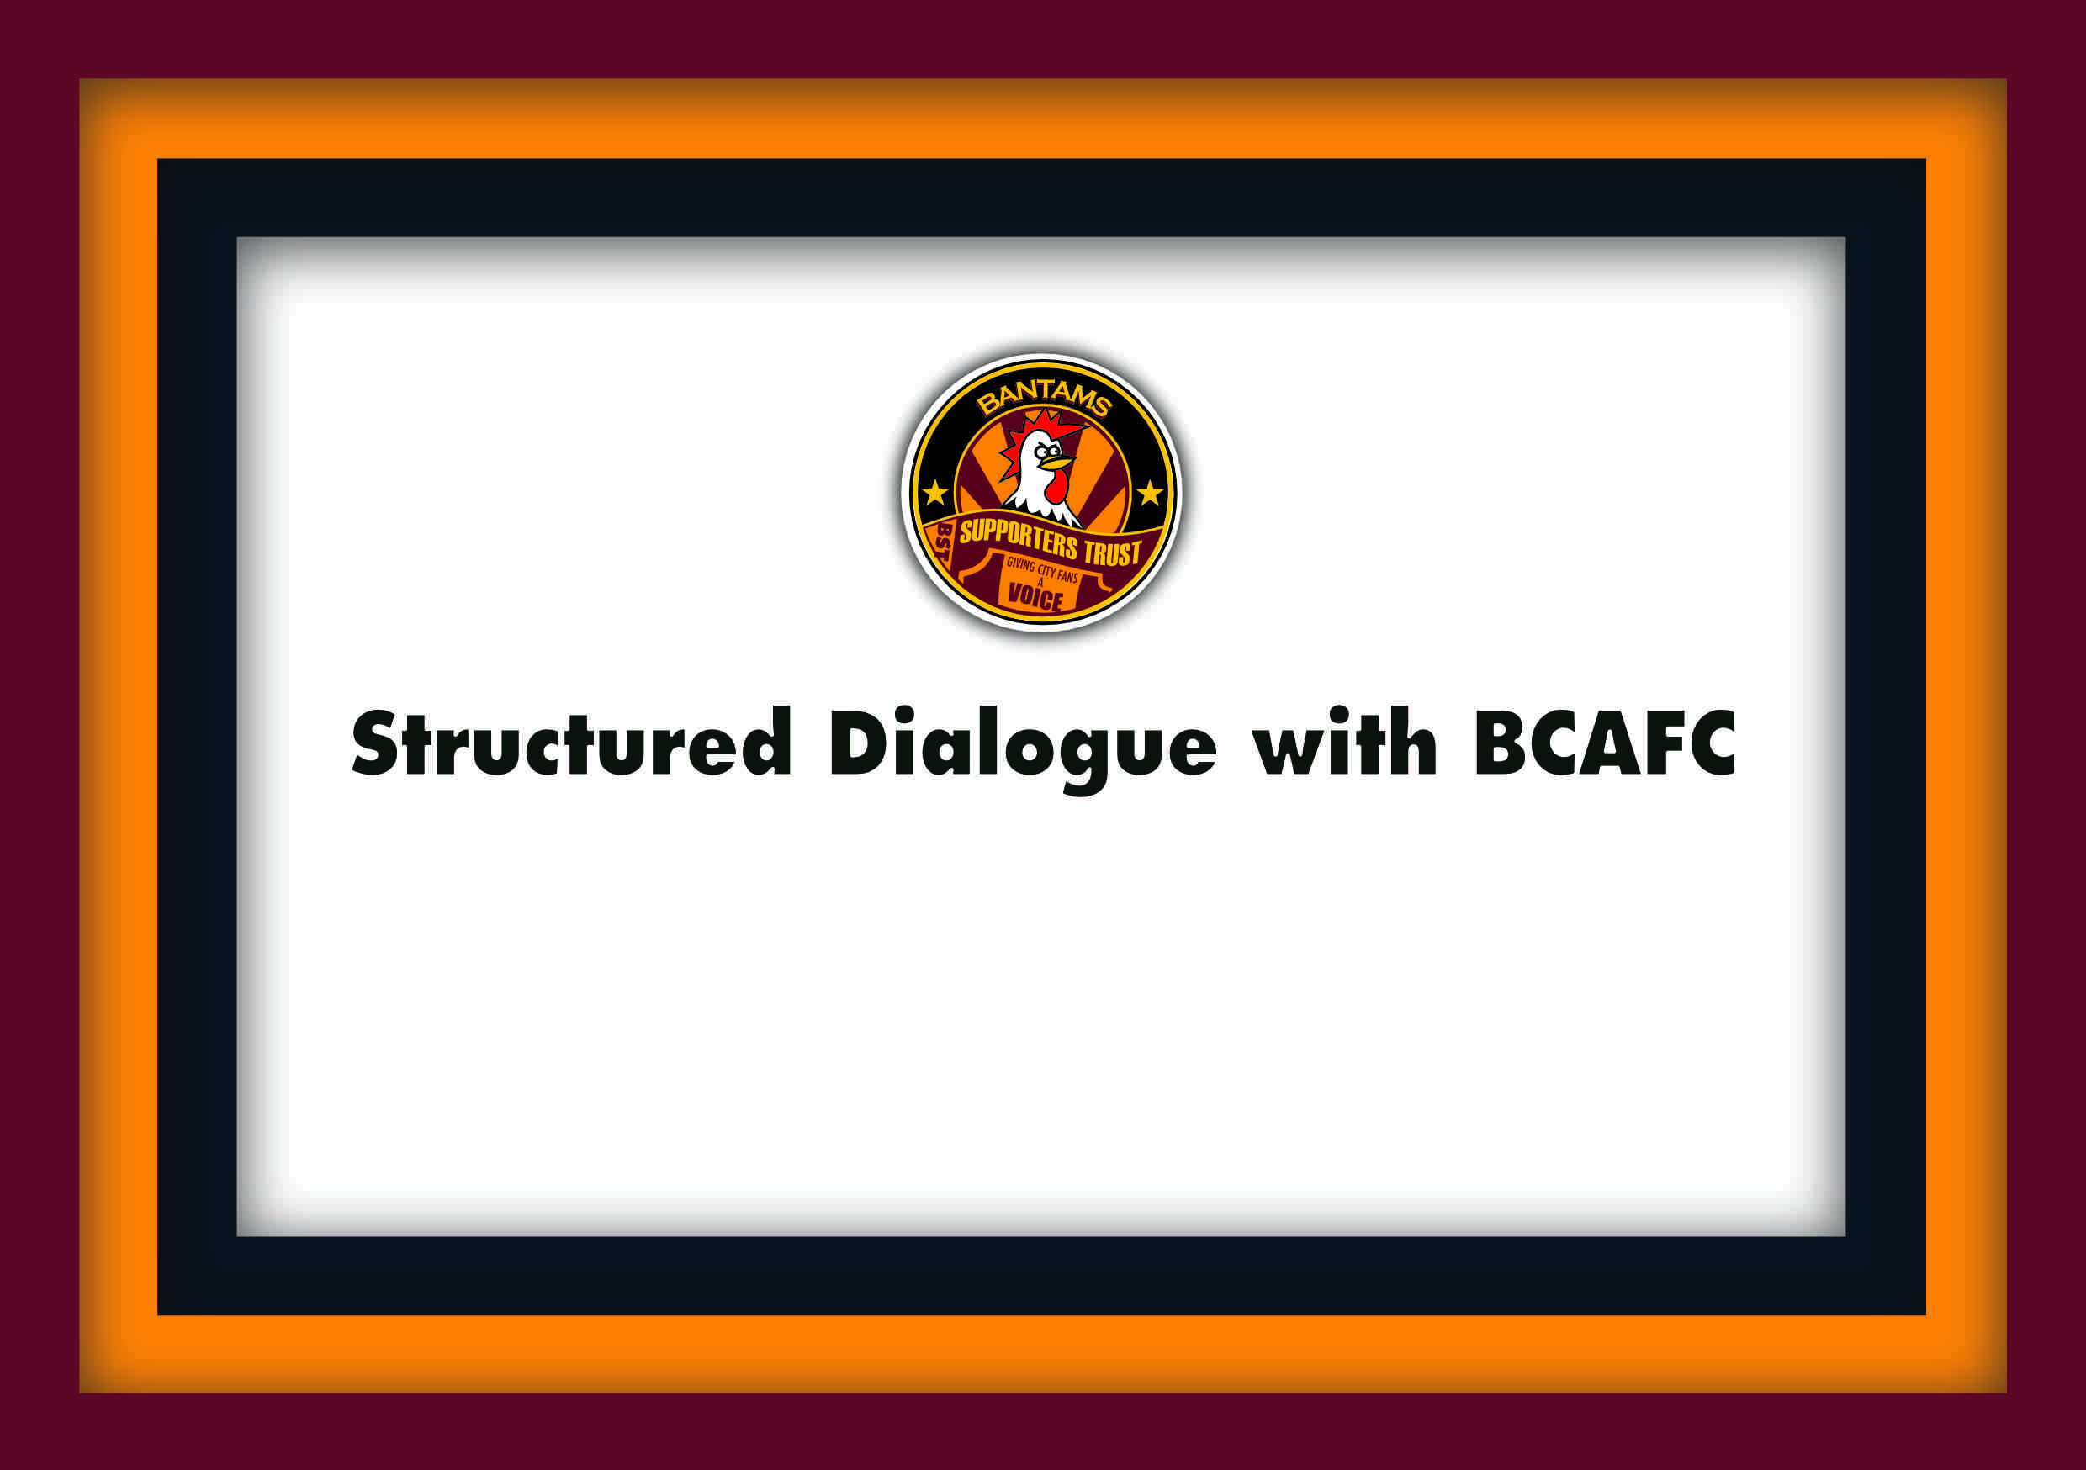

Report of Trust meeting with BCAFC

In attendance from the Club were, Ryan Sparks (RS) – Club CEO and Paula Watson (PW) – Director of Operations. Representing the Trust there was, Manny Dominguez (MD) – Chair.

Apologies were given from Justin Bret (JB) – Trust Vice Chair, and Matthew Pickles (MP) also from the Trust.

Bantams Supporters Trust met with the Club on Monday 3rd Nov. We last met on the 4th Aug. There was plenty to discuss since the last meeting, as there is, as ever lots of developments taking place. So, without further ado lets dive into it.

Fans’ surveys
The Club recently had a survey running for season ticket holders about customer service satisfaction feedback in areas like retail, hospitality, and ticketing. It covered all customer service areas. Approximately 2,000 took part. It is felt the Club have a good handle on what supporters want and expect, but the responses hadn’t been analysed yet as the survey only closed recently, the 31st Oct.

The Trust asked whether the EFL had sent the Club supporter responses related to their supported Club questions. The Club haven’t seen them yet.

The Trust made a point that there were was a wide range of issues covered in the survey asking supporters their opinions on how broadcasting matches affects fixtures, or about issues about protecting football clubs through the Football Governance Act and the Independent Regulator, fan engagement, diversity.

It also asks how we as supporters consume and digest football and the football news about our clubs and team news in a digital age.

The club and the Trust both promoted the EFL Survey. The Trust also promoted the Clubs’ survey.

Season ticket sales breakdown
The Trust asked for a further breakdown on sales figures of season tickets which have been published on the Club website, here. The Club said approximately 500 paid the full price during the Early Bird period and it was established that 7,192 paid through direct debit at the Early Bird price.

It was said that in total 16,000 bought season tickets for this season compared with 14,000 last sold last season.

It’s not clear, however, how many of the 13,000 renewals took up the Early Bird Offer.

Season ticket prices for next season
The Club haven’t explored this yet it was said but the headline is that they have no intention to make them expensive. We’ll come to this again in February.

Increased staffing at the Club
There is something of a transformation going down at Valley Parade. It’s not just the transformation on the pitch that has seen a qualitative improvement, Valley Parade has seen an increase in the number of staff employed by the Club, and indeed, a lick of paint around the ground and three sides of the stadium now have new seats. Midland Rd will be completed next summer, and they have recently ordered in new alcoholic beverage pouring machines on the concourses,

The Club say that they have been under a certain amount of pressure to make improvements to an ageing stadium, and not only that but bring in talented staff to come into develop departmental teams to provide better customer / supporter services. Overall, they want to do fan engagement better.

Matchday experience
It has been noted that with the increased attendances there are issues of congestion all around from fans coming in, queuing for food and drink, and exiting the ground. The queues at the kiosks is one reason why they have brought in these live pourers, as beer is the most bought item at the kiosks. The Club are very much opposed to not being able bring beer into the stands.

They have been looking at time-lapse film footage to understand how supporters are leaving the stadium. They may adopt a staggered approach to supporters exiting the stadium.

There is more of a City supporting vibe within the concourses with the graffiti-style artwork in the main stand, and this will be extended in the concourses in other stands.

It was said that the atmosphere area in Block B and the flags in that lower Kop has worked really well. At times it’s been like a sea of colour. There were still some issues in Block B but nothing comes without its challenges it was said.

Safe standing was raised based on the idea of a supporter led fundraising. The idea being that fans would pay a bit extra on their season ticket – for those that want it of course.

It was explained though, that that is not an immediate priority for the Club to have. If it were to happen the Club would have to reserve 10% of the seats to away supporters, and the reality is that the cost is 3 to 4 times the cost of what it was to invest in back in 2010, when the campaign for safe standing was well known.

It was raised that in previous years there has been a successful example of fans raising money when the Club bought the scoreboard called Upgrade The Parade. But it was explained that a significant amount of the money came from one benefactor.

It was said that it has taken 3 seasons to replace old seats in three different sides of the stadium. It could take maybe 5 to 10 years to install railed seating, and that the cost maybe too much for supporters to raise. But lets say it is, it could be that the cost is shared out to other funding providers, or commercial investors. It was explained by the Trust that this type of funding could be done for other projects, for Club charities for example.

Improving our structured dialogue / Fan Engagement
RS said we have a lead on fan engagement. He is the Fan Engagement Officer, Liam Mould. He has attended the Governance meetings that MD has attended and started in the post from September, and has been within the Club for around three months.

Fan Engagement Plan
MD raised that with the Club’s fan engagement, it is working in practice but it needs to update the Fan Engagement Plan (FEP) with the Trust text – a quote from the Chair and add dates for meeting with the Trust, also to be on the Club website. It was requested to send to RS and PW.

MD recommended that Trust and other groups should be involved in the FEP in being part of the process and end of season review. It was suggested we could be involved in the end of season review.

MD reported on poor fan behaviour meeting – that it was a start, and there had been much progress on the recommendations of the EFL with regards to the banning and sanctions policy in terms of education and restorative justice. There was discussion on the Clubs’ communications to supporters regarding being respectful to others when we turn up in large numbers at away matches. PW felt by the Club that they communicate a lot about behaviour as most fans behave and mostly police themselves. There was a debate whether sanctions actually deter offenders from causing an offense. It was said that it has been better this season so far as the Club have not as yet had to pay any fines.

MD reported on a diversity photography project that has been proposed in that it will need funding and that a meeting will be arranged between BEAP and the Trust.

With regards to environmentally sustainable football MD reported that he had written on the theme of getting supporters to and from the match to the bus companies in the city and also had written to the Wet Yorkshire Combined Authority and lead Councillor for transport, Caroline Firth. PW said MD could connect with Adam Kiezer, the Club lead on environmental sustainability.

Football Governance Act and the Independent Regulator (IFR)
MD asked if the Club had seen David Kogan the Chair of the Independent Regulator yet. RS said that they recently attended a regional event in Manchester about the purpose of the Regulatory body and what it will do.

Some of the highlights are here of what it will do:
● Oversee financial regulation
● Strengthen the Owners’ and Directors’ Tests
● Introduce a Corporate Governance Code
● Define prohibited competitions
● Intercede in financial distributions (via a ‘backstop’ mechanism)
● Ensure protections for club heritage
● Specify fan engagement requirements

In terms of fan engagement, the IFR will not prescribe how it should be. Like the
FSA’s guidance, it will be based on broad principles that each club and its fans
can use to build effective engagement. Clubs and their fans will be able to
structure it in a way that works for them.

RS was confident that the Club will be regulatory ready as a sound business and it is likely that we (the Club) will not need their attention, and that David Kogan would be seeing those Clubs that may need help with the running of their Clubs first.

It was agreed that the purpose of the IFR was to mitigate the number of badly run clubs and reduce the number of insolvencies over time by working with Clubs to encourage better business management and take out poor owners through stiffer owners and directors tests. But that may not be easy.

It was noted that fans groups can have contact with the IFR as well, and at a certain stage we as a Trust will be looking to see them. From the Trust’s point of view it would look better if the IFR saw the Club and the Trust in part together.

Financial Performance
MD asked how we have been performing and asked for a snapshot. It was noted that the Club provided annual figures – and these are at Company’s House, but they are often a reflection of how well we did over the previous season. It would be better to see a snapshot of now - figures to support the discussion.

RS was able to give an idea about how well each department had been doing in the first quarter, and on the whole the Club has out-performed certain budgets in the first quarter.

Departmental Performances:
Youth Academy – currently on budget
First Team – currently out-performing budget
Retail – currently on budget
Kiosks – currently out-performing budget
Lottery – currently on budget
Ticket office – currently out-performing budget
Marketing – currently out-performing budget
Stadium – currently over budget
Matchday – currently over budget
Commercial – currently out-performing budget
Banqueting – currently under-performing budget
Central Finance – currently on budget
Training Ground – currently over budget
Development Centre – currently on budget

Ownership
MD asked if Stefan Rupp has put in a significant investment to bring about all these improvements that are taking place within the stadium, staffing and player recruitment, as well as the financial reward for promotion and getting through the League Cup rounds and the income from the Newcastle game – tickets sold and television money, and the answer was yes, it’s had the highest investment in the Club’s history, higher than from any other previous Chairman over the course of the current ownership, most significantly in the last 24 months.

In terms of players’ wages, the club is nowhere near the top out of all the 24 League One competing teams.

