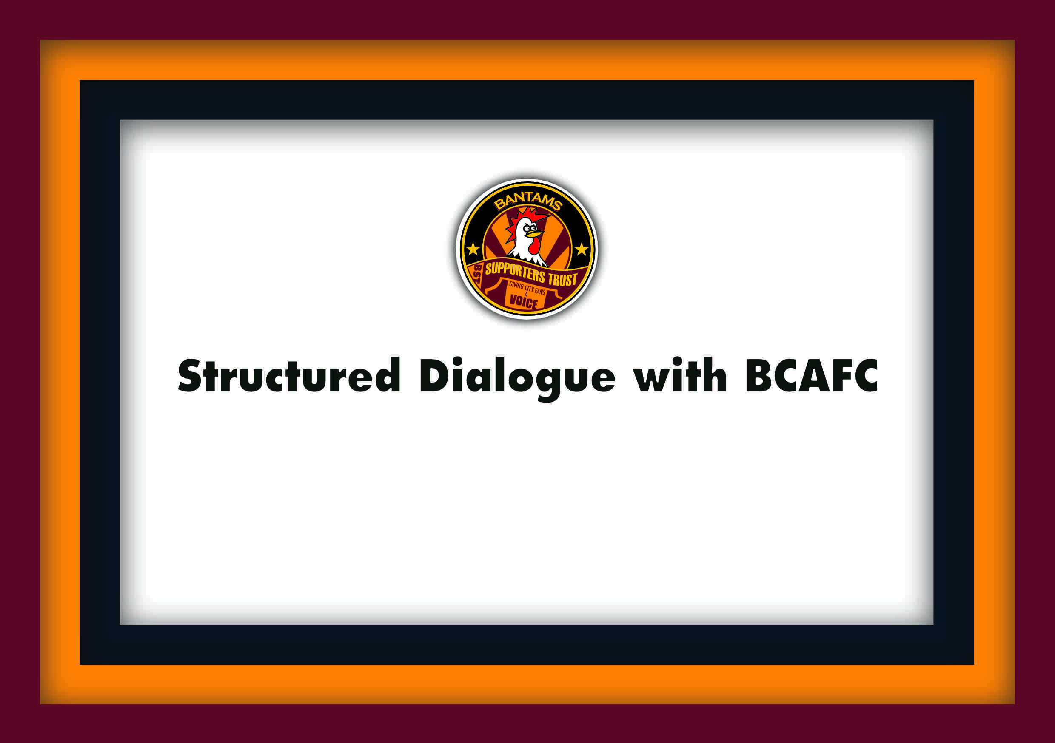

Report of Trust meeting with BCAFC

In attendance from the Club were, Ryan Sparks (RS) – Club CEO and Liam Mould (LM) – Fan Engagement Officer. Representing the Trust there was, Manny Dominguez (MD) – Chair and Carl White (CW).

Apologies were given from Justin Bret (JB) – Trust Vice Chair & Matthew Pickles (MP) – Trust Board Member.

Bantams Supporters Trust met with the Club on Monday 1st June. We last met in early February, so as ever, and after an eventful end to the season, there was a lot to catch up on. So, without further ado lets dive into it.

Season ticket breakdown for 26/27
We asked about sales for this coming season’s season ticket sales. 16,351 bought through the Early Bird window. Just over £15 per game for adults. The Club broke a record in that last year the total sales for season was 16,026, before sales were withdrawn ahead of the 25/26 campaign. RS said the total breakdown in totals for this coming season will be available in August.

We asked if the Club had set a price for this season’s matchday prices yet. RS’s response was affirmative and that they will be announced in July. We asked if they would be nearer the £30 mark and this was affirmative as well.

The Trust were apprehensive about the growing upward trend of ticket prices.

RS’s response was that the Club must attempt to act as a viable business and has, at times, sadly, little choice but to pass on a proportion of the growing cost in utility bills, costs to employers in terms of the minimum wage and national insurance and other taxes to sponsors and our supporters because otherwise the Club would lose out on its competitiveness in its ambition to win on the pitch.

We discussed discounts or special promotions, (Clubs have a minimum of 4). City have had £5 offers at select League matches and EFL Trophy matches. RS mentioned the Plymouth Argyle re-arranged evening fixture, saying it wasn’t taken up as much as the Club had hoped.

With regards to community tickets, it was said that they gave out 9,141 tickets over 20 matches last season at £4 per person, mainly to schools and also grass roots community clubs through the Community Foundation. We said this was a good achievement.

The Bradford End is the area for the community tickets.

Supporters Trust Survey
MD ran through some of the key findings in the Survey. He said it was a small sample and most that filled it in were older. It still reflected broadly the expected trends:
- Season tickets for 2024/25 – most bought online, fewer used the Club app, even fewer bought at the ticket office.
- Away matches for 24/25 - some had issues with not being able to buy/buy more due to not having enough loyalty points.
- 25/26 season tickets – most bought during the early bird period, most bought online and most paid in full. Fewer used the 12-month period and fewer still bought at the ticket office.
- Matchday tickets - A substantial majority believed we should have a flat rate £20. Nearly as many believed that there should be a discount in advance of a match compared with ‘on-the-day’ sales.

RS said it £20 wasn’t going to happen. It could possibly work if that was the flat rate for young people and kids also but we may lose the fans of tomorrow – there is no filter categories that would encourage more sales.

MD mentioned ‘reciprocal deals’ as a way of making special arrangements for away supporters – recalling a few years ago when we subsidised our away tickets with a free drink at Colchester. Offering a cheaper price where both sets of fans can realise a saving can be very valuable. Many supporters in our survey were in favour of this being a Trust campaign. See report here.

- The programme – Whilst most said they would probably not buy it, a significant minority said they would.
RS said that in todays climate they don’t make money, and the Club are paperless now. The Club recently won an EFL award for its efforts on environmental sustainability but they would do a programme for special occasions – a cup quarter or semi-final for example.

- Kiosks/bars – Our findings matched the Clubs customer survey on this issue. Fans not happy with the queues, the limited choices and value for money.
RS said that hopefully there will be an improved response this season.

- Atmosphere – this was seen as very good overall and that flags were definitely an improvement, and most said safe standing would be an added improvement too this.
  - The issues – The shift from upper kop to NW corner and then B-Block.
RS said that they were told to move to a lower position tier for safety reasons and if they didn’t, the stadium capacity would reduce by 10%.

  - Nationalist flags appearing was a concern too.
RS said that they would go by the EFL guidance of what they say are banned flags in stadiums. MD recognized the potential danger of removing them or commenting on them. The Club doesn’t get involved with the politics that is going on in the country. It is purely a football Club that showcases football.

- Other matchday issues raised – Tannoy/PA system, half time entertainment and Wi-Fi

Supporters / Club relationship level of agreement statement trends:
- Supporters Trust do a good job - Yes but could do better
- Supporters Board do a good job - Yes / could do better
- Supporter engagement from the Club is good – Yes but could so better
- I feel like my Club cares about me, and my views – Yes but could do a lot more. More polarised but somewhat agree was high but neither agree nor disagree polled higher.
State of the game level of agreement statement trends:
- 3pm black-out - strongly agree.
- Right to ban drinking from the sight of the pitch – most agree but consensus is changing.
- TV has too much sway to (K.O. times etc.) - Definitely strongly agree.
Football Act & IFR (Independent Football Regulator) potential changes it could bring:
- Fairer redistribution of wealth – Very important
- Ensure competitive balance across the League – Very important
- Stronger protections for Club heritage & identity – Very important
- Enhanced fan engagement, consultation and transparency in Club decision-making – Most send it was important though slightly less than the others

Match-day issue and development
LED advertising Boards – MD said through our survey and via the Trust email we have seen many complain that they are too bight at night matches.

RS said that they would be replaced this coming season with a new system and the main stand will have them as well. The floodlights will be replaced next year, if budgets allow.

The second security gate in the Midland Rd - There had been some anxiety about this amongst fans especially most recently at the Play off Semi final against Bolton.

RS explained that with the added segregation gate it gives 1,800 seats for the away supporters. It’s purpose is to be a safety net for an increased number of away supporters over three blocks but is not likely to be used in a standard, league fixture.

For the Bolton game the arrangement for tickets was the same as what it is like for a cup match. We gave them 2,100 tickets, and the strategy was to create a greater atmosphere for the team to play in. We didn’t want the away support behind the goal because that increases their noise levels and we didn’t want to give Bolton any advantage. We consulted with Graham Alexander and he was happy with that plan. The possibility of a penalty shoot out also came into the consideration.

The Midland Road stand will see some work. All of the seats will be replaced.

Other works
There will be improvements to the 2013 suite and the 1911 bar, and as well in the boxes, as well as the general maintenance, including the toilet facilities. MD said that the supporters thought the Toilet facilities were poor in the Trust survey.

LM said there are plans to create more Fanzones and have more family engagement areas and other activities in the Midland Rd concourse.

Heritage – MD brought up from the Survey that there is a feeling that there is disconnect with former players within the stadium with the idea of naming a stand after a player, murals of ex players or a statue.

This prompted a positive discussion, firstly acknowledging what we have in the ground – the Hendrie and McCall Suite’s, the 2013 suite, 1911 bar, Framed shirts from by-gone era’s, and players have heritage numbers on their shirts. The Club were the first to do this in 2019.

Next was the question of which player would we have as a mural or statue. When we all became supporters and loved the experience we all had our favourite players. Many older fans will think back to Bobby Campbell, Stuart McCall and John Hendrie.
Newer generation of City supporters will think Bobby Pointon. Most supporters can identify with him as he is ‘one of our own’.

Improving Fan Engagement
MD went over some points with LM from our last meeting, regarding how the working groups are structured into engagement with the Club. It was said some are very informal that don’t have a structure, engaging with the Club occassionally, and others have engagement more regularly through the Clubs’ Governance meetings and that the Supporters Board was regarded as a Supporter Advisory Board (SAB).

MD was invited to be involved with the drafting of the new FEP for 2026/27 season. At that point our Trust Chair quote and amendments to the calendar dates - to show we meet quarterly, and the amendments to heritage section were added to the draft pdf to be added by the designers.

Also, we added that we were pleased to say that this year the Club reached its agreed commitment to meet with us 4 times this year which is a first, and the first of many for the future. This was added to the FEP for what the Club has achieved this year. This was part of our end of season review with the Club. The deadline for submission to the EFL is the 30th June.

Community Projects
MD raised one project we could probably do at this stage is to run the My City, My Shirt Diversity photography project, capturing the diversity of Bradford City’s supporters, from coming into Valley Parade, to the concourse, in the fanzines, in the stands and at the Beap Centre, and with a small amount funding we could have some of the prints exhibited in the ‘Community Hub’ Café or indeed the possibly in the Midland Road Concourse. There was a lot of positivity about this from the Club and prompted more discussion about what could be there; potentially murals.

Burns Unit Collection and Memorial
MD raised that we felt the collection went well in terms of what was raised, however, there were some issues around it and felt we could have larger numbers involved and whether there could be a case for a new potential working group to involve other supporters groups, similar to the ‘Remembrance Panel’ of some years ago. MD said he would email them a Trust members’ letter.

Also raised was so the lack of past players at the memorial this year. RS said we should ask the Council about this is. They are the ones that organize it all.

Football Governance Bill & the Independent regulator
MD reported that the Government had launched a new initiative, ‘On Fans’ side’, which explains in simple terms what the Football Governance Act means for clubs and supporters. See here and here.

Also there has been a ‘supervisor’ from the Independent Football Regulator (IFR) allocated for all clubs in the EFL. They have a caseload of between 6 or 7 each.

Financial Planning
MD asked from the 24/25 Accounts review, what are the projections for 25 / 26 and beyond. RS said we lost £3m last season and are expected to lose a similar this year.

Our income for this season (25/26) was £12m to £13m and guestimate income for next season is between £14m and £15m. This factors in sponsorship, EFL/Sky and ticket sales.

Stefan Rupp has provided the biggest investment into the Club, more than any other previous owner.

Mbanq is our biggest sponsor we’ve ever had and not only will they be a shirt sponsor, but they will also be sponsoring other significant assets in the near future.

The Stadium
MD explained that one of the popular campaign ideas was for Valley Parade to be community owned – to initiate a fundraising campaign.

There was a discussion about the value of the ground.

It prompted a very positive discussion about helping the Trust find what it does best over the course of a season. Getting volunteers to help with the bucket collection was raised as an example of that, and the advice was, that we need to have something reachable where we would be gaining the trust of the wider supporter base.

MD said if we can pull off the diversity project, that would be noticed and attract more activity.

Fundraising for a mural was also suggested for a reachable aim.

