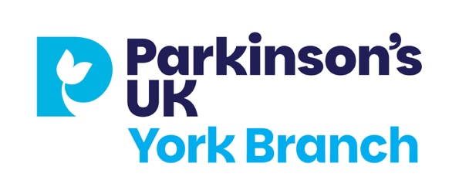

York Branch Christmas Lunch 2026

This year we are returning to the Novotel on Fishergate where we had a great time last year. The date: Wednesday 9 December.
Please try to get there for 12.15 for a prompt start at 12.30pm.

The cost: People with Parkinson’s, partners and carers £18, others £30.50.

Bookings to Lorna please by text 07925 148086 or email thelodge302@gmail.com
There will be a paper sheet available at the next Folk Hall meeting for those without text or email access.

Groups that want to sit together please tell Lorna when you book. Once all the tables are full, bookings will stop but 5 November is the last booking date.

Parking is available, including disabled spaces. Please double up if possible. The Novotel is on a good bus route too.

Please send payment to our York Branch bank account. The details:
Parkinson’s Disease Society of the United Kingdom
Sort Code 20 00 00
Account Number 23732452
Reference: Xmas + your name

The Menu – please tell Lorna your choices – see separate pdf
Starters
Trio of seafood platter
Roasted butternut squash & chestnut soup
Duck liver parfait

Mains
Roast turkey ballotine
Baked lemon garlic butter salmon
Ricotta & spinach ravioli

Desserts
Novotel trio
Yorkshire artisan cake selection
Traditional Christmas pud
Vegan banoffee cheesecake

