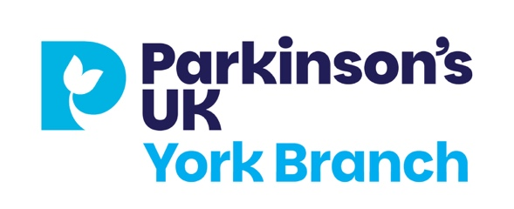

Christmas lunch – Wednesday 10 December 2025
Novotel, Fishergate, York YO10 4FD
12.30pm, please take your seats by 12.20pm
***Starter:
- Sweet potato & lentil soup (V)(GF)
2. Wild boar plum and brandy paté
- Trio of prawn cocktail platter
***Mains:
- Roast turkey ballotine with all the trimmings
- Sesame crusted teriyaki salmon with sautéed oriental vegetables and tempura butterfly prawns
- Ricotta and spinach stuffed cannelloni with home made herb and garlic ciabatta
***Desserts:
(a) Novotel Baileys Trio – salted caramel cheesecake with chocolate mousse and a shot of Baileys Irish Cream Liqueur

(b) Yorkshire Artisan cheese selection with chutney, crackers, celery and grapes

(c) Christmas pudding

(d) Vegan mango cheesecake

***Tea or coffee with mince pie***

Please choose one from each course and send your selection with your payment of £18 per person to:
Lorna Edmondson, The Lodge, Strensall Road York YO32 5 AA. I need to know whose choice of meal for the place cards
Or email your choices and details to thelodge302@gmail.com phone 07925 148086. You can pay by bank transfer Parkinsons Disease Society UK York Branch sort code 20-00-00 Account no:23732452 reference your own details
Last date for booking is 30 November.

There is limited parking at the Novotel, so please travel by bus if possible. Nearest large car park is St. George’s Field.

Parkinson’s UK York Branch
Christmas lunch – Wednesday 10 December 2025
The Novotel, Fishergate, York

Name(s)………………………………………………………

Address…………………………………………………………

Phone no:…………………………….. email……………

 | Member Name | Spouse/Carer name
Please put your names at the
top of the columns 
Starter: Please tick one choice each
Sweet Potato & lentil soup
Wild boar Pate
Trio of Prawn Cocktail
Mains: Please tick one choice each
Roast Turkey Ballotine
Teriyaki Salmon
Stuffed cannelloni
Desserts: Please tick one choice each
Novotel Baileys trio
Cheese and biscuits
Christmas pudding
Vegan mango cheesecake
***Tea or coffee with mince pie***

Paid cash [ ] cheque [ ] bank transfer [ ]

Please note that the subsidy provided for this event is for one member and one spouse/ carer. Friends and /or family are welcome to join us but would be required to pay full price of £30.00

