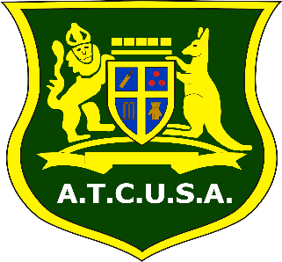 | ADELAIDE TURF CRICKET UMPIRES  & SCORERS ASSOCIATION INC  ANNUAL GENERAL MEETING  Wednesday 3rd September 2025  Karen Rolton Reserve,  Glover Avenue, Adelaide  NOMINATION FORM

In the event no nominations are received for all of the below positions, then nominations shall be called from those individuals in attendance at the AGM.

Any member who is unable to attend the AGM must cast their nomination by email, see bottom of the page.

MEMBERS TAKING ADVANTAGE OF THE ABOVE METHOD MUST ENSURE THAT THEIR NOMINATIONS REACH:

THE RETURNING OFFICER BY 27th AUGUST 2025

POSITION | NOMINEE | PROPOSER | SECONDER | ACCEPTANCE
President
Treasurer
Committee (4)
Committee (5)
Committee (6)
Committee (8)
Committee (9)

Please complete and return the above to:

Returning Officer:
Mr Malcolm Green
malcolm.green8@outlook.com

