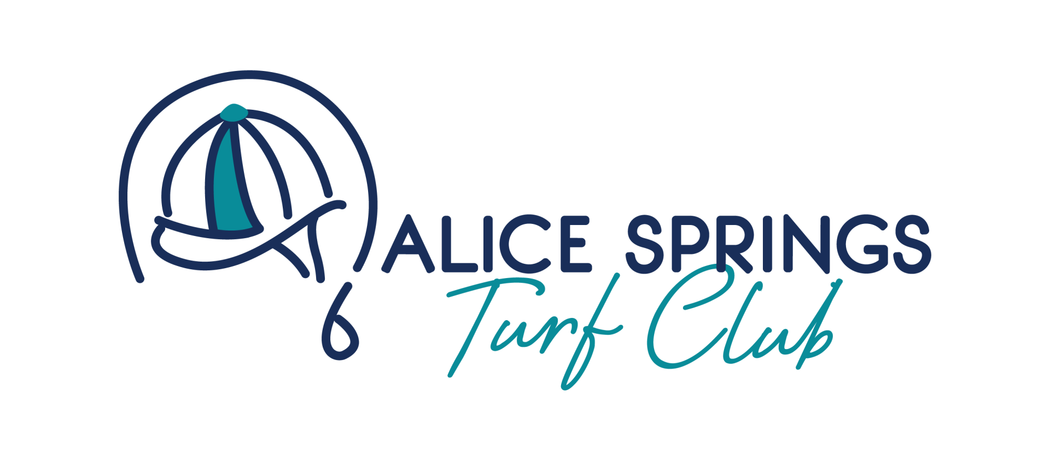

Terms and Conditions – Women in Racing- raising Money for Ovarian Cancer
- Promoter
This raffle is conducted by the Alice Springs Turf Club (“the Promoter”) for the purpose of awarding Major Prize Winner 2.5% ownership share in the thoroughbred racehorse Hello Mary. There are five additional prizes to be won donated by local business.
- Draw Details
  - The raffle draw will take place on Derby Day, Saturday 1 November 2025, at the Alice Springs Turf Club.
  - The draw will occur between two scheduled races on the day (exact races to be confirmed).
- Ticket Sales
  - Tickets can be purchased in person or online.
  - In-person or online tickets are available 9:00 AM to 4:00 PM from Jo Doyle on 0438 843 517. Tickets will also be available at the Alice Springs Turf Club on Sunday the 26th October and Derby Day 1st November 2025 or until sold out.
  - Each ticket is priced at $10 (AUD).
  - A maximum of 500 tickets will be sold, ensuring total ticket sales remain at or below $5,000.
  - Each ticket must include the purchaser’s full name and contact details to be valid.
  - All proceeds from the Women in Racing- raising Money for Ovarian Cancer will be donated to Ovarian Council Australia - https://www.ovariancancer.net.au/
- Eligibility
  - Entry for the Major Prize Draw is open only to residents of the Northern Territory (NT), Australia aged 18 years or older.
  - Full and part-time STAFF members of the Alice Springs Turf Club are ineligible to enter.
  - Proof of NT residency, age, and membership status may be required prior to awarding of Major Prize Draw. Failure to comply disqualifies entrants and may cause a redraw.
- Prizes
  - First Prize:
A 2.5% ownership share in Hello Mary including one year of free training by licensed trainer Kerry Petrick.
    - The Alice Springs Turf Club is not responsible for any additional training, veterinary, or other costs during or beyond the one-year free training period.
    - Any additional costs during the first year beyond free training are to be negotiated directly between the prize winner and the trainer.
    - The prize winner may surrender their ownership share at any time at no cost or penalty to themselves, the trainer, or the Turf Club. If this was to occur and the share handed back to the trainer, prize winner will not be eligible for any future winnings.
    - The ownership share is non-transferable for cash and may not be sold or exchanged.
Additional Prizes:
    - Alice’s Ultimate Beauty USPA product skin basket valued at $390
    - Swanks Gift Basket valued at $180
    - $100 Outbush Gift Card
    - $100 Hoskings Jewellery Voucher
    - Mombasa Deluxe Spa Ritual & blow wave valued at $250
- Non-Cash and Non-Transferable
  - All prizes are not redeemable for cash and cannot be exchanged or transferred except as explicitly stated.
- Liability Disclaimer Hello Mary Major Prize Draw
  - The Alice Springs Turf Club and Promoter disclaim responsibility for any costs during or beyond the first-year training, injuries, losses, or damages related to prize ownership or participation in the raffle.
  - Entrants participate at their own risk.
- Verification and Prize Claim
  - Winners must provide valid evidence of identity, age, NT residency, and non-membership status before receiving prizes.
  - Non-compliance may lead to prize forfeiture and redraw.
- Raffle Permit and Approval
  - With ticket sales capped at 500 tickets, totalling $5,000 or less, no permit is required under the Gaming Control (Community Gaming) Regulations 2006 (NT).
  - The Promoter will comply fully with all applicable laws and maintain proper audit records.

- General Conditions
  - The Promoter’s decision on all raffle matters is final and binding.
  - By purchasing a ticket, entrants agree to these Terms and Conditions.
  - The Promoter reserves the right to modify, cancel, or suspend the raffle if required by law or unforeseen events.

