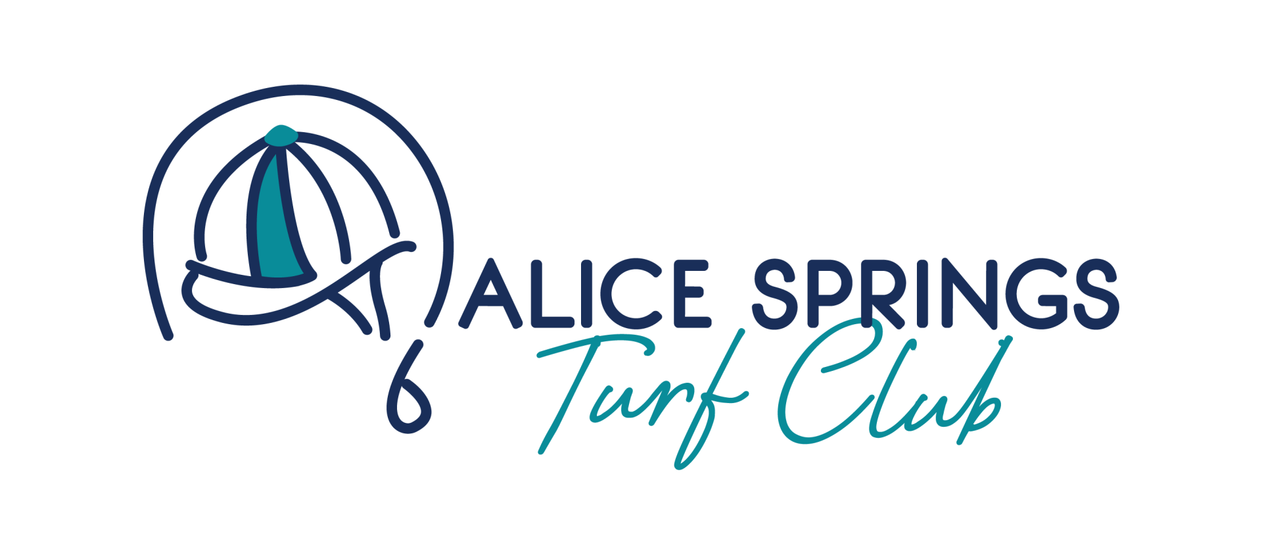

Alice Springs Turf Club Derby Day Ticket Giveaway Terms & Conditions
Promoter
Alice Springs Turf Club, Stuart Highway, Connellan NT 0870.

Eligibility
Entry is open to all residents of Australia, aged 18 years or over.

Employees of the Alice Springs Turf Club and TRNT and their immediate families are not eligible to enter.

Competition Period
The competition begins at 9:00am ACST on Tuesday, 21st October 2025, and ends at 12:00 Noon ACST on Tuesday, 28th October 2025.

Only one entry per person will be counted during the competition period.

Entries received after closing will not be accepted.

How to Enter
To enter, participants must complete the online entry form via the official competition link, hosted through Sociamonials.

No purchase or payment is necessary to enter.

Entrants may only enter once. Multiple entries will be deemed invalid.

Prize
The prize consists of 2 x double passes (4 tickets in total) to the "Young Guns in the Marquee" event on Derby Day, Saturday, 1 November 2025, at the Alice Springs Turf Club, Ladbrokes Pioneer Park.

Each ticket includes 4 drink vouchers, nibbles throughout the afternoon, and bus transfers to and from the Alice Springs Convention Centre.

The total prize value is not redeemable or exchangeable for cash or any other product.

Winner Selection and Notification
Winners will be selected at random from all eligible entries using Sociamonials random draw functionality at 12:00 Noon ACST, Monday, 27 October 2025.

Winners will be notified via phone provided at entry and announced on the Alice Springs Turf Club's social media pages.

If a winner cannot be contacted within 48 hours, the promoter may redraw the prize.

Use of Entry Information
Competition entry information will only be collected and used by the Alice Springs Turf Club for the purposes of conducting this competition.

Entry details may be shared with sponsors of the club and Derby Day for promotional purposes related to the event only.

Participants may opt-in by ticking a box on the entry form to receive further promotional material from the Alice Springs Turf Club.

Additional Conditions
The promoter accepts no responsibility for late, lost, or misdirected entries.

Facebook is not responsible for or associated with the administration or prizes of this competition. This competition is not sponsored, endorsed, or administered by, or associated with Facebook.

The promoter reserves the right to disqualify entries or cancel the competition at any time, subject to relevant permits and applicable laws.

All decisions are final and no correspondence will be entered into.

