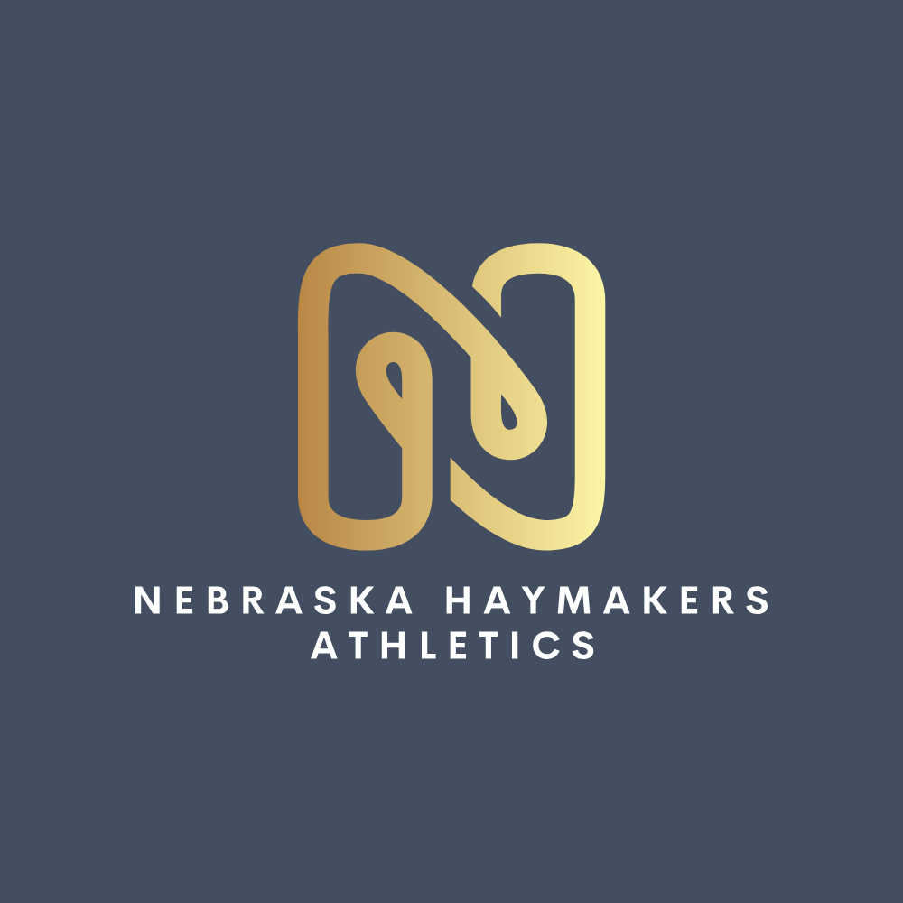
Nebraska Haymakers Sponsorship Form

Sponsor Name
Address
Phone Number
Email
Please make checks, corporate matches and/or other donations to: Nebraska Haymakers Athletics
Sponsorship Levels

Level | Cost
Dugout Team Banner Sponsor ($500):  Your business logo prominently featured on our team banners displayed right on the dugout fence during our home games at Churchich Park, Away games and Travel tournaments. | $500
Practice Shirt Supporter ($250):  Your business name or small logo featured on the back of our weekly team practice shirts worn by our athletes all season long. | $250
Base Hit Contributor ($100):  A direct donation to buy new baseballs and safety gear. We will proudly feature your business name on our official website donor page. | $100

Please return completed form to:
Lee Koenig
2012 Eagle Ridge Dr
Papillion, Ne 68133
nebraskahaymakers@gmail.com
Please email the logo you wish to be displayed to nebraskahaymakers@gmail.com
Enclosed is my gift of $___________
Every single dollar goes directly into safety gear and team costs. Because we operate as a registered non-profit under Nebraska Haymakers Athletics, your contribution is 100% tax-deductible. EIN #41-4336624

Team/Player that acquired Sponsorship:______________________________

