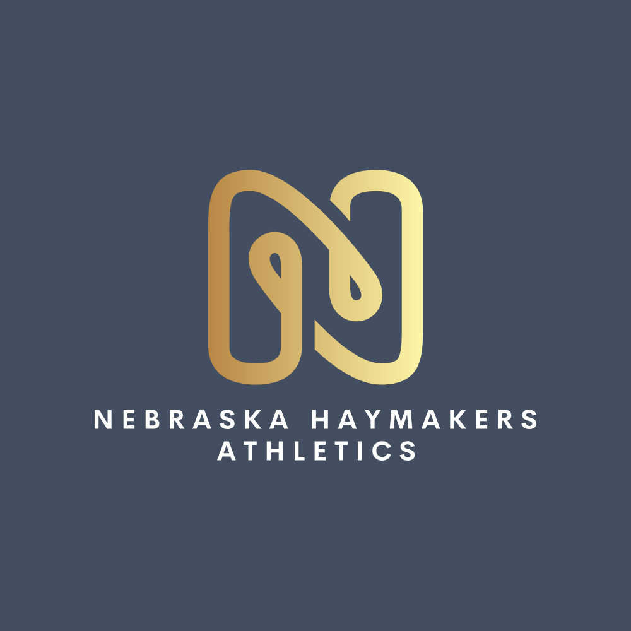
Nebraska Haymakers Corporate Sponsorship Form

Sponsor Name
Address
Phone Number
Email
Please make checks, corporate matches and/or other donations to: Nebraska Haymakers Athletics
Sponsorship Levels

Level | Cost
Championship Diamond Partner ($3,500):  Elite, multi-team visibility. Includes a stand alone custom field banner prominently displayed at Churchich Park all season long, your company’s logo permanently printed on the sleeve or chest of all teams jerseys across all age groups, prime top-tier logo placement on our homepage, and dedicated quarterly corporate spotlights on our social media networks. | $3,500
Grand Slam Elite Sponsor ($2,500):  High-impact game-day presence. Includes a standalone custom banner at Churchich Park, your company logo featured prominently on the back of all player outerwear/hoodies, a dedicated individual social media thank-you feature, and prominent placement on our official website. | $2,500
Vegas Gold Uniform Supporter ($1,250):  Focused branding. Includes your company logo on a shared facility banner, your logo featured on all team practice shirts, a shared monthly feature in our parent newsletter, and an official listing on our organization's digital partner page. | $1,250

Please return completed form to:
Lee Koenig
2012 Eagle Ridge Dr
Papillion, Ne 68133
nebraskahaymakers@gmail.com
Please email the logo you wish to be displayed to nebraskahaymakers@gmail.com
Enclosed is my gift of $___________
Every single dollar goes directly into safety gear and team costs. Because we operate as a registered non-profit under Nebraska Haymakers Athletics, your contribution is 100% tax-deductible. EIN #41-4336624

Team/Player that acquired Sponsorship:______________________________

