THE COMMERCIAL CHRONICAL
Cash Rate Update | increased to 4.1%

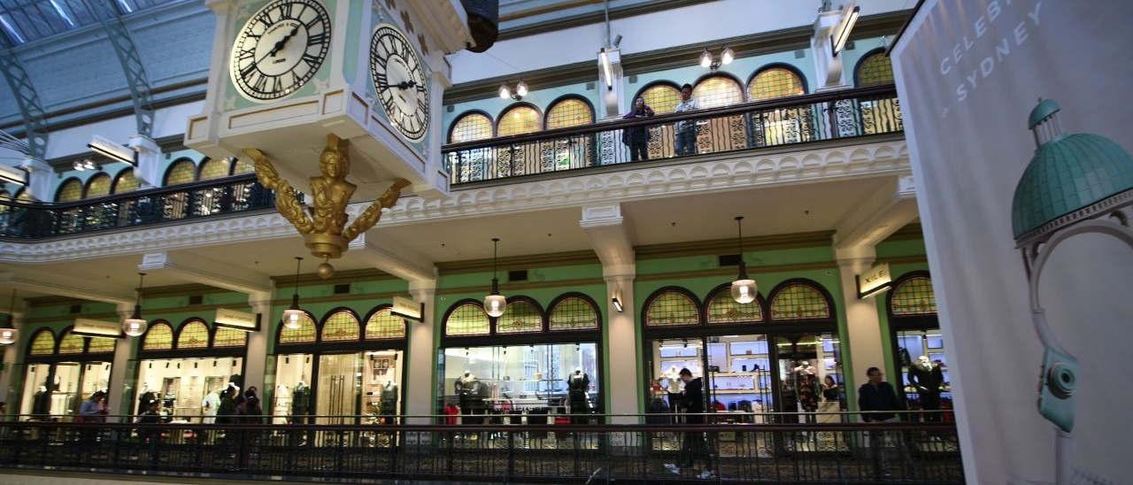

CAPITAL GROWTH RETURNS TO COMMERCIAL PROPERTY MARKETS
Commercial property markets have returned to positive capital growth after two years of adjustment, with national all-property returns reaching 7.4 per cent for the quarter ending December 2025. Ray White Group, Head of Research, Vanessa Rader said the return of positive capital growth at 2.0 per cent marks a shift from the correction phase that dominated recent years. "The December 2025 data represents more than incremental improvement, it marks the transition from yield adjustment to capital growth," Ms Rader said.

Retail sector leads market recovery
The retail sector continues its leadership position, delivering total returns of 9.2 per cent driven by capital growth of 3.0 per cent alongside income returns of 6.0 per cent. Sub-regional centres lead the sector at 10.9 per cent total returns with capital growth of 3.9 per cent, while regional centres recorded 10.5 per cent returns. "The consistency of performance across all retail subcategories indicates the sector's structural recovery is broad-based rather than concentrated in specific property types," Ms Rader said.

Industrial maintains strong performance
Industrial assets recorded total returns of 8.6 per cent, with capital growth strengthening to 4.1 per cent alongside income returns of 4.3 per cent. "Queensland industrial led with total returns of 10.8 per cent and capital growth of 5.7 per cent, driven by population influx and expanding logistics requirements," Ms Rader said. "Western Australia industrial posted exceptional returns of 10.0 per cent with capital growth of 4.2 per cent, reflecting resource sector strength and supply constraints that continue to attract east coast investors."

Office markets show regional variations
Office markets remain under pressure from structural challenges, though notable regional variations reveal how fundamentals are driving dramatically different outcomes, Ms Rader said.

Total returns reached 5.9 per cent nationally, but capital growth remained subdued at just 0.4 per cent. "Brisbane CBD office delivered the strongest performance with total returns of 10.6 per cent, driven by capital growth of 4.4 per cent," Ms Rader said. "The combination of vacancy below 11 per cent, pre-committed Olympic infrastructure activity, and limited new supply continues to support valuations in the Queensland capital."

She said Melbourne CBD office remains the notable underperformer with total returns of just 3.8 per cent and capital growth declining by 1.6 per cent. "Melbourne represents the clearest example of how vacancy and oversupply dynamics directly impact capital values," Ms Rader said.

Quality assets outperform
Ms Rader said the return to positive capital growth validates the strategic positioning that many investors adopted during the downturn. "Those who acquired quality assets at expanded cap rates are now seeing both strong income yields and emerging capital growth," she said. "However, capital growth isn't returning uniformly across all assets. The data clearly demonstrates quality and positioning matter more than ever, with premium assets in strong sectors achieving meaningful capital appreciation while secondary assets in challenged sectors continue facing value pressure."

She said that despite upward inflationary pressures on interest rates seen in 2026 potentially dampening urgency in the marketplace, capitalisation rates are likely to remain in their holding pattern. "For investors seeking to position portfolios for the next growth phase, understanding which specific markets and property types are leading capital growth will likely be critical to generating superior returns," Ms Rader said.

AI AUTOMATION SET TO RESHAPE AUSTRALIAN INDUSTRIAL PROPERTY MARKET

Australian industrial property continues to lead commercial real estate performance, but artificial intelligence is poised to fundamentally transform which assets remain competitive, according to Ray White. Industrial property delivered total returns of 8.6 per cent in December 2025, with capital growth of 4.1 per cent, the strongest of any major asset class.

"Industrial was Australia's most-traded asset class in 2025, with $29.58 billion changing hands across the year, up 44.9 per cent from 2024, accounting for 36.8 per cent of all national commercial property activity," Ray White said.

Average transaction sizes have grown to $6.01 million as buyers recognise existing stock carries genuine scarcity value, with Brisbane nearly doubling its volumes to $7.84 billion while Sydney remained the dominant market.

"The depth and consistency of this activity, drawing institutional capital from Canada, Singapore and the United States alongside domestic super funds and REITs, reflects a market that global investors continue to regard as fundamentally undersupplied," Ray White said.

AI driving operational transformation
Ray White said artificial intelligence is rapidly moving from a back-office tool to the engine room of modern warehouse and logistics operations. "Automated storage and retrieval systems, autonomous mobile robots and AI-powered inventory management are becoming standard fitout in the most sought-after facilities globally," Ray White said.

The warehouse automation market in the United States is projected to more than double from US$25 billion in 2024 to over US$54 billion by 2029, with Amazon targeting 30 to 40 per cent automated order fulfilment by 2030. "Australia is well positioned to benefit from these trends. The country's persistent labour cost challenges and the concentration of e-commerce and logistics activity along major metropolitan fringe corridors create the same economic incentives for automation," Ray White said. The transport, postal and warehousing sector recorded 5.1 per cent business growth in the year to June 2025, among the fastest growing industries in the country.

Supply constraints intensify pressure
The NSW Government's Employment Lands Development Monitor reveals the severity of supply constraints in Sydney. "Of the 20,210 hectares of zoned employment land across Greater Sydney, just 631 hectares of undeveloped land has access to water and sewer connections, representing less than nine per cent of all undeveloped stock," Ray White said.

Almost all of this sits in Western Sydney, concentrated around the Aerotropolis precinct. "For the vast majority of established Sydney industrial markets, developable land is effectively exhausted. As the logistics industry moves toward AI-driven automation that demands larger, more technically specified facilities, the land capable of accommodating those buildings is further from the city than ever," Ray White said.

New specifications creating market divide
AI-enabled automation systems require substantially greater power capacity than conventional warehousing, along with high-bandwidth data infrastructure, enhanced temperature control and redundant power supply. "Assets that could meet these requirements will likely command premium rents and attract the strongest tenants. Those that cannot face growing obsolescence pressure," Ray White said.

Ray White said the relationship between AI and overall demand for industrial space is complex, with smarter supply chains driving e-commerce growth while efficient inventory management could reduce total footprint requirements. "The net effect on aggregate demand is uncertain, but we're seeing movement toward well-specified, technology-capable assets in locations with strong logistics connectivity, and away from ageing secondary stock," Ray White said.

"For investors, the near-term picture for industrial property remains among the most attractive in the commercial sector, but the medium-term opportunity lies in understanding which assets are positioned to meet tomorrow's occupier requirements."

.
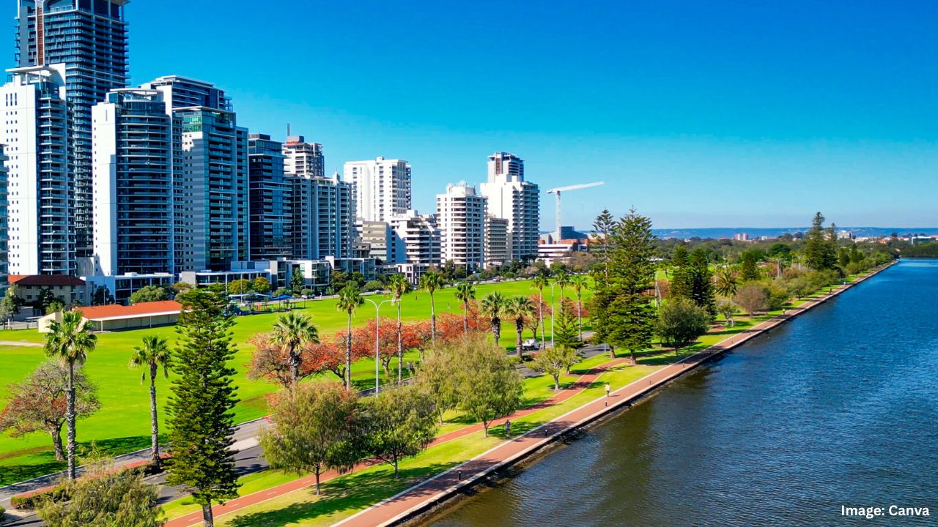

BRISBANE AND PERTH OFFER COMPETITIVE OFFICE FIT-OUT COSTS IN AUSTRALIA
Investors looking to fit out office spaces in Brisbane and Perth are benefiting from the competitive costs in Australia, though prices are expected to rise significantly over the next year. According to Knight Frank's Fit-Out Cost Guide 2026, Brisbane and Perth recorded the most affordable office fit-out costs in the country at an average of $934 per square metre. However, both cities still ranked among the top 10 most expensive capital cities across the Asia-Pacific region.

Sydney and Melbourne remained the most expensive Australian capitals for office fit-outs, with average costs of $1,334 and $1,300 per square metre respectively. The significant price gap between these major cities and their mid-sized counterparts reflects different stages in their market cycles and varying labour pressures.

The report revealed that fit-out prices across Australia are set to increase between 2 per cent and 5 per cent over the next 12 months. The anticipated rise is being driven by tightening labour markets, sustainability requirements, and global trade uncertainty affecting material costs.

Singapore topped the Asia-Pacific region as the most expensive market for commercial office fit-outs, with costs exceeding $2,000 per square metre. Knight Frank Australia national head of project management Mark Blinco said the Australian market varies significantly depending on location.

"The Australian market is at very different points in its cycle depending on what capital city you look at," Blinco said. "We have Sydney, where fit-out costs remain high and will likely continue to grow due to labour and material cost pressures, but also softer markets like Brisbane and Perth, where costs remain steady but are overall more manageable, even with infrastructure booms underway for the Olympics in 2032." Blinco noted that Melbourne's office market continues to experience the lingering effects of the city's COVID-19 shutdowns and changes to office mandates, which have kept fit-out prices elevated.

Knight Frank head of project management for Queensland, Paul Kennedy, said Brisbane's competitive pricing position may not last long. "Brisbane's average fit-out cost places it below Sydney and Melbourne, keeping the city attractive for occupiers managing capital budgets; however, broader construction cost escalation is unavoidable," Kennedy said.

Kennedy highlighted that labour shortages pose a significant challenge for the Queensland market. "Labour shortages reinforce this pressure. Queensland faces a construction workforce shortfall peaking near 50,000 workers in 2026–27, elevating risks of delays and cost overruns," he said.

The workforce shortage in Queensland is expected to create additional pressure on both timelines and budgets for commercial property investors undertaking fit-out projects in the coming years Knight Frank head of global portfolio solutions for Asia-Pacific, Francesco Demarco, said investors need to take a more strategic approach to fit-out planning. "The challenge for occupiers is no longer controlling fit-out costs, but understanding why costs are rising and what it means for long-term strategy," Demarco said.

"The return on capital investment is increasingly harder to justify. Labour constraints, sustainability compliance, and trade-related material pressures are structural; they will likely not resolve quickly. Therefore, the smart approach is to integrate fit-out planning into broader portfolio decisions from the outset, aligning specification levels with business requirements, and using cross-market cost data to make more informed capital investment decisions."
HOW SLOW-PAYING CLIENTS COULD DAMAGE YOUR BUSINESS
For many small and medium businesses, getting paid on time could be one of the biggest challenges. It’s not uncommon for invoices to carry payment terms of 30, 60 or even 90 days, particularly in industries like construction, manufacturing and wholesale. While long payment terms may seem like a normal part of doing business, slow-paying clients could quietly create financial pressure behind the scenes. Even profitable businesses could run into trouble if cash isn’t arriving when it’s needed. Understanding how delayed payments affect your business could help you take steps to protect your cash flow and keep operations running smoothly.

Cash flow bottlenecks
Cash flow is the lifeblood of any business. Even when sales are strong and invoices are being issued regularly, delayed payments could create bottlenecks that make it difficult to cover everyday expenses. When cash is tied up in unpaid invoices, businesses may struggle to pay wages, rent, utilities or other operating costs. This could create a situation where revenue looks healthy on paper, but the business still feels financially stretched. Over time, these bottlenecks could force businesses to rely on credit cards, overdrafts or short-term borrowing just to keep things running.

Supplier payment delays
Slow customer payments could also create a chain reaction throughout the supply chain. If you’re waiting on invoices to be paid, you may need to delay payments to your own suppliers. While this may solve the short-term problem, it could strain relationships with the businesses you rely on. Suppliers may tighten credit terms, reduce payment flexibility or prioritise customers who consistently pay on time. In some cases, they may even require upfront payments, which could put additional pressure on your working capital.

Lost growth opportunities
One of the less obvious impacts of slow payments is the opportunities a business may miss. When cash flow is restricted, businesses may have to turn down new contracts, delay hiring staff, or postpone purchasing equipment that could help increase productivity. In other words, the business may be profitable and growing in theory, but lack the cash to actually invest in that growth. Over time, this could limit the ability to expand and compete with businesses that have stronger cash flow.

Stress on working capital
Working capital represents the funds a business uses to manage its day-to-day operations. When a large portion of that capital is tied up in unpaid invoices, the financial pressure could build quickly. Businesses may find themselves constantly juggling expenses, delaying payments, or dipping into reserves just to keep operations moving. This could create uncertainty and make financial planning more difficult.

In some cases, businesses explore solutions such as tightening payment terms, improving invoicing processes, or using invoice finance to access funds tied up in outstanding invoices. Delayed payments are often an unavoidable part of running a business, particularly when working with large clients that operate on extended payment cycles. However, there are a range of options that might help, like invoice finance or even lines of credit. Speak to a finance broker today to compare your options for getting your business's cash flow back on track.

.



5 MISTAKES BUSINESSES MAKE WHEN FINANCING EQUIPMENT
For many businesses, new equipment is essential to growth. Whether it’s machinery, vehicles, or specialised technology, the right assets could improve efficiency, increase production, and help secure larger contracts. But financing equipment is a financial decision that needs careful planning. While equipment finance could be a great tool for preserving cash flow and spreading costs over time, mistakes in the process could create unnecessary financial pressure down the track.

Here are five common mistakes businesses make when financing equipment and how to avoid them.

Focusing only on the interest rate
It’s natural to look for competitive choices when comparing finance options. However, the interest rate alone doesn’t tell the full story. Fees, loan structure, repayment flexibility, and loan term could all affect the true cost of the finance. Some loans may differ in interest rate but may offer more favourable terms, such as competitive choices or more flexible repayments. When evaluating equipment finance, it’s important to consider the comparison rate and the overall loan structure rather than focusing solely on the headline rate.

Ignoring maintenance and operating costs
The purchase price of equipment is only part of the picture. Ongoing costs such as maintenance, servicing, insurance, fuel, and repairs could significantly impact the total cost of ownership. Businesses sometimes finance the asset itself without factoring these additional costs into their cash flow planning. If those expenses are higher than expected, they could put pressure on monthly budgets. Before committing to finance, it’s worth estimating the full operating costs of the equipment and ensuring they fit comfortably within the business’s financial capacity.

Financing assets with short lifespans
Another common mistake is financing equipment over a period that outlasts the asset’s useful life. For example, if equipment is likely to become obsolete or require replacement in three years, financing it over five years could leave the business paying for an asset that is no longer generating value. Matching the finance term with the expected lifespan of the equipment helps ensure repayments align with the period the asset is contributing to the business.

Overestimating future revenue
New equipment is often purchased with growth in mind. It may allow a business to increase production, take on new clients, or improve efficiency. However, assuming that revenue will likely increase immediately could be risky. Growth could take time, and external factors such as market conditions or customer demand may influence how quickly the equipment generates additional income.

When planning equipment finance, it’s generally safer to base repayments on current cash flow rather than projected revenue growth.

Not comparing lenders and finance options
Equipment finance products could vary widely between lenders. Interest rates, fees, approval processes, and repayment structures could all differ depending on the provider. Some businesses accept the first offer they receive without exploring alternatives. Taking the time to compare lenders and finance structures could help meet the needs of the business. A finance broker could help compare options across multiple lenders.

This is general information only and is subject to change at any given time.
Your complete financial situation will need to be assessed before acceptance of any proposal or product.

