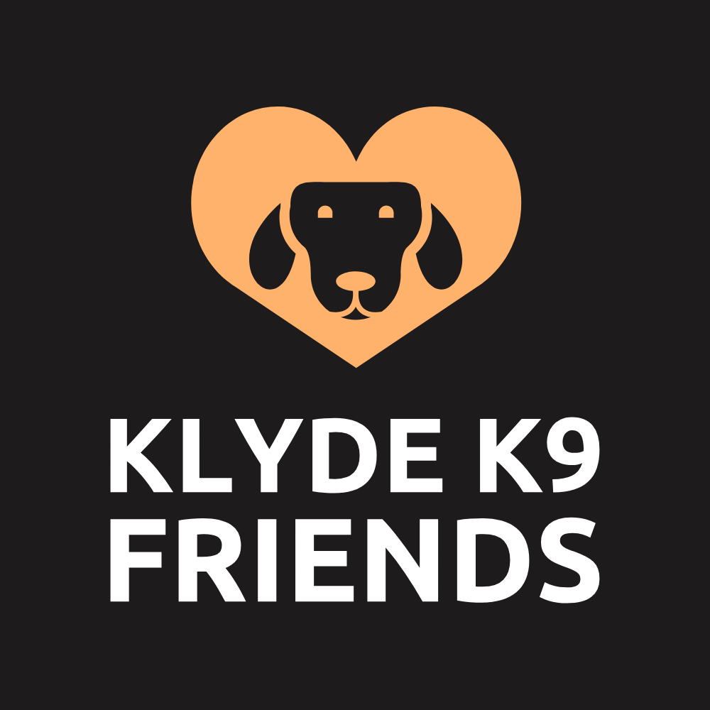,
Dog Daycare Application Form
Please fill out all information on Pages

Owner Information
Title: Forename and Surname: Email:

Home Phone: Work Phone: Mobile Phone:

Home Address:

Alternative Contact
Title: Forename and Surname: Email:

Home Phone: Work Phone: Mobile Phone:

Emergency Contact/Pickup (If urgent contact is required during the day and you are not available)
Title: Forename and Surname: Email:

Home Phone: Work Phone: Mobile Phone:

How many other dogs in the household: Is your dog child friendly:

How did you hear about us?
Word of mouth Leaflet Vet
Klyde K9 Facebook Instagram Other
Website Local Advertising
If other, please specify:
Dog Information:
Name Breed: Sex Male/Female:

Date of birth (Age): Colour: Spayed/Neutered:

Microchip number:

Veterinary Information:
Vet Practice: Address:

Telephone Number:

Dog Medical and Health (If yes please complete)
Kennel Cough Date Received: Date Due:
Yes No
5 in 1 (Dhppv, Distemper, Parvo etc.) Date Received: Date Due:
Yes No
Fleas/Worm Treatment Date Received: Date Due:
Yes No
Any Medical Condition If yes please specify (hips joints, seizure, please indicate any vet advice)
Yes No

Recent injury/illness If yes, please specify (Please indicate any bet advice)
Yes No
Taking any medication If yes, please specify (Please indicate any bet advice)
Yes No
Allergies/Food sensitivities If yes, please specify (Please indicate any bet advice)
Yes No
Dog Behaviour
Where does your dog spend most of its days? Is your dog allowed on the furniture at home

Number of walks a day? Average length of walks (mins) On lead (Yes/No)

How many times is your dog fed per day? Are you happy with treats at daycare (Yes/No)

Has your dog ever …
Reacted negatively around food (i.e., growling/resource guarding)
Escaped from your property
Growled at someone
Bitten someone/another dog
If yes, please specify the details:

Dog Socialisation
How often does your dog socialise? Does your dog enjoy playing with other dogs?

How does your dog react to other dogs on lead? How does your dog react to other dogs off lead?

Does your dog share/eat food with other dogs? Does your dog share toys with other dogs?

Dog Training
Has your dog/s attended any formal training (if yes, please detail who with and to what level)

Pet Services/Products used
Has your dog attended dog daycare before? Has your dog attended a grooming service before?

Has your dog had a negative reaction to any of these services? (if yes, please specify the details)
What type of food does your dog eat?
Dry/Biscuit (Brand) Other (Brand)

Wet/Tinned (Brand) Treats (Brand)

Raw (Brand)

Will your dog be due a meal while at daycare? (If yes, what time? You will need to provide a daily portion at each visit)

Klyde K9 Friends
To have a better understanding of your dog's needs, please indicate the type of services that you are interested in. These details are used as part of our meet and greet sessions, where you can discuss our services in more detail. This application form does not commit you to any ongoing Klyde K9 Friends.
Daycare
Frequency (1-5 times a week) Full Day/Half Day: Preferred Days:

Assessment Mornings
All assessments are conducted between 9.00am and 11.00am Tuesdays and Thursdays. We will be in contact shortly to arrange a day that suits you best. You and your dog will be required to stay with us for the first half an hour, then you can leave your dog with us for the rest of the morning.

Terms and Conditions Please read and sign
Liability
I (the owner) confirm to Klyde K9 Friends Ltd that I am legal owner of my dog; that my dog has not been ill with any contagious disease or condition within the past (30) thirty days and that my dog has received all necessary vaccinations. I understand that Klyde K9 is an open day care center. I agree that my dog will socialise with other dogs, and I accept the risks involved and agree that Klyde K9 are not liable for any injuries or illnesses resulting during my dog’s attendance.
I understand that to attend the daycare my dog must be spayed/neutered in line with government regulations in relation to dog daycare. Chemical castration is an acceptable form of neutering for male dogs to attend. Unspayed females can attend but must not attend their sessions while in heat.
I understand that if my dog has a history of aggression or biting, Klyde K9 reserves the right to refuse entry to my dog and I have disclosed to Klyde K9 any known dangers associated with my dog. Any behaviour deemed dangerous or inappropriate by Klyde K9 may result in the instant dismissal of my dog(s) and forfeiture of current blocks payment. This will include any behaviour deemed anti-social by Klyde K9, which will include excessive barking, aggression to staff or other dogs or escapist tendencies.
I expressively waive and relinquish all claims against Klyde K9, its employees and representatives, except those arising from negligence on the part of Klyde K9. I understand that under no circumstances will Klyde K9 be liable for consequential damages or damages beyond the replacement value of my dog.
The transporting of my dog to and from dog related activities, I recognise the risks of injury associated with transporting my dog to and from the property. I expressively waive and relinquish any and all claims against Klyde K9 Friends Ltd, its employees and representatives, except those arising from negligence on the part of Klyde K9.
If any medical problems develop while my dog is in the care of Klyde K9 and I cannot be contacted, I authorise them to do whatever they deem necessary for the safety, health and wellbeing of my dog and I agree to assume full financial responsibility for all expenses incurred.
I understand that my obligation under the Control of Dogs Act 1992: states that my dog must wear a collar and name tag which has my contact details on it. I understand that male dogs over the age one year must be neutered/chemically castrated to attend daycare and that bitches in season must not be brought to the daycare. I understand the Klyde K9 is an all-weather facility and while every effort will be made to dry off dogs before they return home, I accept they get dirty and/or wet while having fun.
I understand that my dog must receive the kennel cough vaccination, but I also acknowledge that even if my dog is vaccinated against kennel cough it is still possible for my dog to contract this and will not hold Klyde K9 responsible if this happens. I will comply with the recommended veterinary isolation advice if my dog does contract kennel cough or any other infectious diseases, payment of sessions will not be credited for illness and injury at the discretion of Klyde K9 Friends Ltd staff.
I agree that I will be liable for excessive destruction of property caused by my dog and I confirm my dog is not destructive of household items etc.
I agree with my dog being photographed and filmed while in daycare and to the photographs and films being used for promotional purposes. All such photographs and films will remain the property of Klyde K9 Friends Ltd.

Payment Requirements
I understand that I must pay for day care costs in advance using either standing order, cash or credit/ debit card. I understand that my payment is to secure my dog(s) place at daycare and if I want to keep their place I must pay for the place and not attendance. This means if you wish to place your dog in daycare 2 days a week, you must pay the month in advance placement i.e. 4 weeks, 2 days a week. Payment is needed and non-refundable or exchangeable if you decide not to send my dog to daycare on any given day.
You are entitled to a 2-week payment break from daycare payment each year, this will allow you to not bring your dog to daycare and not have to pay to reserve their place during this time. We can of course discuss longer breaks on an individual basis and are willing to be flexible. Please talk to a member of staff if you need more than 2 weeks, this is at the discretion of Klyde K9 only.
I agree to pay for the month’s daycare in advance and no later than the 1st day of that month. For example, your place for January must be paid by the 1st of January or your dog will not be granted access to daycare services.
I understand that I will be charged 100% for ‘no shows’ or call offs within 24 hours of expected attendance. Call offs within 48 hours notice may be credited at the discretion of Klyde K9 and is not guaranteed. I understand that the hours of operation are 8am – 5:30pm and a £5 late fee charge applies for every 15 minutes thereafter. If I have not picked my dog up by 7:00pm, Klyde K9 will plan for overnight boarding at my expense.
If I purchase a morning session and fail to pick my dog up by 1pm, I will be charged the full day rate. If I purchase an afternoon session and fail to pick up my dog by the session end time, additional late fees will apply as above.
I agree with my details being kept on file for the duration of my dog’s attendance at Klyde K9 Friends Ltd daycare. My details will remain confidential and will not be shared with anyone other than the accountant if necessary. If at any point my dog no longer attends Klyde K9 Friends, my details will be promptly and securely destroyed.
Please note that previously purchased sessions may be credited at the discretion of Klyde K9 staff only and all credited sessions must be used within one month of the credit date. Please note that all purchased sessions must be used within three months of purchase date, or all payment will be forfeited, and all registration fees are non-refundable. If you intend to remove your dog from daycare, a month’s notice is required.
I confirm that I have read, fully understand and will abide by the terms and conditions of this agreement.
Payments to be standing order (direct debit) can be made via: Cash, Bank Transfer or Card Machine on site,
Bank Details
Account Name: Klyde K9 Friends Ltd
Account Number: 19416074
Sort Code: 83-22-20
Alternatively, payments can be made via card at the Daycare premise on our bank card terminal.

Accept Terms and Conditions
I have read all the above and agree:
Sign : Print:

Date:

