Home Learning Tasks Year 5 Mars class
Date due: Week commencing 23.02.26
  Be a Regular Reader!  Please read every day and read a range of books. Make sure that you read aloud too as this is a different skill. You will need to make a note of what you have read under each day in your diaries. Remember when you have finished a book write a review or tell us about it. | Be a Word Whizz!  Practise the spellings you are given. You will need to look at these several times a week. We will test on the following Fridays (as a dictation). | Be a Mathematician!  Log on to TIMES TABLE ROCK STARS and answer a minimum of 100 questions a week. We will be looking for this to be above 90%. If you have trouble accessing TTRockstars at home, you can use an iPad at break or lunch times.
Vocabulary quizzes
Mars will be having regular quizzes throughout the term to see if they have retained what they have been taught. Please revise the vocabulary on the back of this sheet and their definitions regulary ready for the quizzes!
Be a Builder!  Explore your street and local village. What is the name of the road you live on? Create a 3D model of your street (or village) using any materials of your choice (e.g. clay, Lego, bricks and stones). | Get active outdoors!  Download or get a map of your local area or further afield if you wish (plenty of lovely places in Norfolk) and plan a walking route.  Take photos of the route you plan and you enjoying your walk and upload them to Class Dojo.  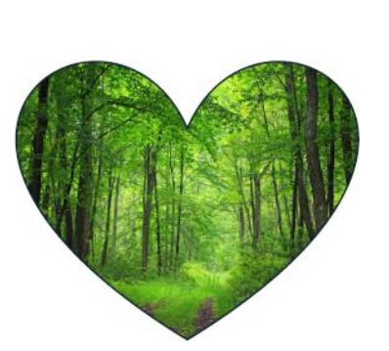 | Mapping the future  What will Stoke Ferry look like in a hundred years’ time? Where will people live, work and spend their free time? What building materials will be used? How will it be more eco-friendly? Draw a map or make a model to show your ideas.
Be a researcher  Find out about Napoleon and write down at least seven facts about him. | The Storming of the Bastille  Draw a comic strip showing what happened during The Storming of the Bastille. | The execution of Royalty  Write an eye witness account of the execution of King Louis XVI and Queen Antoinette.
e
The homework grid should be completed within the half term. The compulsory tasks ( ) must be completed each week. You then need to complete at least one additional task from each coloured column by the end of the half term.
- All work needs to be completed in your homework books, photos should be taken and stuck in or drawings and explanations written of models etc.
- Work can be handed in for marking as and when it is completed or by Friday 16th February 2024 at the latest.

The French Revolution and UK Geography
The French Revolution |  | UK Geography
Revolution | a time when people, ruled or governed by a power, overthrow that power and try to  change how people live and work | Industry | Activity where raw materials are changed into goods that can be used and traded.
Absolute monarchy | when a king or queen is in complete control and doesn’t need to follow any rules or laws | Arable farming | Farming where crops are planted, tended to and then harvested.
Republic | a country governed by elected representatives, not by a king or queen | Pastoral farming | Farming where animals are raised and used for food or other produce such as  wool.
Clergy | people who have a role within the church, e.g. Catholic Priest | Mining | Where a raw resource is extracted from the earth, for example, coal.
Nobles | wealthy people from families who are considered important | National Park | An area protected by laws to ensure land is preserved.
Debt | a sum of money that is owed | Viaduct | A type of bridge built across a valley to allow transport to cross from one side  to another.
Exile | when a person is banned from living in a country, often used as a punishment | Valley | The low-lying land between mountains or hills.
Allied | joined together, countries sometimes join together to fight in wars | Relief Map | A map showing the shape and height of land.
The Bastille | a prison in Paris used by the French kings | Population | The number of people living in a specific area.
Battle of Trafalgar | a battle that took place off the coast of Spain between the French and the British  navy: it was won by the British admiral, Nelson, who defeated Napoleon and prevented  a French invasion of Britain | Topography | The surface features in an area of land, e.g. hills, mountains, valleys, lakes and  rivers. Topography can also include features made by humans such as  viaducts, dams, roads, and even cities.

