2025-2026 Autumn 2 Transport Homework Grid
Personal, Social and Emotional Development  Road safety  - Go outside with a grown up and learn where and how to cross the road safely.  Watch Pip and Declan learn about road safety.  https://www.bbc.co.uk/bitesize/topics/zfcvhbk/articles/z62nxyc  Board games  - Play a board game – practise taking turns and celebrate winning or losing! Learn that it’s the taking part that counts.  Pass a Smile  - Can you pass a smile to someone in your family, do they notice? How does it make you feel? | English  - Can you find some non-fiction books, from home or maybe from the library about transport? We would love to see them.  - Can you draw and label your favourite transport?  - Can you discover a new book about transport online? (You can sign up to ‘Vooks’ for free or search on YouTube for children’s stories).  - ‘Books for Topics’ recommend some lovely books about transport Children's Books: Transport and Journeys (booksfortopics.com)  - Learn to recite different nursery rhymes or simple poems by heart. Can you add your own actions?  Join in with World Nursery Rhyme week.  https://www.worldnurseryrhymeweek.com/  - We will send homework for phonics and reading separately, please look out for this in book bags or on Dojo. Thank you. | Maths  - Learn different number songs such as 1, 2, 3, 4, 5 Once I caught a fish alive, 5 little monkeys and 10 Green Bottles.  https://www.bbc.co.uk/teach/school-radio/nursery-rhymes-a-to-z-index/z4ddgwx  - Draw a circle outside and then throw 3 bean bags or similar and see how many land inside the circle and how many land outside the circle.  - Can an adult hide some toys in your garden? Can you go on a toy hunt to find your toys? Can you describe to the adult where you found the toys? (Think about positional language – on top, behind, next to).  - Can you play this game with an adult? Ask your adult to hide up to 5 toys under a bucket/box, lift up the bucket/box, can you subitise how many toys there are?
Understanding the World  - Can you find out about transport in different countries get an adult to help you find out about – tuk tuk’s, gondolas, Felucca, Dog sled, bullet train. Which part of the world do these come from? Can you locate it on a World map?  - Can you look at some pictures of transport from the past? Can you make a collage of transport from the past and transport used today around the world?  - Choose a selection of items from around the house and predict if you think they will float or sink before testing each item in the bath or sink. Did you notice any patterns? Why do some float and some sink? |  | Communication and Language  - Can you play Simon says following directions and recognise down, up, left and right.  - Can you read a story you know well together and can you retell the story. Could you order pictures of the story and explain the story to an adult.  - Can you teach someone some prior vocabulary from Drawing Club?
Physical Development  Seasonal walk  Go for a walk to the local park, river or beach. Take a bag and collect different natural items to use for loose part counting and art.  Put on your favourite songs and dance along to the beat!  Can you move your body in different ways? Can you dance alone and with a partner (mummy, daddy, teddy, friend, etc.)? Can you dance to slow music and to fast music?  Can you make up a routine? Try to remember the different moves in sequence. | Show and Tell  Children can bring in or share on Tapestry and we will share this with the class on our interactive whiteboard. They especially enjoy finding out about something, if it is linked to our topic. | Expressive Arts and Design  - Can you make a picture of the 4 seasons? Split your page into 4 parts and draw a tree in each part. What colours would you need in each season?  - Collect boxes and tubs and use them to make a junk model of some sort of vehicle. What adventure can you have with them?
Please continue to share as much as possible on Dojo.

Key vocabulary for the half term | Exciting books for topic  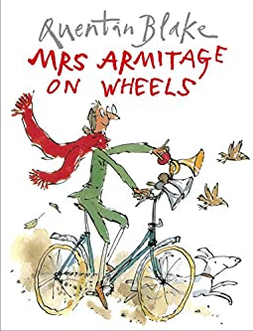  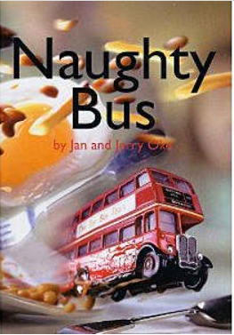  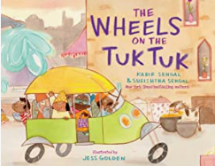  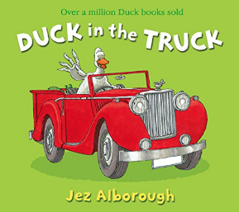  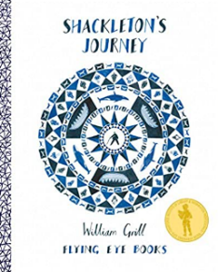  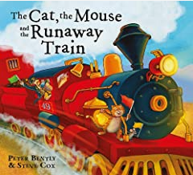  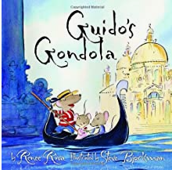  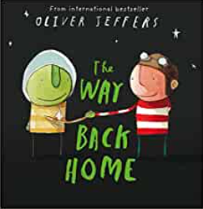
  Journey | When we travel from one place to another.
  Transport | When we travel using a vehicle.
  Road Safety | Rules to keep us safe when we travel.
  Technology | Using what we know to make things that can help us. Vehicles use technology.
  Invent | To create something new.

