Our trip this term will be to Wells beach to consolidate our science learning on animals and their habitats and our geographical learning based on the coast and rural areas.

Science – Astronomy
During this unit of work the children will learn about:
Introduction to Astronomy
Model of the Solar System
Orbit and Rotation
The Moon and its Phases
Constellations

.

PSHE- Relationships
Children will consider the question, How do we recognise our feelings? Children will learn to name and describe feelings, identify things that make us feel good or bad and what to do to help ourselves when we feel bad.

Investigators
Powerful Voices
Summer 2

History
The children will be studying the topic of Powerful voices. They will focus on the following:

Gandhi
Rosa Parks and Martin Luther King
Malala Yousafzai
Greta Thunberg
David Attenborough

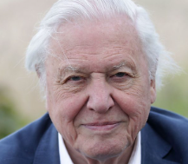
Music
The children will be exploring the unit: Lullabies. The musical focus will be on how lullabies effect the way we feel. The genre focus and repertoire will be traditional, jazz and 21st century. Our final piece will be to create a soundscape to fall asleep to by including dot notation for pitch patterns and stick notation for rhythm.

RE
Our unit is ‘How do people welcome a new person into their community?’. This involves learning about the Baptist Christian community, the Muslim community and the monastic community.

Art
This half term the children will be learning about Murals and Tapestries. They will focus on:
Introduction to murals
Frescoes-Michelangelo and the Sistine Chapel
Crivelli’s Garden- Paula Rego
Tapestries
The Last Supper- Leonardo da Vinci
Completing a class mural

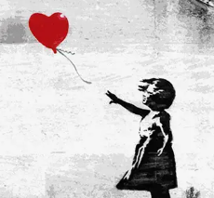
PE –Striking and Fielding
This half term the children will develop the skills of catching, throwing and striking.
Computing – Digital Citizenship
This half term the children will learn about news and media literacy. Children will explore sources to understand if they are reliable or not. In our computing lessons, we will be using ‘scratch’ to make our own animations.
HALF TERM VALUE – Trust The value of trust will be woven into all learning.

