Be a regular reader!  Investigators Homework Grid  Summer 1    Please read to an adult daily and get your reading record book signed so I can see all the super reading you are doing! Books will be changed weekly when I am confident you are able to read it fluently. Remember for every time you read at home, you will earn a raffle ticket for the end of term reading prize.  Make sure when you read your book with an adult you discuss your book with them. What was your favourite part of the story? What did you learn from the book? Who was your favourite character? | Be a word wiz!  Due Date: Monday 1st June 2026  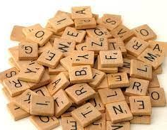  Please practice the spellings you are given each week on Dojo ahead of your spellings test each Friday.  Please also continue to practice the KS1 common exception words, a copy of these can be found in your homework dairies. | Be a number wiz!    Please practice the 2, 3, 5 and 10 times tables every week. You can practice these however you would like!  You could write them, say them, or practice them online.  Useful resources for timetables include:  - Hit the Button  - TimesTable Rockstars (TTRS)  - Complete Maths Tutor.
Become a wonderful writer!  In English this half term, we are learning about poetry. We will focus on ‘Duck’s Ditty’ and ‘On the Ning Nang Nong’.  Write your own poem connecting to divine based on ‘generosity’’ to link to our Christian value this term. This could be a rhyming poem like those studied in class, or even an acrostic poem.   | Be a super scientist!  In science we are learning about Materials and Matter. Conduct your own experiment at home! (with parents supervision)  Can you find a solid, turn it into a liquid and turn it back into a solid again?  Take lots of photos and describe the process in your homework books. | Be a maths marvel!  Practice telling the time! We really need to focus on our time telling skills again this term so it would be very useful for the children to continue practicing this at home. We will be looking at the following times:  - O’clock  - Half past  - Quarter past  - 5 to
Computing Whizz!  Connect with others by using your skills learnt in computing in Spring 1 to create your own pictogram showing your family and friends favourite animals!  https://www.j2e.com/jit5  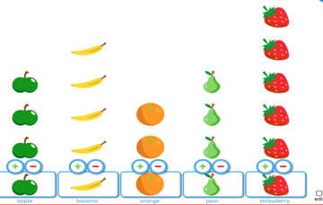   | Become a creative chef!  Enjoy some Northern European cooking! Use the internet with your parents help to research a recipe. Share your recipe and cooking photos with us on Dojo. Can you do a taste test with your family too?  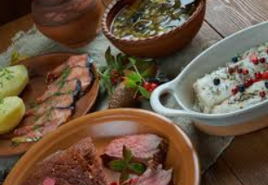  Find some recipe ideas on this website:  https://www.seriouseats.com/northern-european-recipes-5117230 | Be an out of this world artist!  Sketch your own historical painting retelling one of the Greek Myths we studied in Spring 1.  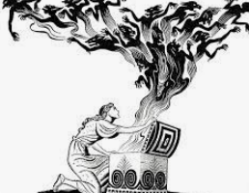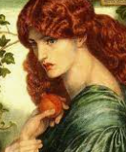

This homework grid gives a range of tasks that you can do with your child this half term. The top three boxes that are marked with a star are tasks that should be completed weekly. These can have significant impact across all your child’s learning.

All work should be completed in your homework books, please record it here even if you have uploaded evidence to Dojo. Please take photos and ensure they are stuck in along with any drawings, paintings or documents that show off the work you have done.

This homework should be completed and returned by Monday 1st June

Key vocabulary for our Geography and Science unit this half term can be seen below. Please help your child to learn and remember these words.

