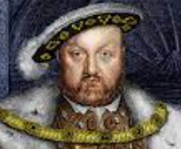
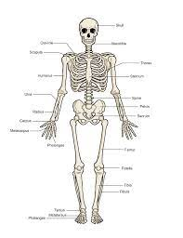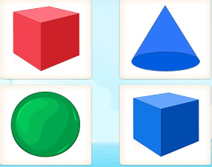
Maths
Length and height:
- Measuring in centimetres and metres
- Comparing and order lengths and heights
- Four operations with lengths and heights

Mass, capacity and temperature:
- Compare mass, volume and capacity
- Measure in kilograms, millilitres and litres
- Four operations with mass, volume and capacity
- Temperature

PSHE
We will be learning about drug education in accordance to the Department of Education requirements. This will involve learning about how substances can affect the body, attitudes towards substances and other ways individuals can feel better without substances like medicines.
History – The Tudors
The children will be focusing on the following:
- Life in Tudor England
- Henry VIII
- The English Reformation
- Edward VI and Mary I
- Queen Elizabeth I

Art and Design – Landscapes and symmetry
This half term the children will be focusing on:
- Introduction to landscape painting
- Constable and Turner
- Painting in the style of Turner
- Symmetry in art
- Goldsworthy and symmetry
Investigators
Spring 2
The Tudors
Computing and Digital Citizenship
- We will be learning about Programming. This will involve looking at robot algorithms and using a floor robot. We will then to begin to design our own algorithms.
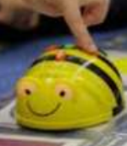
Music
Our learning will focus on ‘Gamelan’. There will be a musical focus on tempo and dynamics. During this unit, we will be looking at different timbres and percussion instruments and how to create these.
PE – Multi-skills
They will be practising sending and receiving a ball. They will also develop knowledge of attacking and defending roles.

English
Reading – The children will be reading the text, ‘The Aesop’s Fables’ by Geraldine McCaughrean which is based on a variety of animals with lots of different personalities!

Writing – Children will write descriptive sentences and retell the fables studied. They will plan their openings, problems and resolutions to stories. The children will also explore instruction writing.

Grammar – The children will learn how to use inverted commas and a variety of speech verbs within their work. We will also continue to use apostrophes for possessions and contractions.

Spellings – We will continue to learn spelling rules for adding prefixes and suffixed to root words.
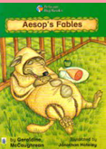
Science
This half-term we will be learning about Plants.

During this unit of work we will be learning about the plants around us and the differences between seeds and bulbs. We will also be growing our own cress to determine what the optimum conditions are in order for plants to grow.
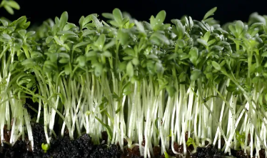

Timetables
We will be beginning to learn our 3 timetables. We will also revisit our 0, 1 , 2, 5 and 10 timetables.

Religious Education
- Our unit this term is based on different case studies involving Muslim and Sikh worldviews. This will involve looking into Onjali Q Rauf and Sir Rabinder Singh.

