Be a regular reader!  Investigators Homework Grid  Spring 2    Please read to an adult daily and get your reading record book signed so I can see all the super reading you are doing!  Books will be changed each week when I am confident you are able to read them fluently. Make sure when you read your book with an adult you discuss your book with them. What was your favourite part of the story? What did you learn from the book? Who was your favourite character? | Be a word wiz!  Due Date: Tuesday 14th April 2026  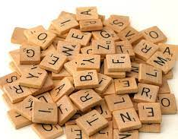  Please practice the spellings for your weekly Friday spelling test. These spellings can be found in your homework books and also on Class Dojo.  Please also continue to practice the KS1 common exception words, a copy of these can be found in your homework books | Be a number wiz!    This term, we are going to be focusing on our 3 times tables. Please also continue to practice the 2, 5 and 10 times tables every week. You can practice these however you would like! Remember I am always looking out for my times table certificate every week!  Useful resources for timetables include:  - Hit the Button  - TimesTable Rockstars (TTRS)  - Complete Maths Tutor.  Going deeper: When you are confident on your 2,3, 5 and 10 timetables, try to answer division questions based on these tables.
Become a wonderful writer!  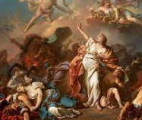  In English this half term, we are learning about Fables  Try and write your own fable (short story) and include the following:  - Similes  - Adjectives  - Speech  - Conjunctions (remember your commas in compound sentences!)  Remember!  When writing your stories please take your time to form your letters correctly and join your letters accurately. | Be a super scientist!  In science we are learning about Plants. Research an exotic plant and make a fact file on it!  - Where is the plant located?  - What does it need to survive?  - How does it grow? In the ground? On a tree? On a bush?  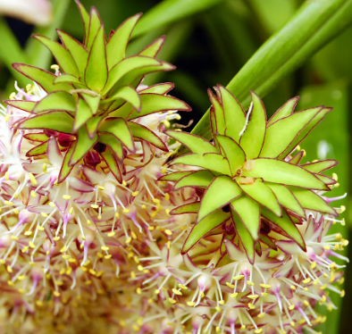 | Be a maths marvel!  Practice telling the time! Next term we will be focusing on telling the time, so it would be extremely useful for the children to start practicing this at home ahead of our learning. This will help them in their SATS. We will be looking at the following times:  - O’clock  - Half past  - Quarter past  - 5 to  Challenge: Complete maths problem solving questions in the table on page 3.  
Christian Value of Creativity using our spirituality heart ‘me, myself and I’.  Write a sentence describing what ‘creativity’ means. How could you express yourself through your portrait?    ‘Creativity means ……..’  Challenge:  Show your creativity by creating a portrait in the style of Picasso using your Spring 1 learning. | Become a honourable historian!  Research life in Tudor England.  What were their clothes like?  What food did people eat?  What games did they play?  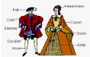 | Be an out of this world artist!  Draw, paint or make a model of a famous landmark in the British Isles. Be as creative as you like.  Can you research your chosen landmark and write some interesting facts about it?  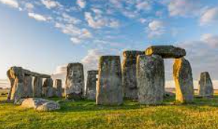

This homework grid gives a range of tasks that you can do with your child this half term. The top three boxes that are marked with a star are tasks that should be completed weekly. These can have significant impact across all your child’s learning. Please see the Maths homework on the next page.

All work should be completed in your homework books, please record it here even if you have uploaded evidence to Dojo. Please take photos and ensure they are stuck in along with any drawings, paintings or documents that show off the work you have done.

This homework should be completed and returned on Tuesday 14th April 2026.

We will be really focusing on handwriting this half term aswell, so if you would like some handwriting packs to take home to practise even more, please Dojo or ask me and I can make you some. Thank you

Maths - In maths this term, we are going to be focusing on reasoning and problem-solving questions based on the different skills and methods we have learnt this year. Please complete at least one from each column, as this will help prepare children for the upcoming SATs in May.

Length and height  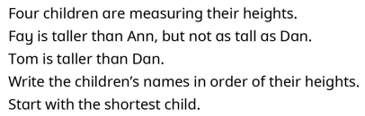 | Multiplication and division  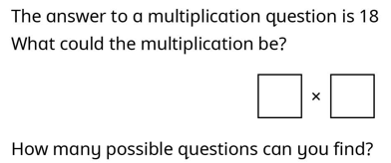 | Mass, capacity and temperature  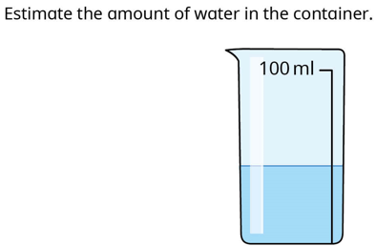 | Fractions  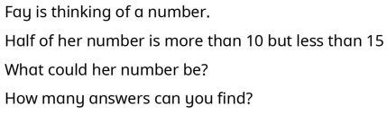
Length and height  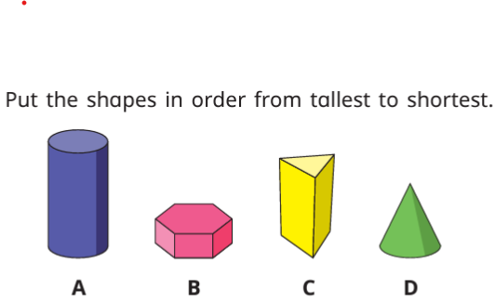 | Multiplication and division  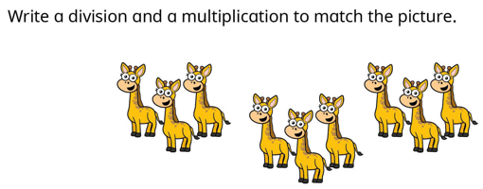 | Mass, capacity and temperature  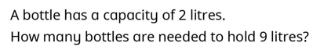 | Fractions  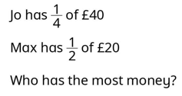
Length and height  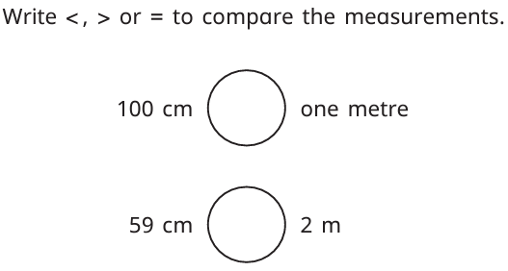 | Multiplication and division  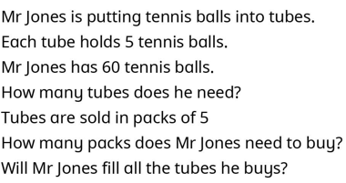 | Mass, capacity and temperature  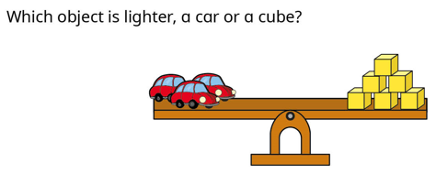 | Fractions  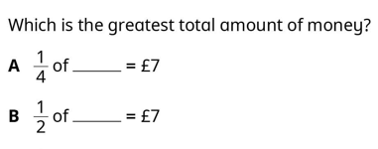

Key vocabulary for our History and Science unit this half term can be seen below. Please help your child to learn and remember these words.
