Be a regular reader!  Investigators Homework Grid  Spring 1  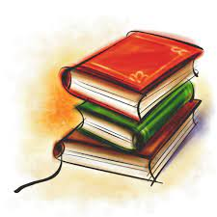  Please read to an adult daily and get your reading record book signed so I can see all the super reading you are doing!  Books will be changed each week when I am confident you are able to read them fluently. Make sure when you read your book with an adult you discuss your book with them. What was your favourite part of the story? What did you learn from the book? Who was your favourite character? | Be a word wiz!  Due Date: Monday 23rd February 2026.  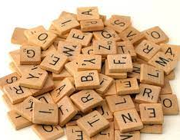  Please practice the spellings for your weekly Friday spelling test. These spellings can be found in your homework books and also on Class Dojo.  Please also continue to practice the KS1 common exception words, a copy of these can be found in your homework books. | Be a number wiz!  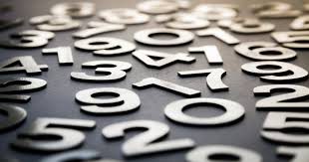  Please practice the 2, 5 and 10 times tables every week. You can practice these however you would like! Remember I am always looking out for my times table certificate every week!  Useful resources for timetables include:  - Hit the Button  - TimesTable Rockstars (TTRS)  - Complete Maths Tutor.  Going deeper: When you are confident on you 2,5 and 10 timetables, try the 3 timetables!
Become a wonderful writer!  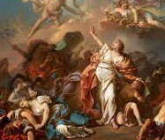  In English this half term, we are learning all about Greek Myths. Choose your favourite Greek Myth and retell it verbally or in written form.  Step for depth: Include expanded noun phrases within your story. | Be a super scientist!  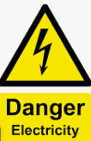  In science we are learning about Electricity. Create a poster on how to be safe with Electricity. | Be a computing genius!  Revisit your Roman learning from History in the Autumn term and create a fact file on the Romans. If you are able to access a computer at home, it would be fantastic to see you include a variety of pictures showing the ways Romans improved life in Britain (aqueducts, roads, sanitation and bath houses).  Some ideas to include in your fact file:  Roman way of life, Roman army, Boudicca rebellion, Romans language, Roman sanitation and Roman towns.
Christian Value of Forgiveness    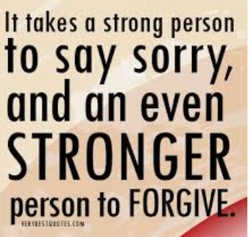  Read a bible story based on forgiveness. Use your storytelling skills to retell the story. Please record evidence on dojo.  Step for depth: Can you think of a time in the bible when someone showed forgiveness? | Become a great Geographer!  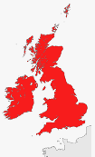  Find and label the countries on a map of the British Isles. Label the capital cities and the names of the seas surrounding the British Isles. Name the small islands that surround the British Isles.  Can you mark on the map where we live? Or any other interesting places you know or have been to? | Be an out of this world artist!  Draw, paint or make a model of a famous landmark in the British Isles. Be as creative as you like.  Can you research your chosen landmark and write some interesting facts about it?  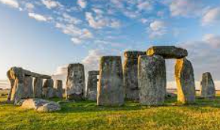

This homework grid gives a range of tasks that you can do with your child this half term. The top three boxes that are marked with a star are tasks that should be completed weekly. These can have significant impact across all your child’s learning. Please see the Maths homework on the next page.

All work should be completed in your homework books, please record it here even if you have uploaded evidence to Dojo. Please take photos and ensure they are stuck in along with any drawings, paintings or documents that show off the work you have done.

This homework should be completed and returned on Monday 23rd February 2026.

Maths - In maths this term, we are going to be focusing on reasoning and problem-solving questions based on the different skills and methods we have learnt this year. Please complete at least one from each column, as this will help prepare children for the upcoming SATs in May.

Addition and subtraction  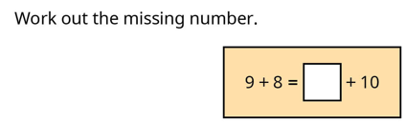 | Shape  Which shape is the odd one out and why?  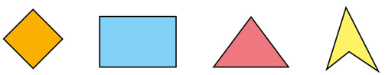 | 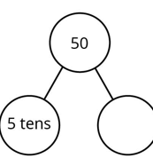  Place Value  What is the missing  part? | Money  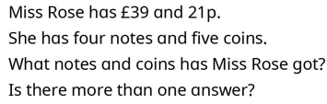
Addition and subtraction  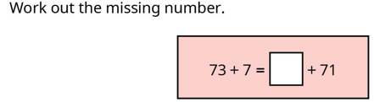 | Shape  Compare the 3D shapes. What is the same? What is different?  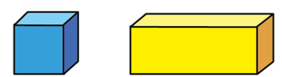 | Place Value  Complete the number sentences.  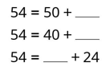 | Money  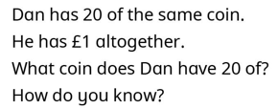
Addition and subtraction  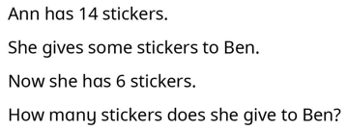 | Shape  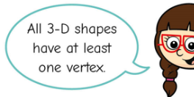  Do you agree with Jo?  Explain your  answer. | Place Value  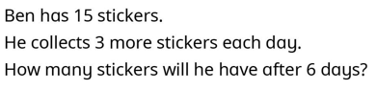 | Money  Ron buys two of these items. He gets 35p change. What did he buy? 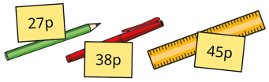
Addition and subtraction  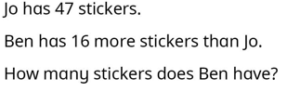 | Shape  Does the picture have a vertical line of symmetry? Explain your answer.  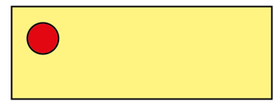 | Place Value  Write the numbers in order from smallest to greatest.  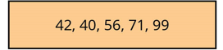 | Money  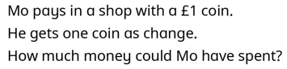

Our key vocabulary for Geography and Science can be found below.

