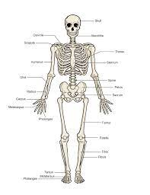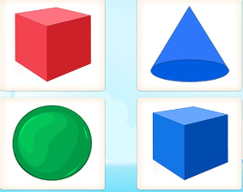
Religious Education
- Our unit is based on different Christian case studies such as John Wesley, Good Samaritan and other local Christian community.

DT
In DT this term, we will be making a pencil case. This will involve designing, making (including sewing and cutting) and evaluating our final product.
PSHE
We will be learning about Diversity and communities. This will involve understanding the importance of acceptance, respect and celebrating individual differences within ours and others communities..
Computing and Digital Citizenship
- We will be learning about Pictograms. This will involve collecting data in tally charts and using attributes to organise and present data on a computer.
Physical Education Our unit this half term is gymnastics. The focus will be on developing flexibility, strength, technique, control and balance.

Geography– The British Isles
This half term we will be focusing on:
- The British Isles and England.
- Scotland.
- Wales.
- Ireland.

Art and Design – Portraits and self-portraits
This half term the children will be drawing and painting self-portraits. They will focus on:
- Portraits and self-portraits.
- Using colour in self-portraits.
- How artists represent themselves.
- Artist study – Picasso.

Maths

Money
- Count money using notes and coins.
- Compare amounts of money.
- Finding change.

Multiplication and division:
- Multiply through repeated addition.
- Multiply using arrays.
- Make doubles.
- Multiply and divide by 2, 5 and 10.
- Identify odd and even numbers.

English
Reading – The children will be reading the text, ‘The Orchard Book of Greek Myths’ by Geraldine McCaughrean.

Writing – Children will write descriptive sentences to describe Pandora’s box and the magic within it and Prometheus and the Pomegranate seed (including the Underworld) from our Greek Myths and retell the story. Children will then write letters to Peresphone.

Grammar – The children will learn how to write simple, compound and complex sentences. Children will also learn how to write exclamation and question sentences and use them appropriately. They will also focus on using commas in lists and after fronted adverbials.
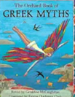
Music
Our learning will focus on ‘Peter and the Wolf’. The musical focus will be on pitch through composing and performing music inspired by the 20th century composer, Prokofiev.
Investigators
Spring 1
The British Isles
Science
This half-term we will be learning about Electricity.
During our sequence of lessons we will be learning about:
- Introduction to Electricity.
- Safety.
- Exploring Circuits.
- Investigating conductivity and non-conductive materials.
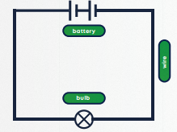

Timetables
0, 1, 2, 5 and 10 timetables. Please continue to use TTRS!

