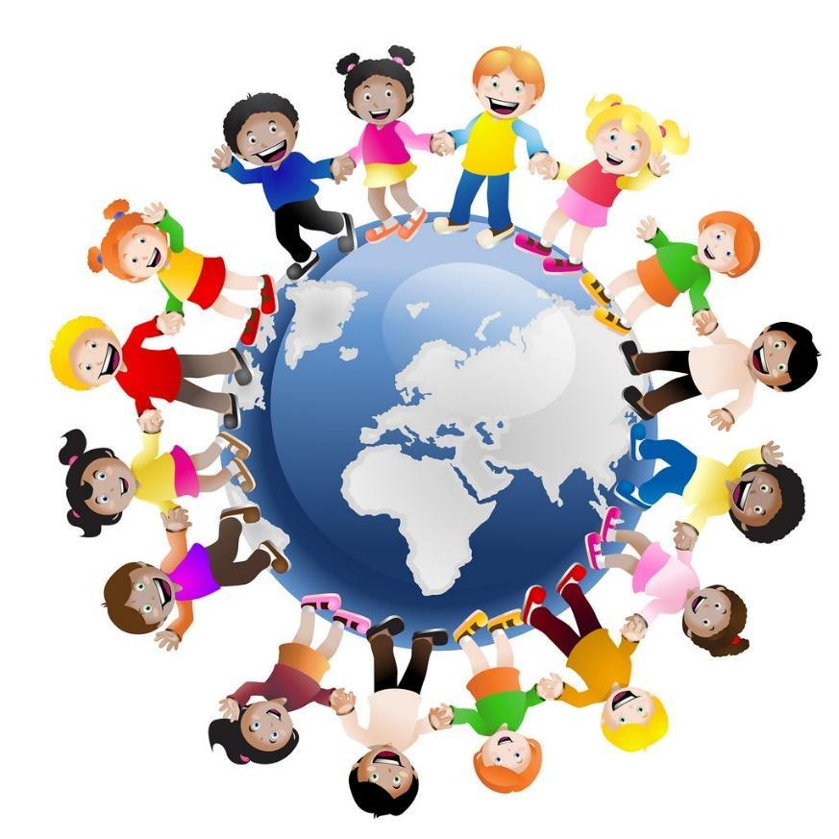
Saturn
Autumn 1
All About Me
Understanding the World
Developing a sense of chronology; my past, present, future and that of others including characters from stories.
Exploring Families; when I was a baby, family trees, diverse representations of family life.
Exploring the location of our school and the local area, including my route to school and how I get there.
Thinking about our local area, what do we like or would like to change.
Exploring our Community; the people who feature in our lives, our school, friends, families, religious communities, people with shared interests, including people who help us in our community.
Exploring the human body: Facial features, main body parts, the senses.
Observing the seasons of the year; autumn, deciduous and evergreen trees.
Expressive Arts and Design
Art:Exploring colours - Dull colours and bright colours. Drawing straight lines, curved lines and painting.
DT:Using different materials by cutting and sticking puppets of ourselves.
Music: Exploring different sounds with our bodies by putting sounds together to make music, listening and moving to music.

Mathematics
Match, Sort and Compare
Match pictures and objects.
Identify a set.
Sorting objects to a type and exploring sorting techniques and rules.
Create sorting rules.
Talk About Measures and Patterns
Compare size, mass and capacity.
Explore and create simple patterns.
Copy and continue simple patterns.

Literacy
Fiction including picture books with familiar settings, relating to families and people who help us.
Oral retelling of familiar stories using own words and recently introduced vocabulary.
Story language; becoming familiar with phrases like ‘once upon a time’, ‘a long time ago’, ‘lived happily ever after’.
Use puppets to retell familiar stories.
Poetry; learning and reciting simple poems with rhyme and repetitive language.
Initial sounds and simple CVC words in line with an approved SSP scheme. (Sounds-write)
Provide opportunities for mark making.
Focus on letter formation in line with our handwriting policy.
Religious Education
Christian Value: Thankfulness
Big question - What makes me Special? Finding out about religious worldviews and ourselves and how some people belong to a religious worldview.

Visit or Visitor
We are hoping to go on a walk around the village this half term to explore the local area.
Physical Development
Spatial awareness and multi-step instruction games.
Running, jumping and moving in different ways with increasing control.
Small tools; cutlery, tweezers, pipettes, scissors. Cutting paper and card, tracing, using templates, playdough.
Drawing myself; what features do I have?
Personal Social and Emotional Development
Talk about likes and dislikes and how they are different from or similar to other children.
Set a simple goal and work towards it.
Wait for what they want.
Give focussed attention to the teacher and other adults in school.
Talk about rules and why we have them in the classroom.
Follow simple rules.
Identify appropriate and inappropriate behaviour in school.
ICT
Exploring what technology is and how to use it safely.
Communication and Language
Listen to others one on one or in small groups.
Join in with repeating refrains and anticipating key events and phrases in rhymes and stories.
Understand use of objects and tools in the classroom.
Respond to multi-step instructions.
Retell past events from stories and from own experience in chronological order.

