Autumn 1 - Saturn Home Learning Grid Topic – All about me!
Personal, Social and Emotional Development  * Talk to your child about themselves and what makes them unique.  * Talk about the area you live in and who else lives there.  * Encourage your child to find out more about their family and how they are related.  * Encourage your child to try new things even if they need lots of support and encouragement.  * Show your child a picture of them when they were small and ask them to describe one way they have changed. | English  * Enjoy sharing a wide range of stories with your child. Talk about the pictures and ask questions such as - How do you think this character feels now? What was your favourite part of the story  and why?  * Encourage simple writing tasks such as name writing or labelling the parts of the body.  * We will be giving the children time in the library to choose a book to take home, this will develop reading for pleasure. It is not expected that the children read these books they are just to share at bedtime, in the car or whenever there is a quiet few minutes. Please ensure books are put back into their book bags so that we can change them.  * If your child is given a reading book encourage them to share it with you to you a little every day.  * Letter formation sheets will be given out at the beginning of each week for children to practice their initial code phonics sounds that we have been teaching in school. | Maths  * Counting, counting and more counting!  * Compare heights of family members- ask  questions like: Who is the tallest? Who is the  smallest?  * Ask your child to help cook and use this as an opportunity to weigh and measure.  * Talk about how members of your family are different such as hair and eye colour. Can you show this in a simple pictogram?
Understanding the World  * Look at different occupations and discuss what might be important about these roles.  * Talk about how amazing our bodies are and how we need to look after them. Using the correct  scientific vocabulary for body parts is daunting but important even from a young age, so please be brave and have those conversations. |  | Communication and Language  * Share Dojo observations from school with your child. Ask questions about what they were doing and why they enjoyed doing this activity.  * Develop your child’s vocabulary wherever possible. Share nonfiction books that foster curiosity as well as provide exciting new words!
Physical Development  * Develop skills with throwing and catching by using different size and shaped objects, such as socks, teddies or a frisbee.  * Encourage your child to dress themselves for school, especially focusing on independently zipping up coats ready for winter.  * Develop pencil grip and encourage activities that support the muscles in the hands. Such as: playing with playdough, using scissors, pegging out the washing and threading beads or pasta. | Show and Tell  Please can the children share some photos of their family, home and pets, either send in a photo or share some things on Dojo that they can talk about. | Expressive Arts and Design  * Use natural resources to create pictures and collages of yourselves.  * Sing your favourite rhymes and songs together.  * Explore printing using hands and feet!

Value - Thankfulness
Draw a picture or card for someone to say thank you.
Share with us on dojo what you are thankful for.

Key vocabulary for the half term  Family People who are connected to each other.  Community A group of people who live in an area.  Local area The place where I live.  Map A picutre or a drawing of a place.  Emergency When someone needs help quickly. | Exciting books for topic  Book Lists for Topics - All About Me (booksfortopics.com)  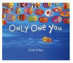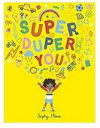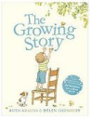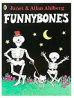  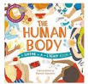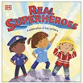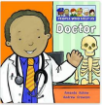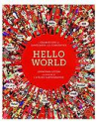

Please share as much as possible on Dojo - there is no such thing as too much! We are always thrilled to see what experiences the children have outside of school and this also informs our assessments. Remember to capture your child’s voice as this is what is most important to demonstrate their understanding.

