|  |  |  |
| --- | --- | --- |
| Neptune Homework Grid      Hand in date: Monday 3rd November 2025 | | |
| BE A REGULAR READER  Please read every day. Read a range of  different types of books, including poems  and non-fiction. Make sure you read aloud too as this is a different skill and you can practise making it interesting for the listener. Make a note of what you read under each day in your Reading Record and write a comment to note your thoughts about what you have read. Make sure you have your Reading Record in school every day and hand it in every Friday. | BE A WORD WHIZZ  Practise the spellings we send home as often as you can. Try writing the word in different styles and colours, looking for letter patterns or making up a mnemonic to help you.  e.g. Big Elephants Can Always Understand Small  Elephants = because.  There will be a test of the week’s words on Friday. | BE A MATHEMATICIAN    Log on to TIMES TABLE ROCK STARS and answer  a minimum of 100 questions a week. We will check  this on a Friday along with your average accuracy score. We will be looking for this to be above 90%.  This half term we will be revisiting prior learning by looking at the 3 times tables and the 6 times tables. At the end of Year 4, they will complete the government MTC, which is an important statutory assessment. **Daily times table practice will help ensure their success with this assessment and is therefore vital.** |
| CREATE YOUR OWN STONE AGE SHELTER!  During the Stone Age people built shelters to live in using materials that they had gathered. Gather some natural materials and make an attempt at building your own model shelter. It would be wonderful for it to be small enough to come into class! | BE A STONE AGE ARTIST!  One of the very first forms of art was Cave Art. Visit this link for some examples: <https://edu.rsc.org/resources/cave-art-history/1528.article>. Can you create your very own Cave Art using paint, chalk or crayons? | Marvellous Map-Maker  Create your own map of the Regions of England and try to fill each one with famous/historical landmarks and/or any exciting facts you may find out about each region. |
| BE A STONE AGE ARCHIECT!  During the Stone Age, people lived in small settlements. They had to think carefully by making sure their shelters were close to water, food and safe from predators. Using your cartography skills, create a map of your very own Stone Age settlement! Include symbols, a key and grid references. | BE AN OBSERVER!  Stonehenge is a circle of stones built during the Stone Age over 5000 years ago! It has become one of the most famous landmarks of our country. Using this link: <https://www.natgeokids.com/uk/discover/history/general-history/stonehenge-facts/> write a list of ten facts about Stonehenge and prepare to share them with the class. | BE A POET!  Write an acrostic poem about the Stone Age. Can you include any rhyming words? Could you use repetition in anyway? |
| BE A NARRATOR!  This half term, we are reading Stig of the Dump. Using your knowledge of descriptive writing, write your own narrative. In this story you are the main character, and you have accidentally been sent back in time to live in the Stone Age. Where are you? How will you survive? Who shall you meet? | Terrific Tour Guide  Pick a local town or village and write a fact file all about it. See if you can find some exciting historic facts!  Have there been any famous faces in your area?  How has it changed over time?  Are there any historic landmarks or buildings? | BE A NAVIGATOR!  Firstly, create and label your own eight-point compass. Then, using a map of the local area find out what is located around a familiar place e.g. your home, our school etc. Once you had completed this, find out what is located on each of the compass points from that place. For example: North-West is the park. |

* Starred activities are compulsory and must be done every week.
* You need to complete at least one activity from each of the coloured columns by the end of the half term.
* Activities must be done in your homework book. Drawings or photos of models should be stuck in with a title to explain what the work is.
* **Work can be handed in for marking each Friday. All homework books are to be returned into school on Monday 3rd November 2025.**

History Vocabulary Geography Vocabulary

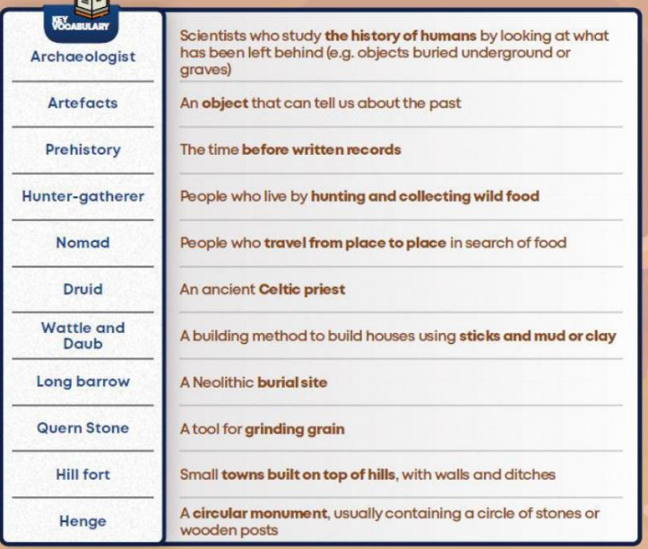 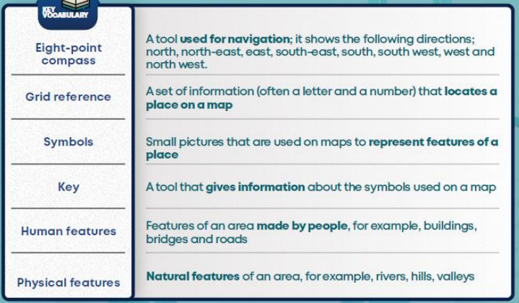

Key Stage 1 Spellings (prior learning)



