Spring 2 Neptune Homework Grid Anglo-Saxons, Scots & Vikings Hand in date: w/c Tuesday 14th April 2026
BE A REGULAR READER  Please read every day. Read a range of  different types of books, including poems  and non-fiction. Make sure you read aloud too as this is a different skill and you can practise making it interesting for the listener. Make a note of what you read under each day in your Reading Record and write a comment to note your thoughts about what you have read. Make sure you have your Reading Record in school every day! | BE A WORD WHIZZ  Practise the spellings we send home as often as you can. Try writing the word in different styles and colours, looking for letter patterns or making up a mnemonic to help you.  e.g. Big Elephants Can Always Understand Small  Elephants = because.  There will be a test of the week’s words on Friday. | BE A MATHEMATICIAN  Log on to TIMES TABLE ROCK STARS and answer a minimum of 100 questions a week. We will check this on a Friday along with your average accuracy score. We will be looking for this to be above 90%. If you have trouble accessing TTRockstars at home, you can use an iPad at break or lunch times.  We are currently embedding our knowledge of the 4 times tables. This includes solving multiplication and their corresponding division calculations.
Be a researcher!  Research the Vikings and create a poster that contains at least 6 key facts about the Anglo-Saxon to Viking period in Britain. Think about any pictures that could be included. Here are some useful websites:  https://www.bbc.co.uk/bitesize/topics/ztyr9j6  https://www.bbc.co.uk/bitesize/articles/z8j66g8 | Be spiritual!  Star Gazing and Cosmic Exploration  Look up at the stars on clear nights. Think about the vastness of the universe and the wonder of the cosmos. Write down any questions about the universe, life, and your place in it. | Be a cartographer!  Create a map of Britain showing the Anglo-Saxon kingdoms and how they changed when the Vikings invaded.
Be an artist!  Select a famous figure from the Viking era. Draw or paint or collage a picture of them. It could be a king, soldier, god or someone else. Here is a useful link to help:  https://www.worldhistory.org/article/1296/twelve-great-viking-leaders/ | Be a comparer!  Draw or print out a picture of yourself and a Viking child. Write about the similarities and differences between you both. Include information about their day, school, family, toys, pets, work. | Be a reporter!  Research the Jorvik centre in York. Write key information about it. How can you present it? What sub-headings will you need? How will you keep the reader interested?  https://www.jorvikvikingcentre.co.uk/
Be a creator!  Make a model of a Viking long boat.  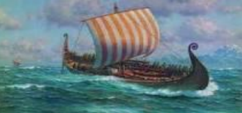 | Be a Viking writer!  Write a diary entry for a Viking warrior. How would a diary entry be written long ago? Where are you fighting? Who are you against? Why is there a battle? | Be a Viking gamer!  Design a Viking board game. How many players can play? What is the purpose of the game and how do you win?  Raid and Trade online game: https://www.bbc.co.uk/bitesize/articles/zdmgbqt  Information about Viking games:  https://www.shetlandmuseumandarchives.org.uk/blog/viking-toys-and-games

- Starred activities are compulsory and must be done every week.
- You need to complete at least one activity from each of the coloured columns by the end of the half term.
- Activities must be done in your homework book. Drawings or photos of models should be stuck in with a title to explain what the work is.
- Work can be handed in for marking each Friday. All homework books are to be returned into school on Tuesday 14th April 2026

History Vocabulary Geography Vocabulary
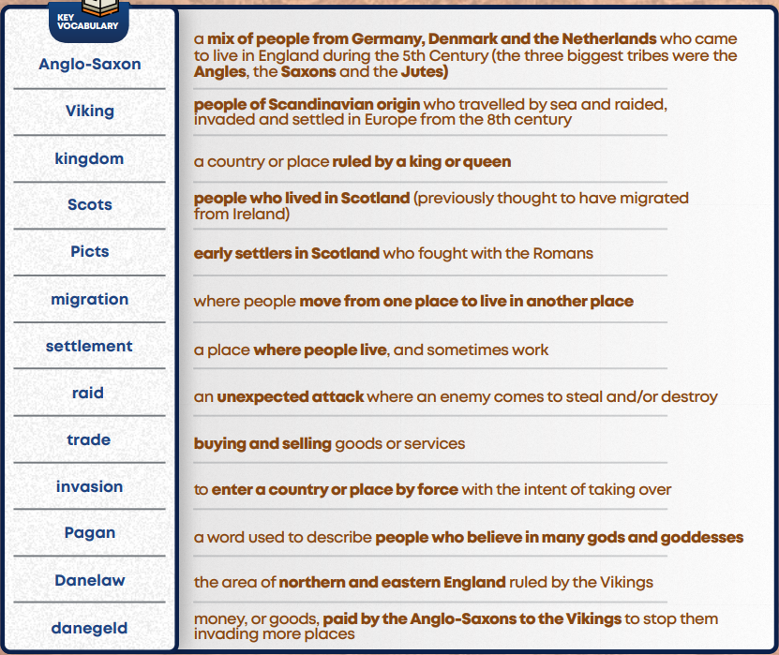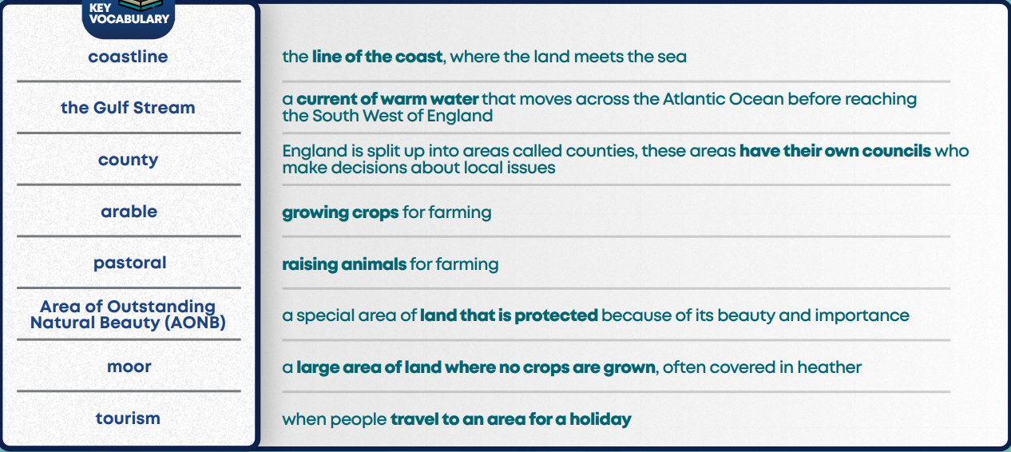
Key Stage 1 Spellings (prior learning)
