Investigators Homework Grid
Summer 2

Be a regular reader!  Please read to an adult daily and get your reading record book signed so I can see all the super reading you are doing!  Books will be changed weekly when I am confident you are able to read it fluently. Remember for every time you read at home, you will earn a raffle ticket for the end of term reading prize.  Make sure when you read your book with an adult you discuss your book with them. What was your favourite part of the story? What did you learn from the book? Who was your favourite character? | Be a word whizz!  Please practice the spellings you are given each week on Dojo ahead of your spellings test each Friday.  Please also continue to practice the KS1 common exception words, a copy of these can be found in your homework dairies.  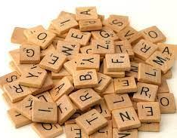 | Be a Times Table Titan!  Please practice the 2, 3, 5 and 10 times tables every week. You can practice these however you would like! If you are confident on these tables please make sure you are confident working out division questions based on them.  You could write them, say them, or practice them online.  Useful resources for timetables include:  - Hit the Button  - TimesTable Rockstars (TTRS)  - Complete Maths Tutor.  
Be a wonderful writer!  The Sword in the Stone  One day, Arthur pulled a magical sword from a stone!  Imagine you were there when it happened.  Write a short story about:  - what the crowd could see,  - how Arthur felt,  - what happened when he pulled the sword out,  - and what happened next.  Try to include:  - adjectives (shiny, enormous, magical),  - exciting verbs (pulled, gasped, cheered),  - and speech marks for talking. | Be a Trust Trailblazer!  This half term we are learning about the Christian value of trust.  Think about a time when:  - someone trusted you,  - you trusted someone else,  - or you trusted God to help you.  Write a short paragraph or story explaining:  - what happened,  - how you felt,  - and why trust was important.  You could also draw a picture to go with your writing.  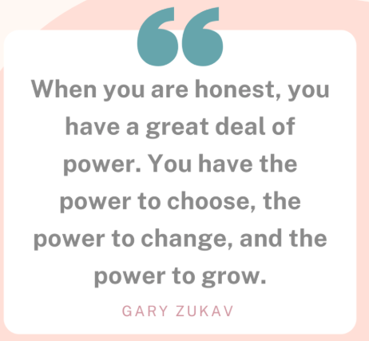 | Be a spiritual seeker!  Create a “Spiritual Me Map” or “4 Worlds Page”. Draw yourself in the middle, then add 4 sections around you:  1. Me, myself and I  - 3 words that describe you (e.g. kind, brave, calm)  - something you are proud of  2. Others  - someone important to you  - show one way you help or care for others  3. Nature  - something in nature you love (tree, ocean, sky, animals)  4. Divine  - something that feels amazing or mysterious (stars, light, sky, sunrise)  - a big question you wonder about (e.g. Why are we here?)  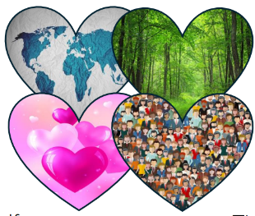
Be a honourable historian!  Be a Voice for Change!  Choose one powerful voice:  Greta Thunberg, David Attenborough, or Rosa Parks  These people are known for speaking up and helping to make the world a better place.  Breaking News Poster  Create a newspaper front page about them! Include:  - a big headline (e.g. “BRAVE VOICE SPEAKS UP!”)  - a drawing  - a short caption explaining what they did   | Be an adventurous astronomer!  Space Postcard  Imagine you have travelled into space.  Draw a postcard from space showing:  - a planet you have visited  - what you can see (stars, moons, galaxies)  - what it feels like  Add a short message like:  “Greetings from space! I can see…”  Remember: Space is full of wonder, mystery, and discovery — great astronomers ask questions and notice amazing things!  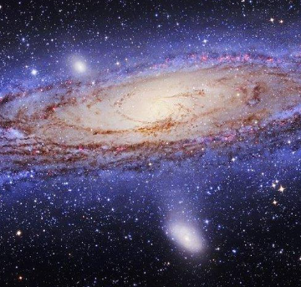 | Be a courageous creator!  We have been learning about the school in India and thinking about how children’s lives can be different around the world.  Create a digital-style poster, slide, or information page that encourages people to help others.  Your work could include:  - ways our lives are different  - things we should be thankful for  - how we can show kindness and support  - ideas to help children around the world  Challenge: Can you include:  - one fact you have learned,  - one way people can help,  - and one hopeful message for the future?  Remember: A courageous creator uses their ideas and creativity to make the world kinder, fairer, and more hopeful.  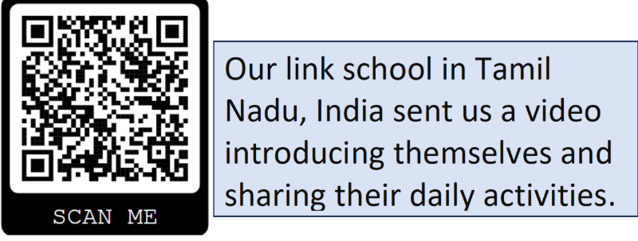
This homework grid gives a range of tasks that you can do with your child this half term. The top three boxes that are marked with a star (*) are tasks that should be completed weekly. These can have a significant impact across all your child’s learning. All work should be completed in your homework books, please record it here even if you have uploaded evidence to Dojo. Please take photos and ensure they are stuck in along with any drawings, paintings or documents that show off the work you have done.
Please hand your homework books in on Monday 6th July 2026.
Find our key vocabulary for the term below.
RE: Baptism, Believer’s Baptism, Belong, Buddha, Buddhist, Monastic Community, Monk, Nun, Philosopher, Poverty, Prayer, Prophet, Seclusion, Shahadah, Vow, Worldview,
History: Empire, Protest, Boycott, Activist, Civil Rights, Campaign, Climate Change
Art: Mural, Fresco, Plaster, Pope, Sistine Chapel, National Gallery, Tapestry, Weaving, Composition,
Music: Lullaby, Legato, Verse, Chorus, Texture, Accompaniment, Unaccompanied, Solo, Unison, Harmony, Dissonance, Improvisation
Science: Solar System, Planets, Orbit, Rotate, Moon, Reflect, Waxing, Waning, Constellation

