2025-2026 Spring 1 ‘Space’ Homework Grid
Personal, Social and Emotional Development  Plan a tea party on the moon for the aliens. You could draw pictures of the food you want at the party. Think about what kind of food an alien might like - star biscuits, rocket jelly or moon cheese balls, the possibilities are endless! You could even make some star biscuits. | English  - Can you create your own space alien and write some sentences to describe them?  - Can you write 10 things you would want to take into space?  - Can you discover a book about space in your books at home? If not ‘Books for topic’ recommends some lovely books on our space theme, maybe you could get one of these out from the local library Book Lists for Topics - Space (EYFS/KS1) (booksfortopics.com)  - We will send out homework for phonics and reading separately, please look out for this in book bags and on Dojo. | Maths  - Can you play a game of Snakes and ladders (or use this Space themed one Comets and rockets.pdf). Encourage the children to count on using the numbers on the board.  - Play a game of bingo using the numerals 1-10 to help children with their number recognition to 10 or beyond. Ladybird Bingo - Minibeasts Bingo Game for Kids - Twinkl  - Can you draw a picture of space using only 2D shapes? Can you name the shapes you have used in your picture?
Understanding the World
- Go outside when it is dark or look out of the window and talk about what you can see. Can you count the stars? Can you find the moon? Does the sky change from one night to the next?

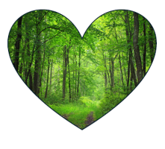
Communication and Language

Develop and teach your family your own alien language - what word could you use for ‘hello’? How about ‘blooba’, ‘floppa’ or ‘cookaboo’? You choose - it’s your alien language!
Physical Development  - What shapes can you make with your body?  - Can you use these shapes to make a sequence?  - Don’t forget about your starting and finish position | Show and Tell  This half term please try to focus what your child shares to reflect our topic. These opportunities enrich communication, listening and attention skills. Please take a photo or a video, share on Dojo and we will share this with the class on our interactive whiteboard. | Expressive Arts and Design  Create a vehicle that you could use to travel into space. What would it look like? You could create a rocket using cardboard tubes, a spacecraft using old boxes, or you could design a different type of vehicle to get you there!
Please continue to share as much as possible on Dojo.

Key vocabulary for the half term | Exciting books for topic  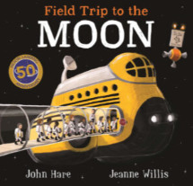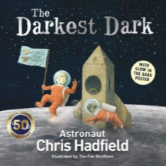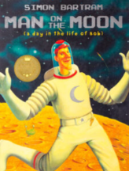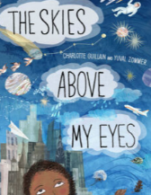  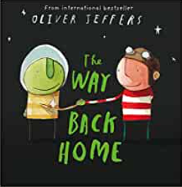  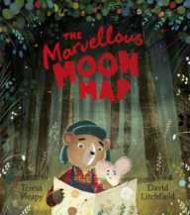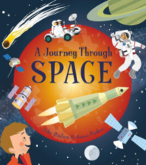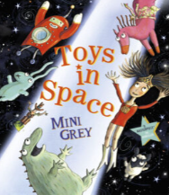
  Earth | The planet we live on.
  Space | Where all the planets and stars are found.
  Astronaut | A person who travels into space.
  Orbit | The path an object takes when it travels around a planet, moon or star.
  The moon | Our moon orbits the Earth.

